Preface

This Guide is intended to be read by system administrators responsible for the daily operations that support the transaction processing. It assumes familiarity with the system and Microsoft Windows.

# About Business Operations

This user guide covers the daily operations that facilitate transaction processing in Trade Innovation. It also covers the menu options in the Trade Innovation SWIFT, batch setup application and configuration applications.

The Business Operations in Trade Innovation refer to the functions that enable a System Administrator to perform daily operations which include:

* Executing daily batch processing handled in the system, and configuring batch routines
* Using the System Tailoring and Message Manager applications to view and process inward SWIFT messages
* Viewing and transmitting outward SWIFT messages generated by the system and incorporate them into the workflow
* Viewing and handling inward and outward electronic messages
* Using the Message Manager application to process requests received via the customer gateway interface service
* Entering foreign exchange rates during business hours and how they are applied to transactions awaiting foreign exchange rate fixing.

This chapter provides an overview of the following operational areas.

## Trade Innovation’s Daily Cycle within Global Processing

### Management of Business Days under Global Processing

Global processing allows different parts of the banking business to co-ordinate with separate back offices within a single zone.

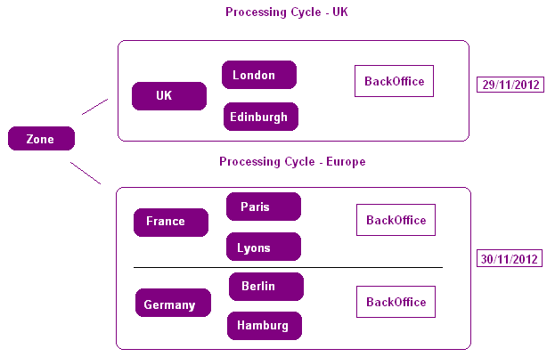

Separate processing cycle end of days are configured to run for each part of the business. All business dates are managed per processing cycles.

* Processing date is maintained for each processing cycle.
* Profit start date is maintained for each processing cycle.
* Next business day date is maintained for each processing cycle.

Transaction date (for the next business day) is maintained for each processing cycle.

Where dates are shown against the zone. The earliest date of all running cycles is presented.

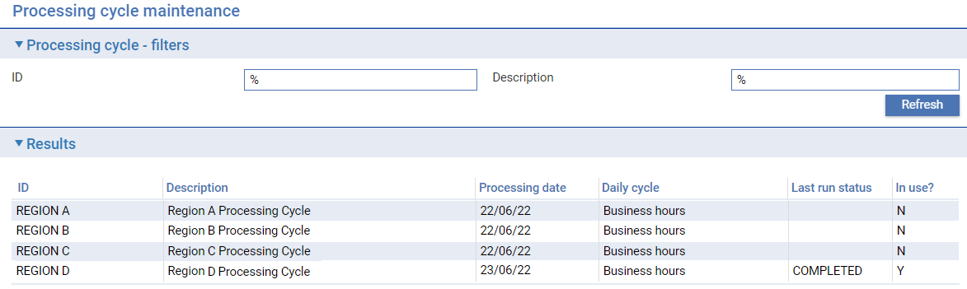

### Processing Cycles

Global processing enables Trade Innovation to manage separate banking entities of the business within a single zone. A processing cycle manages the running or end of day actions for one or more main banking entities and their associated back office system. Multiple main banking entities can also be mapped to represent a banking business or banking group within a processing cycle. Separate processing cycles can be set-up to cover main banking entities located in different time zones. The operator can run each processing cycle end of day according to the time in each region:

The following must be set up for each processing cycle:

* Main Banking Entities
* Actions Mapped into each cycle phase
* Action Run Attributes
* Business Day Calendars
* Report Profiles
* Schedule Diary Events

Each processing cycle manages its own business day, passing through the following four phases:

* End of business hours
* End of day
* Start of day
* Start of business hours

Within each processing cycle end of day, various batch processing routines and diary actions are carried out during the four phases in conjunction with the associated back office processing.

The system permits your bank to incorporate its own programs - referred to in this Guide as custom control actions - into processing cycles.

Trade Innovation Processing Cycles are run from within zones.

### End of Day Processing

Processing Cycle definitions can be defined regionally by time zone to manage the end of day requirements for one or more main banking entities. Each processing cycle runs an independent end of day for the main banking entities and back offices assigned.

As system administrator, you will need to run Trade Innovation’s end of day for each processing cycle as it is required throughout a 24 hour cycle, and ensure that each completes successfully for each day.

All transaction activity in Trade Innovation is undertaken against a behalf of branch. Where an end of day is running for a main banking entity that includes that branch, daily input for that branch is no longer possible and Extended Business Hours now applies to that branch. Other branches in the zone may continue daily input while their main banking entities remain in business hours.

Where you are running a main banking entity integrated with a back office system, then, when overnight processing is initiated it can send a message indicating its change of status, zone and current processing date, that the back office can then use to trigger the initiation of its own overnight processing cycle. Before the back office end of day can start, Trade Innovation end of day processing waits for all transactions that involve sending interface service messages to the back office to be completed.

Should any of the actions included in overnight processing fail, as system administrator you will be able to use the batch processing application to effect recovery. Trade Innovation provides facilities for monitoring the progress of overnight processing which identify any actions that fail.

1. It is possible to configure the system to log off daily users from the zone, but only where one cycle and main banking entity are defined.

When generating end of day reports (system-level reports), the generated report cannot be viewed by other users unless the report has been set to ‘Shared” in the Report Profile.

For more information on end of day reports, refer to *Reports User Guide* – Trade Innovation.

### Extended Business Hours Processing

Transaction processing under Global Processing is available virtually 24 hours a day. Transaction events can be input and authorised for the next business day whilst an end of day is in progress. For events with behalf of branches falling within main banking entities currently within end of day, a state of extended business hours is enabled. Here input is permitted for the following business day.

Extended business hours cover the following phases:

* End of business hours
* End of day
* Start of day

A message in the banner at the top of the screen, including the following business date informs the user that input is allowed only for the next business day.

Within transactions, the user is warned if the event has passed into extended business hours mid input, or continuing after pending. After authorisation, release items (such as postings and SWIFT messages) are released at the end of extended business hours.

Extended business hours ends at the start of business hours phase when the back office is available for the following day. Pended release items for events authorised during extended business hours are released at this point.

### Synchronising with the Back Office

#### Zone Status

Trade Innovation can inform that back office, via interface service messages, whenever it changes phase. Various system options allow your bank to control how Trade Innovation behaves when running integrated with a back office system. The system options are classified according to the following areas:

* Zone
* Main banking entity level
* Services
* Parameter set based

The System Tailoring User Guide – Trade Innovation provides a list, and an explanation of what each system option controls.

#### ‘Use local data’

Where the bank’s back office services provide static data such as customers, accounts and standing settlement instructions then there may be times when the services become unavailable e.g. during end of day as the back office performs its own processing or is off-line because of unexpected system errors. In these circumstances, the bank can set on ‘UseLocalData‘ for the relevant service to allow transaction input to continue during extended business processing or where the host services are not available. Where ‘UseLocalData’ is set, this allows the user to browse and select data that has been downloaded through previous service calls and that is held in the Trade Innovation database. This allows transaction input to continue using previously retrieved data (and no service calls are made). Whilst previously retrieved data can be used, any new details required such as a new customer can only be retrieved and used when the service becomes available again.

#### Interface to Back office

Trade Innovation’s underlying interface message processing to each back office ensures that, should the connection between Trade Innovation and the back office fail during business hours, any messages between the two will be retransmitted automatically, and processed without duplication, when the link is re-established.

## Times Shown under User’s Time Zone

Global processing allows transaction events to be processed by teams in multiple locations. It may be required as one business centre is reaching the end of its working day a transaction event can be concluded by a user in a separate time zone where it is still daily business hours. To facilitate multiple time zone access, timestamp information is presented in the Dashboard and transaction detail screens in the logged on user’s time zone. See the *Common Facilities User Guide* – Trade Innovation for details.

Additionally Business Operations can be undertaken by users across time zones. See following example:

### End of Day Details as seen from its Requested Location

An example of an end of day requested from Paris, France. The location is shown in brackets by the refresh button.

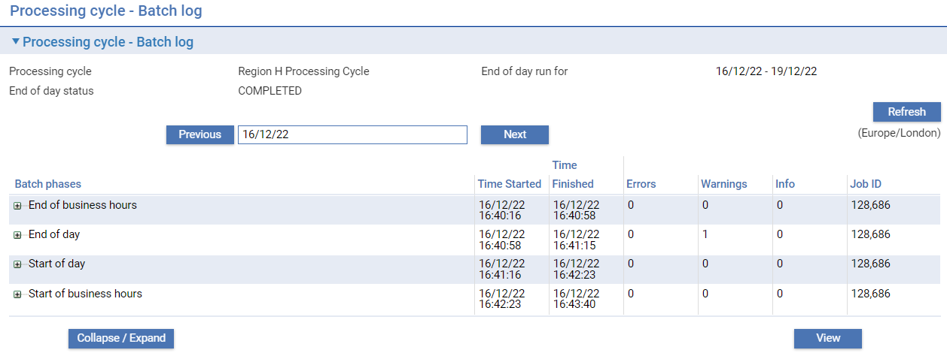

### End of Day Details as seen from its Maintained Location

If the local operator is not available, the end of day could be maintained from another location, in this case from New York. A New York user sees the action times according to their location.

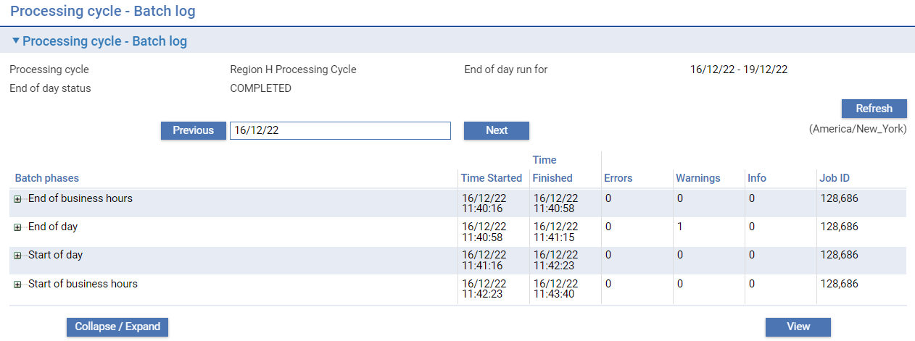

The user’s location is set in the Security applications **Security|Users maintenance** menu option.

1. The processing date and the next business day of any processing cycle are not affected and are presented constantly for all users.

### Global Application Details

Global application timestamps are shown according to the server’s locale.

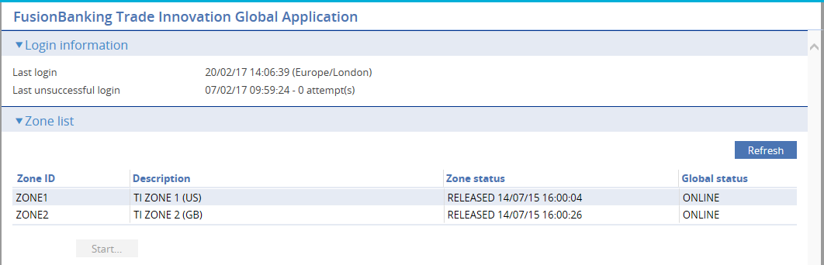

## Transaction Deletion after Book off

After transactions are booked off the bank may wish to retain transactions in the system for audit access or to arrange a backup snapshot prior to deletion.

Finastra recommends the approach of taking backups of zone data made available as deployed zones for the purposes of viewing data only. All booked off masters and associated release item data will be available to view. Backups should be made at frequencies which are synchronised with the booked-off transaction retention periods defined within the zones.

1. For archiving purposes, the bank must implement regular zone backups in conjunction with using the Booked off Masters Deletion action available to map within processing cycle End of Day phases.

To ensure all booked off masters are captured it is recommended to utilise a zone backup frequency which is equal to or slightly shorter than the shortest master retention period defined within the zone.

An optional audit of booked off master deletions is available through the notifications mechanism.

An optional verification interface (API) is provided to allow the bank to undertake a check that a master is present in a backup copy prior to executing a booked off master deletion in the End of Day.

See Chapter – Deletion of Booked off Masters for further information.

## SWIFT Messages and Incoming Customer Gateway Interface Service Messages

The Trade Innovation message manager application allows you to transmit outward SWIFT messages generated by Trade Innovation and process inward SWIFT messages, incorporating them into the Trade Innovation workflow. Inward messages received using the customer gateway interface service can also be incorporated into Trade Innovation’s workflow.

The Trade Innovation message manager application also includes functionality that allows you to attach scanned-in images of commercial and financial documents supporting a transaction, for storage in your document management system (DMS). This enables you to use Trade Innovation, rather than an external system, to log documents received.

As you attach images you can specify the master record to which they belong and the event they are to be used to create. When necessary, you can specify that they should create a new master record. For each set of documents, the application creates an internal customer gateway message to Trade Innovation which is used to create the required event at an input step.

## SWIFT MT798 FileAct Attachments

SWIFT MT 798 messages are used by banks in a corporate-to-bank and bank-to-corporate environment (i.e. a ‘SCORE’ – Standardised CORporate Environment). Files may be attached to these messages via Tag 23X, using code ‘FACT’ (SWIFTnet FileAct).

FileAct is an automated messaging service that SWIFT has designed to enable banks and their corporate customers to exchange files. FileAct supports both interactive and store-and-forward modes and is particularly suited for the exchange of large volumes of data, allowing the transfer of text, images or any other type of data. Where multiple attachments are received or sent, zipped files are used.

Incoming and/or outgoing SWIFT MT798 messages are transformed in the Payment Manager application to, or from, an appropriate gateway.xml message which is transmitted or received by Trade Innovation.

When messages are received by Trade Innovation, any attached files are unzipped, the contents extracted and these are attached to the appropriate master record. Likewise; files that are required to be transmitted by Trade Innovation may be zipped and attached to the outgoing gaterway.xml/MT798.

## Interest Consolidation

Trade Innovation provides functionality to allow interest due on financing transactions belonging to certain product types and for certain customers to be consolidated by currency and debited automatically on a regular basis. The consolidation process takes place per main banking entity within each processing cycle end of day.

Trade Innovation permits you to reverse this consolidation process for individual main banking entity/customer/product type/currency combinations (see Reversing the Effect of Interest Consolidation).

Functionality is also provided to allow you to update existing financing transactions after customer and/or product type details have been amended to include them in or exclude them from interest consolidation processing.

## Static Data Downloads to Corporate Access Systems

Trade Innovation allows you to download the following types of data to any corporate access system you support:

* Details of customers who are users of the customer gateway interface service, including address information
* Account details
* Customer and account types
* Account officers
* Countries
* Currencies
* Exchange rates
* Customer pre-allocated references
* Supply chain finance programmes
* Supply chain finance programme sub-types
* Supply chain finance buyers/sellers
* Supply chain finance buyer/seller relationship

You can use the static data application to tailor the mappings of these messages.

## Batch Setup Application Menu Options

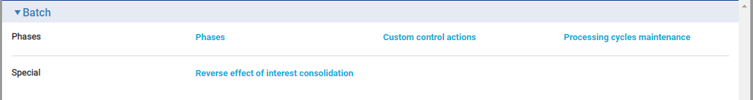

The following table shows the menu options in the Trade Innovation batch application:

| **Menu Option** | **Sub-option** | **What it Does** |
| --- | --- | --- |
| Phases | Phases | Allows you to set up batch processing phases.(See Viewing Phases) |
|  | Custom Control Actions | Allows you to set up and maintain custom control actions for each zone (see Including Custom Control Actions in Batch Processing). |
|  | Processing Cycles Maintenance | Allows you to configure the running requirements for each processing cycle within the zone (see Processing Cycles). |
| Special | Reverse Effect of Interest Consolidation | Used if Trade Innovation’s interest consolidation functionality is implemented. This menu option is used before the start of day to reverse the effect of the previous night's interest consolidation for specific customers and transactions (see Reversing the Effect of Interest Consolidation). |

## Trade Innovation Message Manager Application Menu Options

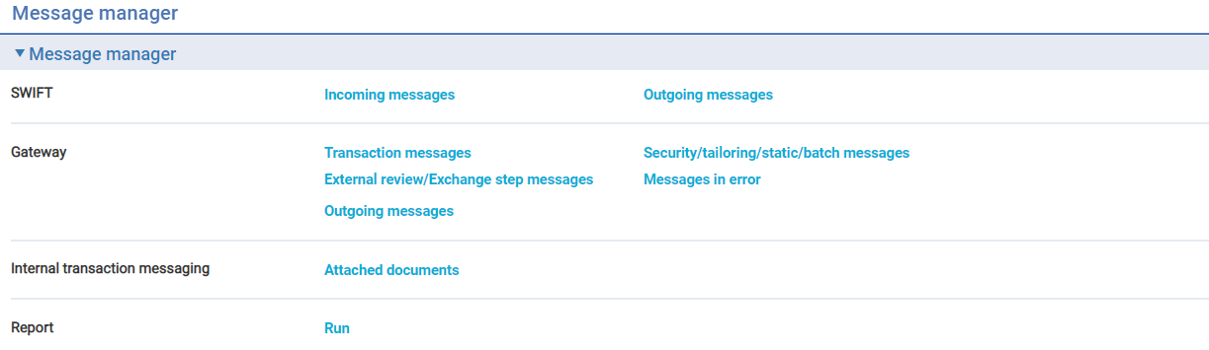

There are a number of menu options available and the following table describes the purpose of each menu option that is available in the Trade Innovation message manager application:

| **Menu Option** | **Sub-option** | **What it Does** |
| --- | --- | --- |
| SWIFT | Incoming Messages | Allows you to view and process incoming SWIFT messages. |
|  | Outgoing Messages | Allows you to view outward SWIFT messages (see Viewing, Re-sending, and Deleting Messages) and resend when required. |
| Gateway | Transaction Messages | Allows you to incorporate incoming transaction messages from the customer gateway interface service into the Trade Innovation workflow (see Viewing Inward Customer Gateway Interface Transaction Messages). |
|  | Security/Tailoring/Static/Batch Messages | Allows you to incorporate incoming security, tailoring or statis data messages from the customer gateway interface service into the Trade Innovation workflow (see Viewing Inward Gateway Interface Security, Tailoring, Static and Batch Messages). |
|  | External Review/Exchange Step Messages | For use with Advanced Trade Innovation workflow only. Allows you to incorporate incoming messages from external systems, in response to review and exchange step outgoing messages, into the Trade Innovation workflow (see Viewing Inward Gateway Interface External Review and Exchange Step Messages). See the *SDK – Workflow Implementation Guide – Fusion Trade Innovation* for more details. |
|  | Messages in Error | Allows you to view, print or delete messages referring to incoming gateways message requests which could not be processed into Trade Innovation (see Viewing Inward Gateway Interface Messages in Error). |
|  | Outgoing Messages | Allows you to view/edit and resend outward customer gateway interface service messages. |
| Internal Transaction Messaging | Attached Documents | Allows you to attach commercial and financial documents supporting a transaction to the appropriate master record (see Attaching Scanned Images to a Master Record). |
|  | External review/Exchange step messages | For use with Advanced Trade Innovation workflow only. Allows you to incorporate incoming messages from external systems, in response to review and exchange step outgoing messages, into the Trade Innovation workflow. See the *SDK – Workflow Implementation Guide – Trade Innovation* for more details. |
| Report | Run | Allows you to run associated defined SWIFT-related reports. See Reports Guide *– Trade Innovation.* |

The Message Manager Application screen is also provided with a link which indicates the number of outgoing messages which have resulted in a negative acknowledgement (a SWIFT ‘NAK’).

Selecting this link opens the SWIFT Message Out Browser: See Viewing, Re-sending, and Deleting Messages for further details.

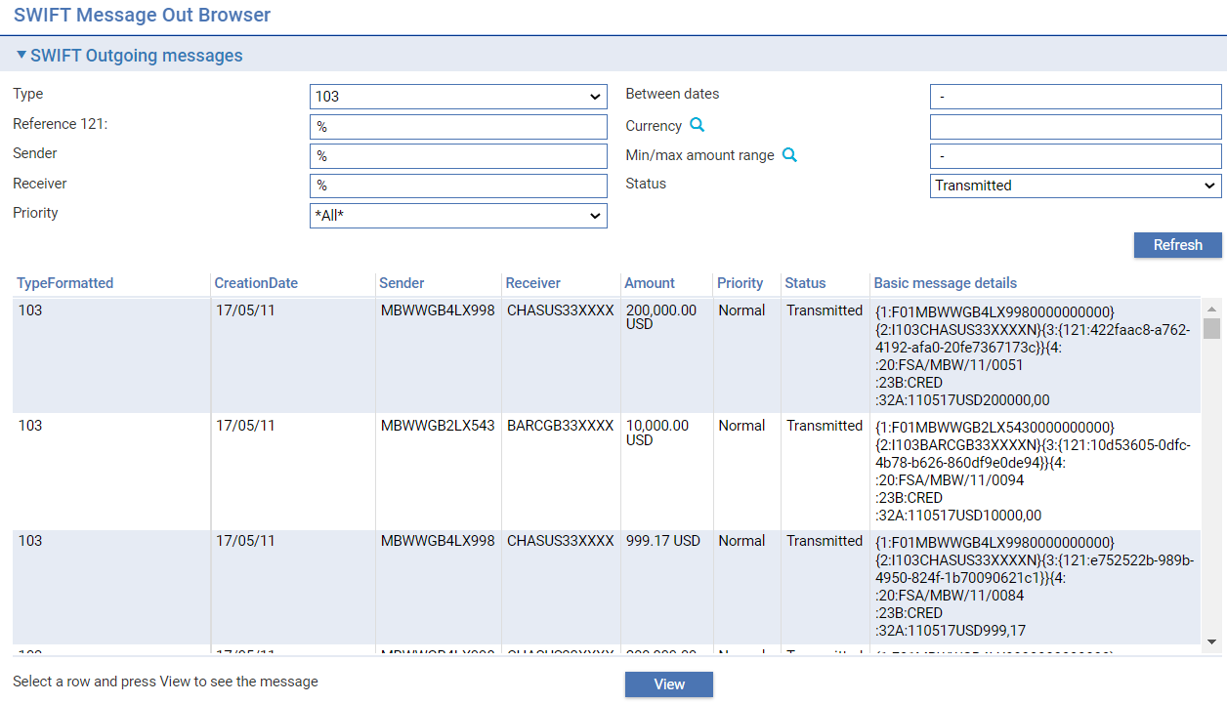

# Logging On and Managing Zones

This chapter explains how to set up and manage zones.

For instructions on granting users access to zones see the Security Guide *– Trade Innovation.*

## Logging On to Trade Innovation

When you log on to Trade Innovation, the system displays a page that lists all the zones you have access to for your system.

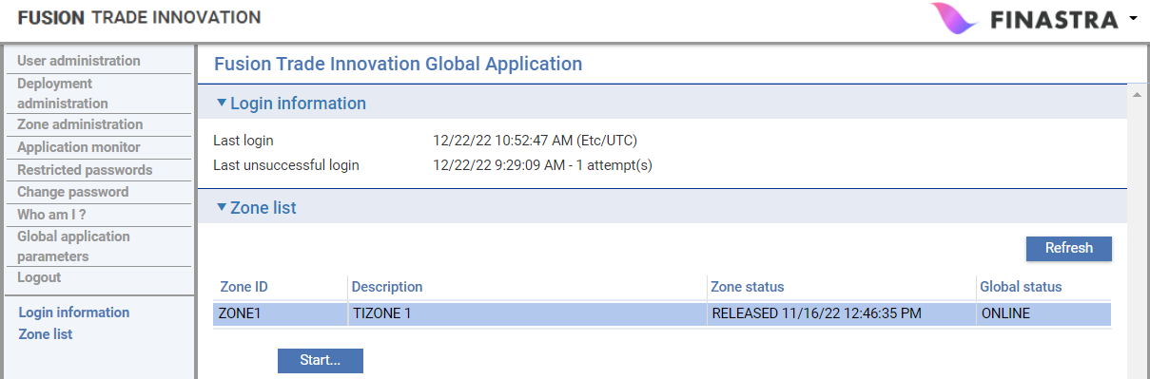

For each zone it shows:

| **Heading** | **What it Shows** |
| --- | --- |
| Zone ID | The zone's unique identifier. |
| Description | A description of the zone. |
| Zone status | The status of the zone, followed by a time stamp showing when it changed to that status. Possible values are:   * RELEASING (the system is releasing the zone to allow daily users into the zone) * RELEASED (the system has released the zone to daily users) * CLOSING (the system is closing ready for end of day to commence) * CLOSED (the system has closed and is ready for end of day to commence) * SUSPENDING (the system is about to suspend the zone from daily users) * SUSPENDED (the system has suspended the zone from daily users) |
| Global status | Indicates whether the zone is online or offline. |
| The Zones List window has the following buttons: | |
| Start | Used to start work in a zone. System administrators, security officers and operators can use this button at any time, regardless of the status of the zone (provided it is online). Normal & helpdesk uses cannot use this button while zone is closed or suspended. |
| Refresh | Refreshes the information being displayed. Use this button to refresh the data shown each time you return to the Zones list page. |

1. The zone status only applies to an end of day context if the overnight cycle defined has those actions configured. These actions would only be configured in a single processing cycle setup, or possibly where cycles are closely synchronised.

The Deployment administration and Zone administration links are used by security officers and system administrators to set up and maintain zones. For the other links at the left side of the window see the Security Guide *– Trade Innovation.*

## Defining a Deployment

A deployment is an instance of the Trade Innovation software running in an application server.

When you select the Deployment administration link Trade Innovation displays a page that lists those deployments already set up on your system.

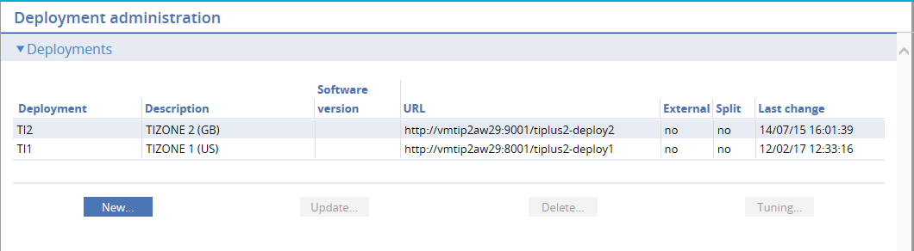

Information is shown under the following headings:

| **Heading** | **What it Shows** |
| --- | --- |
| Deployment | The deployment’s unique identifier. |
| Description | A description of the deployment. |
| Software version | Software version for display in the application monitor. |
| URL | The root URL of the deployment. |
| External system | Indicates whether the deployment is an external system or not. |
| Split | Indicates if the deployment is split with the user access and async framework deployed separately. |
| Last Change | The date on which the deployment changed to its current status. |

The **Update** and **Delete** buttons can be used in the usual way to amend or delete existing deployments. The Tuning button allows you to enter tuning parameters for the async framework for the deployment – it is described in a later section.

To set up a new deployment click **New**.

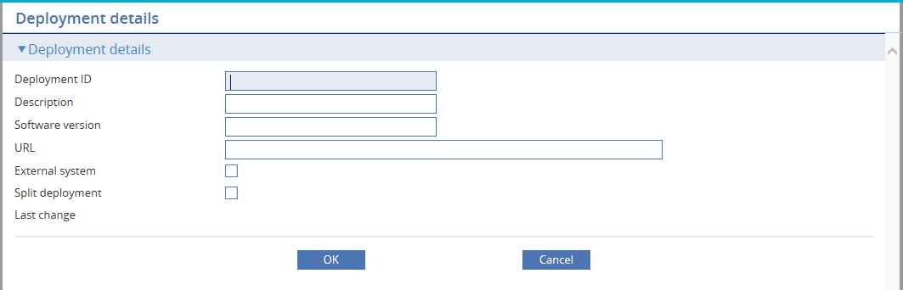

The following table explains what to enter into the fields in this window to define a new deployment. For existing deployments, Trade Innovation displays their current status and the date on which the deployment changed to that status:

|  | **Field** | **What to Enter** |
| --- | --- | --- |
| P504C4T10#yIS1 | Deployment ID | A unique identifier for the deployment. |
| P508C7T10#yIS1 | Description | A description of the deployment. |
|  | Software version | Optionally enter the version of the software for display in the application monitor for versions prior to 2.8.0. From 2.8.0 the system populates the version automatically. |
| P516C13T10#yIS1 | URL | The URL root of the deployment. |
|  | External system | Check this if the deployment is a proxy zone. |
|  | Split deployment | Check this if the deployment is split into separate user access and async framework systems. |

1. The software version is managed automatically for a deployment at 2.8.0 or later. This is can be entered manually to show the actual pre-2.8.0 version that is in use.

### Defining Tuning Parameters

Each deployment has an Async framework component that allows background jobs like end of day to run. A job comprises of a number of steps that run in a particular sequence either in isolation or in parallel with other steps. To control how many steps and jobs can run at the same time, tuning parameters may be defined.

When a deployment is created, a tuning parameter is created to define the maximum number of steps that can be run at the same time – referred to as the number of slots. This parameter cannot be deleted. When a deployment is deleted, all tuning parameters defined for that deployment are removed.

When you click **Tuning** from the deployment administration list, after selecting a particular deployment, the defined tuning parameters are shown.

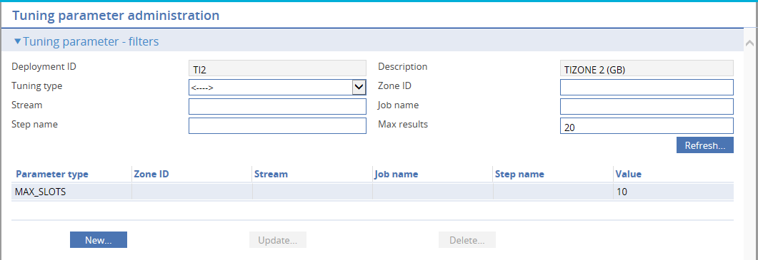

Information is shown under the following headings:

| **Heading** | **What it Shows** |
| --- | --- |
| Parameter type | Type of tuning parameter   * MAX_SLOTS * MIN_SLOTS * MAX_JOBS * MAX_STEPS * ALLOCATE_BATCH |
| Zone ID | Identifier of zone |
| Stream | Name of stream the job will run in (for instance, an end of day job runs in a stream with the same name as the associated processing cycle) |
| Job name | Name of job the parameter applies to |
| Step name | Name of step the parameter applies to |
| Value | The value of the parameter (either slots, steps or jobs based on the parameter) |

The **Update** and **Delete** buttons can be used in the usual way to amend or delete the existing parameters – though it is not possible to delete the MAX_SLOTS parameter for the deployment.

To set up a new parameter, click **New**.

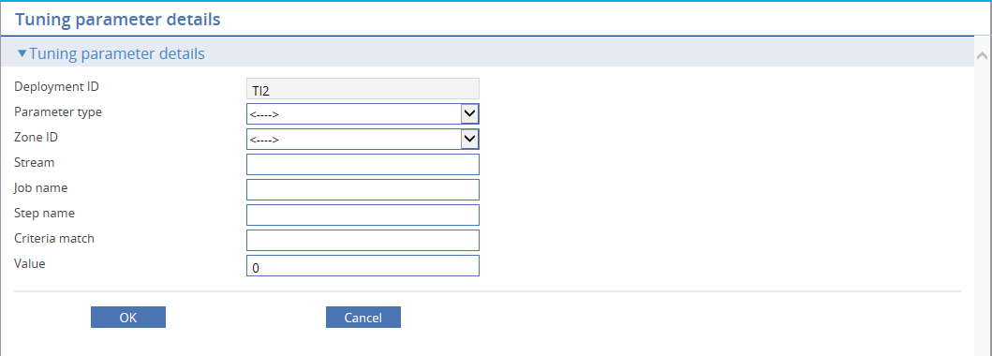

The following table explains what to enter into the fields in this window:

|  | **Field** | **What to Enter** |
| --- | --- | --- |
| P570C4T12#yIS1 | Parameter type | Type of parameter to define (Maximum Slots, Minimum Slots, Maximum Jobs, Maximum Steps, Allocate Batch) |
|  | Zone ID | The zone ID for the parameter |
|  | Stream | The name of the stream a job and its steps will run in |
|  | Job name | Name of job to tune |
|  | Step name | Name of step to tune |
|  | Criteria match | A value to match in the criteria for a step – to differentiate it from another step of the same name |
| P594C22T12#yIS1 | Value | A non-zero value |

The following is a list of tuning parameters that may be defined apart from the initial one:

* Maximum number of slots (MAX_SLOTS) for a zone
* Maximum number of slots for a zone stream
* Maximum number of slots for a named Job
* Maximum number of slots for a named Job in a particular zone
* Maximum number of slots for a named Job in a particular zone stream
* Minimum number of slots (MIN_SLOTS) for a named Job
* Minimum number of slots for a named Job in a particular zone
* Maximum number of concurrent instances of a named Job (MAX_JOBS)
* Maximum number of concurrent instances of a named Job in a particular zone
* Maximum number of concurrent instances of a named Step (MAX_STEPS) within a Job
* Maximum number of concurrent instances of a named Step within a Job in a particular zone
* Maximum number of jobs allocated to run at the same time (ALLOCATE_BATCH)
* Maximum number of jobs allocated to run at the same time in a particular zone
* Maximum number of slots for a named Job in a particular zone stream

For more information on the Async framework component, see the *Installation Guide – Trade Innovation.*

## Setting up a Zone

To set up a zone, there must be a deployment available to associate with the zone. You can also set up an external system using Trade Innovation.

### Defining a Zone

When you select the Zone administration link Trade Innovation displays a window that lists those zones already set up on your system.

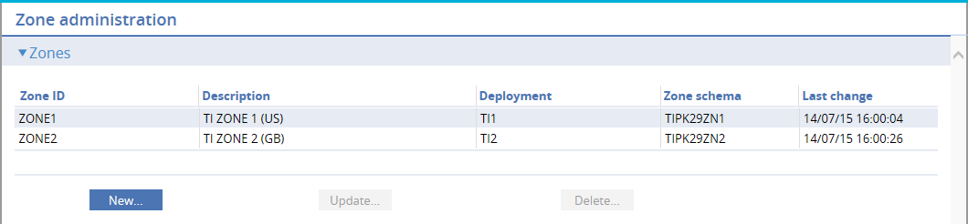

Information is shown under the following headings:

| **Heading** | **What it Shows** |
| --- | --- |
| Zone ID | The zone's unique identifier. |
| Description | A description of the zone. |
| Deployment | The deployment ID the zone is associated with. |
| Zone schema | The name of the database schema associated with this zone. |
| Last changed | The date on which the zone changed to its current state. |

The **Update** and **Delete** buttons can be used in the usual way to amend or delete existing zones.

To set up a new zone click **New**.

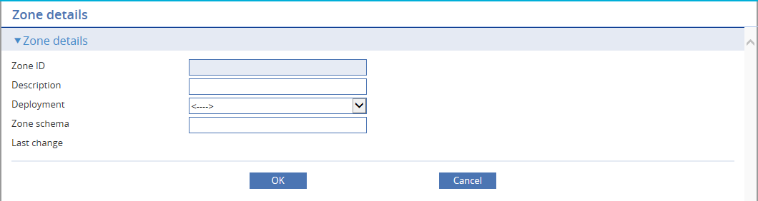

The following table explains what to enter into the fields in this window to define a new zone. For existing zones, Trade Innovation displays the date on which the zone changed to that state:

|  | **Field** | **What to Enter** |
| --- | --- | --- |
| P648C4T14#yIS1 | Zone ID | A unique identifier for the zone. The value GLOBAL is not permitted here. |
| P652C7T14#yIS1 | Description | A description of the zone. |
| P656C10T14#yIS1 | Deployment | Select the deployment this zone will be associated with. |
| P660C13T14#yIS1 | Zone schema | The name of the database schema associated with the zone. |

## Application Monitor

The application monitor keeps track of the status of zones, deployments, and servers. It allows the user to change the status when needed. It also keeps track of user sessions and allows notifications to be sent to one or all users. Logging levels may also be configured.

### Suspending and Releasing a Zone

The application monitor link available to security officers and system administrators shows a list of the configured zones and the servers they are deployed to.

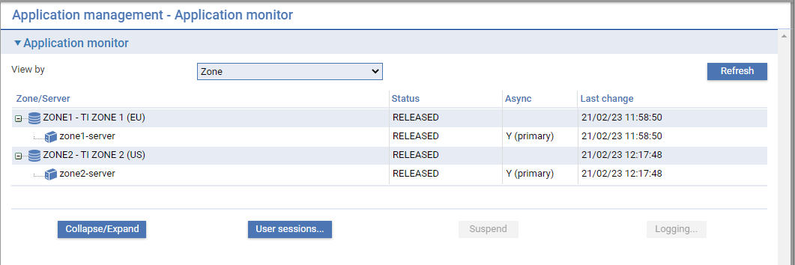

Each line shows either the zone or server, its status, and if the line corresponds to a sever, whether the software includes the Async framework. If it does, it also indicates whether the server is designated as a primary or secondary server.

The **Suspend** or **Release** button on this page is used to suspend or release the selected zone. This should only be used for zone administration outside of daily operations. Suspending the zone will log out all daily users from all processing cycles.

If the zone's status is RELEASED, users can use the **Start** button from the Zone list page to access and start work in Trade Innovation (if the zone is online). If its status is SUSPENDED or CLOSED, normal users will not be able to access it.

You can suspend a zone with a status of RELEASED by selecting it and clicking **Suspend**. The system sends a message to daily users, advising them that Trade Innovation is about to suspend - stating how many minutes before Trade Innovation will suspend - and asking them to log off. A second message is sent one minute before the zone is suspended. After that minute, all users are forcibly logged off. The zones status changes, first to SUSPENDING, and then to SUSPENDED. Normal users will then be prevented from entering that zone, although you, as system administrator, will be able to enter the zone to access a restricted list of applications. Once the last user has been logged out, the zone's status changes to SUSPENDED. Only the following applications are available while the zone is suspended.

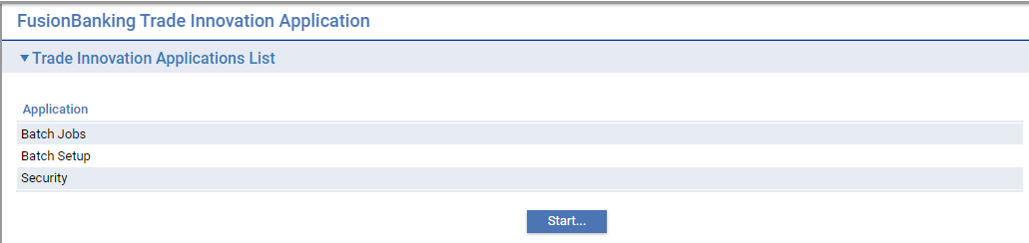

To subsequently release the zone, select it again from the zone view of the application monitor page. The **Suspend** button will have change to be a **Release** button. Click it to release the zone.

Zones may also have the following transitory states:

|  |  |
| --- | --- |
| RELEASING | The status of the zone between your requesting that it be released and the completion of that request by the system. |
| CLOSING | The status of the zone between the overnight cycle requesting that it close and the completion of that request by the system |
| SUSPENDING | The status of the zone between your requesting that it be suspending and the completion of that request by the system. |

### Suspending and Releasing Deployments and Servers

In a similar way to zones, the application monitor allows deployments or servers to be suspended or released.

The Trade Innovation global or zone applications may be deployed to multiple servers (defined within a cluster). Similarly, applications may be deployed to the same server or cluster as each other.

To restrict access to a server or deployment for maintenance purposes, it may be suspended. Users currently accessing that deployment or server are asked to save their work and log off. Once suspended, the deployment or server may be stopped.

The deployment or server view of the application monitor may be reached by changing the View by dropdown to either Deployment or Server. The resulting view shows either servers within deployments or deployments within servers.

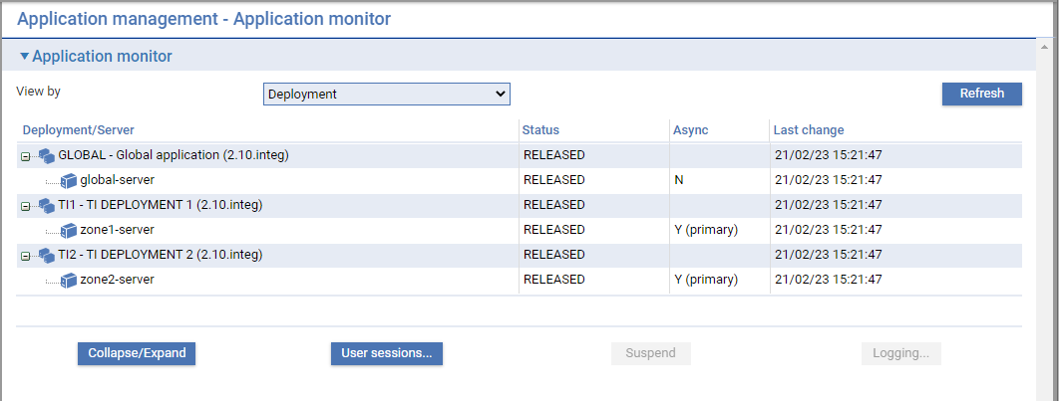

In the Deployment view, each line shows either the deployment or server, its status, and if the line corresponds to a sever, whether the software includes the Async framework. If it does, it also indicates whether the server is designated as a primary or secondary server.

To suspend a deployment, the view must be selected to show servers within deployments (Deployment). Select the deployment and click **Suspend**. Similarly, if it is suspended, the button will be **Release**.

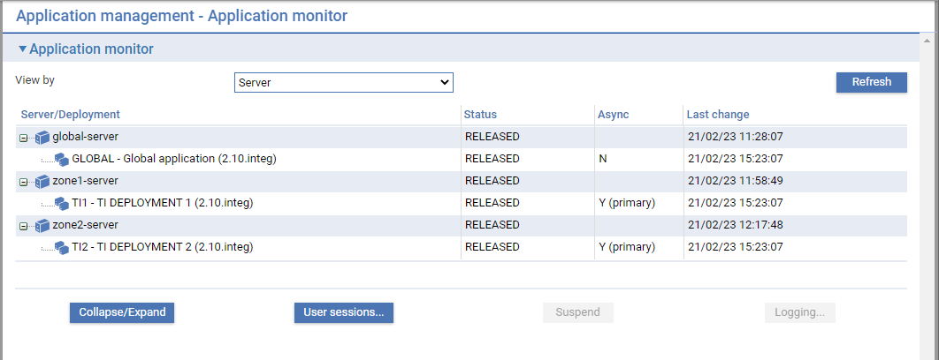

In the Server view, each line shows either the deployment or server, its status, and if the line corresponds to a deployment, whether the software includes the Async framework. If it does, it also indicates whether the server is designated as a primary or secondary server.

To suspend a server, the view must be selected to show deployments within servers (Server). Select the server and click Suspend. Similarly, if it is suspended, the button will be **Release**.

1. In these two views, the global application is represented by the deployment with an ID of ‘GLOBAL.

### Viewing User Sessions

User sessions can be selected at the deployment level or the server level, or the deployment and server level depending on which line is selected in either the Deployment or Server view.

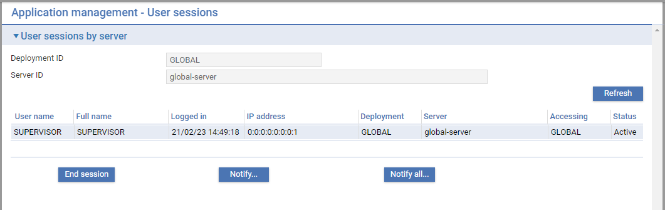

Each line details a separate session accessing the specific deployment/server specified.

The **End session** button will invalidate the session so that the user of the session will need to re-access the system and create a new session.

The **Notify** and **Notify all** buttons allow a message to be sent to one selected user session, or all those listed.

### Setting the Logging Levels

1. Finastra recommend that you check the log files for errors regularly - at least once a day.

The logging level is set in the Deployment view of the application monitor.

From the Zone list page, select the Application monitor link, and change the View by dropdown to Deployment.

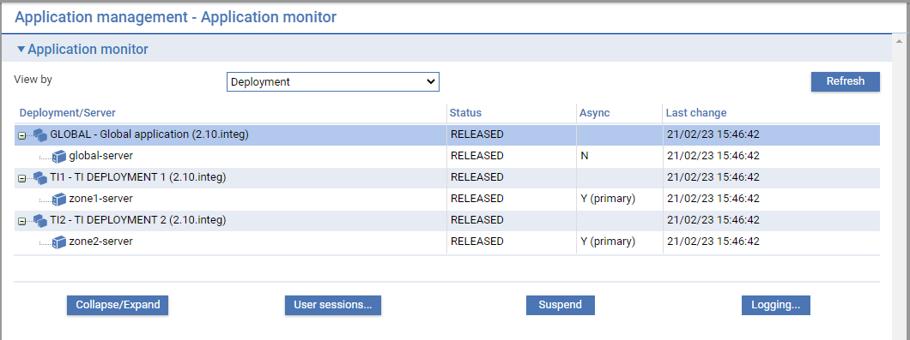

The values set up in the logging configuration files provide the default values for logging.

Select the deployment and click the **Logging…** button. The following page is shown:

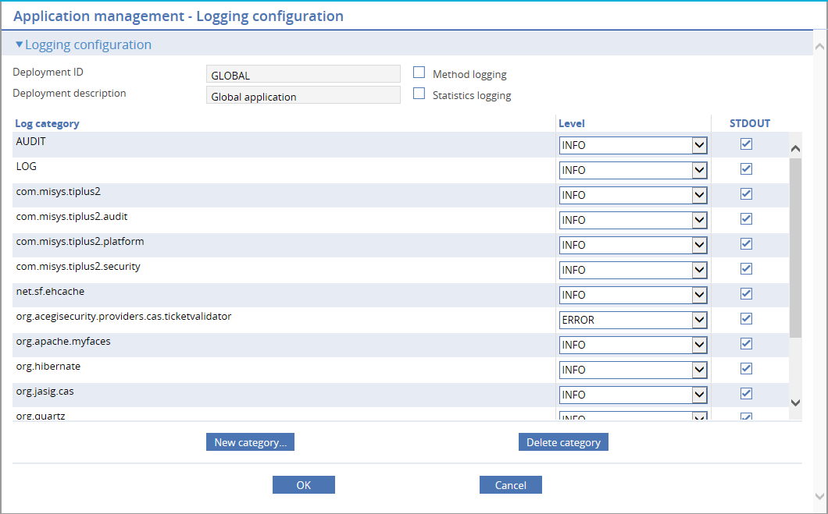

The values you set on the page for the logger levels take effect when you click **OK** and retain the values you set until they are next changed.

The following table explains what to enter into the fields on this page:

| **Field** | **What to Enter** | |
| --- | --- | --- |
| Method logging | This checkbox will enable log entries for every method called in the system to be output for those categories at TRACE level. | |
| Performance logging | This checkbox will output extra performance related entries. This should only be enabled on instruction from Finastra. | |
| Log category | A package name used to identify parts of the system. | |
| Level | You can set whatever each logger will log at.  Permitted values are: | |
|  | TRACE | The system logs information used for debugging, information, warnings, errors and items that cause Trade Innovation to fail including method entry/exit information if the Method Logging checkbox is checked. |
|  | DEBUG | The system logs information used for debugging, information, warnings, errors and items that cause Trade Innovation to fail. |
|  | INFO | The system logs information, warnings, errors and items that cause Trade Innovation to fail. |
|  | WARN | The system logs warnings, errors and items that cause Trade Innovation to fail. |
|  | ERROR | Only errors and items that cause Trade Innovation to fail are logged. |
|  | The logging level should normally be set to WARN for the system logger and INFO for the audit logger. You should only set the system logging level to DEBUG if you are advised to do so by your local Finastra support branch. | |
| STDOUT | If checked, then the log entries for this category will be echoed to the default output log of the application server. | |

Logger entries can be added or deleted by clicking **New Logger** or **Delete Logger**.

# Processing Cycle Actions

Trade Innovation allows the actions required to be run on a daily basis each processing cycle. These actions are pre-defined on the system, available to be mapped as required into the appropriate phases.

As system administrator you can define the order in which actions are performed.

Actions are performed in one of four phases:

* End of business hours
* End of day
* Start of day
* Start of business hours

Actions include:

|  |  |
| --- | --- |
| TI actions | Actions relating to Trade Innovation data. These involve, for example, overnight accrual processing to reflect activity and changes made during the day. |
| TI control actions | Actions that involve initiating and checking system processing. A suite of control actions is delivered with Trade Innovation. |
| Custom control actions | Actions defined by the bank, made available within the Trade Innovation control actions mapping lists. |

In each phase, you define the Trade Innovation actions that are to be carried out, in the order in which they are to be carried out. You then define the Trade Innovation and custom control actions to be carried out in that phase, scheduling them either before or after (but not interspersed with) the Trade Innovation actions.

1. This needs to be carried out separately for each processing cycle within the zone on your system.

If your bank uses Trade Innovation’ Foreign Exchange Rate Fixing functionality, an additional ‘Business hours’ phase is available in which you can map the ‘FX rate fixing’ action, thus allowing rate fixing to be run during the business day. (See Business Hours for further details.)

The Trade Innovation batch application also allows you to configure reports to be run for processing cycles during batch processing When defined processing cycle actions run, each must complete before the next action can begin. This affects how overnight processing is handled. Your bank can flag some actions so that, if an action fails, Trade Innovation goes on to the next action and overnight processing is not held up. The table listing TI actions (see End of Day Processing) flags those actions that can be configured to be bypassed in this way. Facilities are provided to allow you to view the results of overnight processing after it has completed and identify any actions that failed.

Alternatively, your bank can configure actions so that they must complete before the end of day can continue. This requires the processing cycle end of day to be monitored and any failures addressed as they occur.

Defined actions run sequentially, however, for efficiency each action may create a set of subsidiary actions configured by the system to run in parallel according the nature of the function.

An action may create parallel running actions for each main banking entity.

A main banking entity action may create parallel running actions for each branch.

The Batch job runner and Batch log allows collapse/expand functions to drill down into the subsidiary action information.

Trade Innovation is delivered with a default mapping that determines which actions are performed in which phases. Except for the Release P/R and Docs action and the Scheduled Diary Events action Finastra does not recommend changing the default allocation of actions to phases delivered with the system.

## Processing Cycles

The batch set up application **Phases|Processing Cycles Maintenance** menu option, allows configuration for the end of day cycles required within the zone.

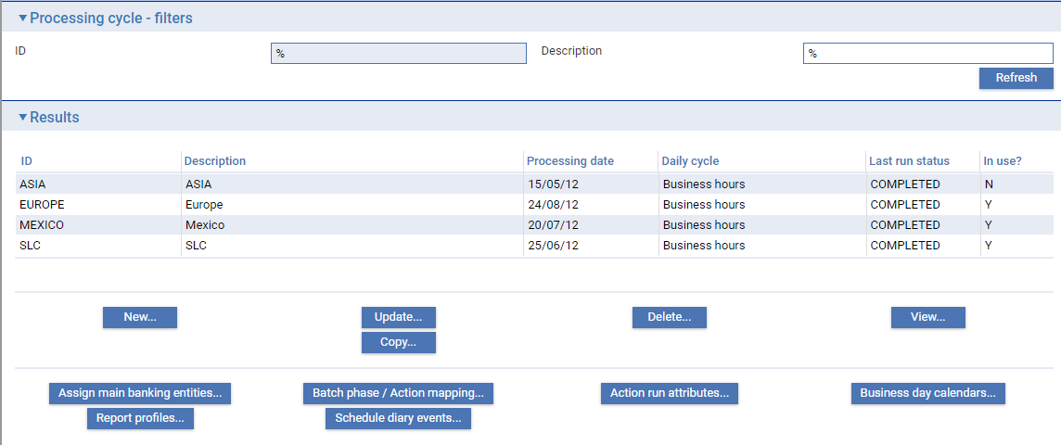

Information is shown under the following headings:

| **Heading** | **What it Shows** |
| --- | --- |
| ID | The processing cycle identifier. |
| Description | The processing cycle description. |
| Processing date | The processing cycle business day. |
| Daily cycle | The processing cycle state - business hours or end of day phase. |
| Last run status | The status of the running end of day or COMPLETED during business hours. |
| In use? | Y - if at least one main banking entity is assigned to the processing cycle. |

Processing cycles can be created, amended, deleted, viewed and copied as per standard Trade Innovation functions.

To create a new processing cycle, click **New**. When entering the ID and description details, the processing date and standard week day mask are also prompted as mandatory.

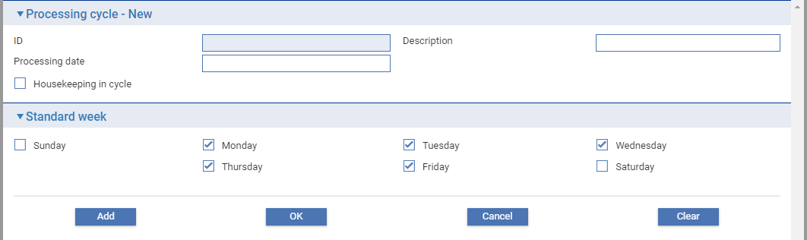

When a new cycle is added, the default business day calendars are created for the current previous and next year. The calendars allow the next business day and profit start date to be initialised.

1. When assigning banking entities to a processing cycle that entity must operate under the same standard week in order to arrive at the correct next business day and profit start date.

### Housekeeping in Cycle

Some generic functions run across the whole zone. These should be run once per 24 hour cycle. They run automatically within the cycle set to run housekeeping. Only one processing cycle should be set per zone. The following functions are included within housekeeping:

* Archive deleted SWIFT in messages
* Delete expired reporting view data files
* Customer reorganisation
* Journal delete
* Delete approved or rejected maker checker items
* Delete obsolete event orchestrations
* Delete sent SWIFT messages
* Delete sent Telex messages
* Delete expired reports
* Delete expired documents
* Delete Supply Chain Finance buyers
* Delete downloaded static messages
* Cleanup SBY to U/T conversion records

### Assigning Main Banking Entities

At least one main banking entity must be mapped to a processing cycle for it to be active. The ‘In use?’ column in the processing cycle results list indicates where main banking entities are mapped.

To assign main banking entities to a processing cycle, select the processing cycle from the list and then click **Assign Main Banking Entities** from the Processing Cycles Maintenance screen.

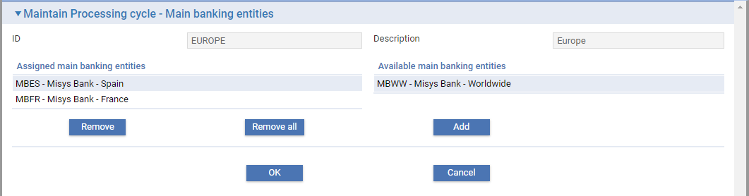

Select the main banking entities you want to include in the daily cycle from the Available Main Banking Entities list and then click **Add** to assign them.

### Assigning Which Actions a Processing Cycle Phase Will Perform

This section explains how to manage which actions are performed during phases.

1. For Trade Innovation actions, except for the Release P/R and Docs action and the Scheduled Diary Events action Finastra does not recommend changing the default allocation of actions to phases provided with the system.

Select the **Batch Phase/Action Mapping** button available within Processing Cycles Maintenance.



To view which actions a phase will perform, select the phase from **Phase** drop-down list.

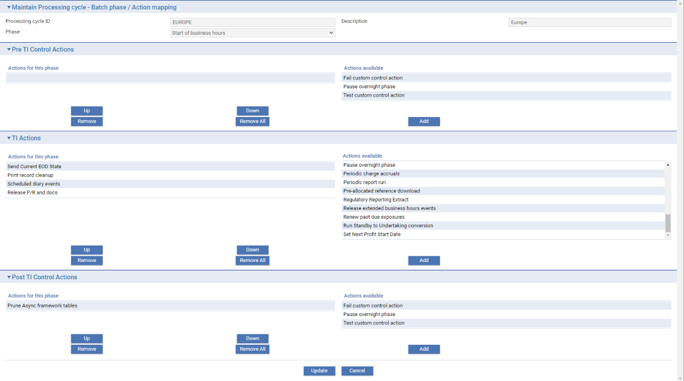

The window displays the following:

* Available TI Actions
* Pre and Post TI Control Actions / Post TI Control Actions
* Including Custom Control Actions in Batch Processing

The Pre TI Control Actions pane lists the control actions that can be included in this phase before TI actions; and the Post TI Control Actions pane lists the control actions that can be included in this phase after TI actions.

1. The actions listed in the Pre TI Control Actions pane and the Post TI Control Actions pane varies, depending on the phase. Validation ensures that required actions are included in the relevant phase and sequence.

The TI Actions pane allows you to define which Trade Innovation actions are to be carried out during this phase in this cycle.

Each of the three panes behaves in the same way. Trade Innovation lists any actions already included in this phase in the ‘Actions for this Phase’ column.

* To include an action in the phase, select the action in the ‘Actions available’ column, then click **Add**. The action is immediately included in the phase; it is added to the bottom of the list in the ‘Actions for This Phase column’.
* To remove an action from the phase select that action under ‘Action for this Phase’ column and click **Remove**.
* To remove all the currently assigned actions from the phase click **Remove all**.

When the phase is run Trade Innovation performs the actions defined for it in the order in which they are listed in the Actions for this Phase column. The **Up** and **Down** buttons allow you to change the order in which actions are listed. Select the action you wish to move; then click the appropriate button to move it up or down in the list.

Click **Update** to save any changes you make.

### Available TI Actions

#### Business Hours

The following table lists the TI action available to processing cycles that are carried out during Business Hours processing. A tick in the third column means that the action can be flagged so that it is bypassed if it fails.

| **Action** | **What it Does** |  |
| --- | --- | --- |
| FX Rate Fixing | If your bank enters new foreign exchange rates during business hours, you have the choice of applying those foreign exchange rates manually during the day, or during overnight batch processing. This action applies foreign exchange rates to events awaiting rate fixing during overnight processing, if they have not already been applied during the day. | P865C6T19#yIS1 |

#### End of Day Processing

The following table lists the TI actions available to processing cycles that are carried out during End of Day processing. The table explains what each action involves. A tick in the third column means that the action can be flagged so that it is bypassed if it fails.

1. Some TI actions are present only if you have the related module installed on your system.

| **Action** | **What it Does** |  |
| --- | --- | --- |
| Account Branch and Deal Branch Changes | Where an account branch or deal branch change has been initiated from the back office, this action moves the specific account or deal to the new branch. See the Common Facilities User Guide *– Trade Innovation* for transaction update constraints to account and branches while an update from the back office is taking place.  When account branch changes are applied to a completed event, account details included in release items, such postings are not updated by the account branch change to ensure that historical entries show the original account number. However, when viewing the event input fields for completed events any account number shown will display the new account number (as the underlying account data referenced has been changed). | P877C6T20#yIS1 |
| Auto-update Team | When a customer's team is changed during the day, for example where a new team within the bank becomes responsible for that customer, the Auto-update Team action can be used to update all outstanding master records for that customer so that they have the same new responsible team.  When a customer’s team is changed during the day, the system flags the customer as requiring change during the End of Day. When the TI Auto-update Team action is run during overnight processing, it uses this flag to identify each customer for whom the team has been amended, finds all outstanding master details and updates them with the appropriate new responsible team. | P882C9T20#yIS1 |
| Billing Settlements | Handles the production of billing statements, the debiting and crediting of charges subject to periodic billing and the eventual book off of a billing master.  The system identifies each customer for whom periodic billing details are set up. For customers for whom the next billing date is today's processing date or earlier it generates either a Billing Settlement event to process the relevant charges, or an Advise event, if the customer requires a billing statement.  Where a billing master is no longer required, it books it off.  Note that this applies to internally billed charges only. It does not apply to charges that are set to be billed ‘Externally’.  Where charges are billed externally, for example, via the Revenue Management engine, they are not included and processed during Trade Innovation End of Day/Batch processing. | P890C12T20#yIS1 |
| Billing Update Billing Levels | Updates categorisation of billed charges, which have not yet been taken into the billing/invoicing, when customer’s billing level has been changed to or from 'User defined' and the related option ‘Schedule update of billed charges‘ is checked. This action should be scheduled before the Billing Settlements action so that the charges are transferred to billing/invoicing with the new billing level and/or charge grouping. |  |
| CLOSE | Available only if a single Processing cycle and main banking entity are used in a zone. Requests all normal users to log off the zone. Users forcibly logged off after Closing user log-off warning time. |  |
| Check Transfer Complete | If each mapped main banking entity is running integrated with a back office system, this action checks that all transfers of gateway, SWIFT and postings information for each entity to the back office have completed. | P902C21T20#yIS1 |
| Currency Download | Downloads currency information from Trade Innovation to the relevant Corporate Access System, according to the details of the system options set for the Corporate Access system. | P906C24T20#yIS1 |
| Customer Mnemonic Changes | Updates the customer mnemonic on all masters, events and release items affected. See the Common Facilities User Guide *– Trade Innovation.*  for transaction update constraints to customer mnemonics while an update from the back office is taking place.  This functionality is only available where the source banking business is defined at the main banking entity level. | P912C27T20#yIS1 |
| Delete Booked off Masters | Deletes expired masters that have been flagged for deletion during booking off. All associated release items are also deleted by this process. Documents in the internal document management system (DMS) are flagged as not-in-use for deletion in the following housekeeping cycle. |  |
| Delete Processed Documents Received | Deletes any files relating to documents received that have been processed (that is, incorporated into your bank's document management system). | P920C33T20#yIS1 |
| Departmental Limits Rebuild | The departmental limits rebuild:   * Revalues exposures using the stored overnight exchange rate * Recategorises where limit structures have changed or the ‘Recategorise all during rebuild’ departmental Limits option is set to Yes * If new limits are added for a customer, it categorises the postings from existing Trade Innovation transactions entered on the Trade Innovation database before those limits were added * Creates default limits for customers for whom no limits have been set up where this is configured for your system * Updates country exposures where your system configured not to do so during the day * Produces details for the Limit Exception report that shows limit violations caused by recategorisation * Removes reconciled exposure items when the balance for a given master reference, customer, branch, currency and account type is zero. * Deletes all reservations that have been matched to a posting exposure together with any unmatched manual reservations that have reached their expiry date.   This functionality is only available where departmental limit is being used.  As Trade Innovation automatically stores the previous exchange rates as part of the initial start of day processing this action should be mapped to Start of Day.  Whilst the rebuild is in progress, the limit checking service becomes temporarily unavailable. Users will receive a warning and must pend their transactions until the rebuild has finished and the service becomes available again. | P936C36T20#yIS1 |
| Exchange Rate Download | Downloads exchange rates from Trade Innovation main banking entities to associated Corporate Access Systems, according to the details of the system options set for the Corporate Access system. | P940C39T20#yIS1 |
| FX Rate Fixing | If your bank enters new foreign exchange rates during business hours, you have the choice of applying those foreign exchange rates manually during the day, or during overnight batch processing. This action applies foreign exchange rates to events awaiting rate fixing during overnight processing, if they have not already been applied during the day. |  |
| FX Rate Fixing Reset Fix Next Day | After rate fixing is completed for transactions with FX deals awaiting Fix rate today, the rate fixing status is Complete. This action resets it for each MBE to Not fixed for the following day. |  |
| Financing IAS39 Changes Extract | Produces an extract of cash flow and transaction information changes since the last run tailored according to the system options defined, then saves to the DMS and transfers to the specified ftp directory. | P952C48T20#yIS1 |
| Financing IAS39 Full Extract | Produces an extract of all cash flow and transaction information tailored according to the system options defined, then saves to the DMS and transfers to the specified ftp directory. | P956C51T20#yIS1 |
| Financing Accruals | Passes postings for the daily accrual or amortisation of interest for financing transactions.  For loans with interest in arrears with variable interest rates or loans with interest in advance that are past due, this action retrieves the latest interest rate for use in calculating interest for any outstanding loans that use that rate. | P961C54T20#yIS1 |
| Financing Auto Cost of Funds | Generates monthly interest payments to the funding party for all financing transactions associated with an export credit agency facility. | P965C57T20#yIS1 |
| Financing Auto Monthly Interest | Consolidates interest accrued to date for financing transactions, producing a single debit to each customer's settlement account. Consolidation of this sort is carried out only for customers and product types that are flagged as requiring it, and for customers who are not suspended.  Whether consolidation is carried out or not depends on the AllowAutoMonthlyInterest system option.  Functionality is provided to allow you to reverse consolidations of this sort at the start of the day (see Reversing the Effect of Interest Consolidation). | P971C60T20#yIS1 |
| Financing Extracts | Produces two financing extracts for expected repayments and past due loans. | P975C63T20#yIS1 |
| Financing Suspension | Flags as suspended any loans to customers who have been suspended. Ensure this action is mapped in all cycles to process all main banking entities for the customer. | P979C66T20#yIS1 |
| Financing Suspension Clean Up | Adjusts the recognised interest amount on suspended loans by the amount of interest received during the business day. Ensure this action is mapped in all cycles to process all main banking entities for the suspended customer. | P983C69T20#yIS1 |
| Interest Consolidation Flag Reset | This is used to update financing transactions to reflect changed values for customer and product type settings governing which transactions are to be included in interest consolidation. If the settings governing which customers and product types are subject to consolidated interest processing be changed to True during the day, this action flags existing financing transactions as now subject to interest consolidation.  This functionality is available only if you have Trade Innovation’s consolidated interest functionality implemented (this is controlled by the AllowAutoMonthlyInterest system option). | P988C72T20#yIS1 |
| Invoices Exposure Rebuild | Revalues exposure against buyers and seller/buyer relationships using the details of invoices with master records with a status of 'LIV' and, where relevant, spot rate. |  |
| Invoices Exposure Revaluation | This action:   * Revalues buyer's exposure relating to invoices using current spot exchange rates * Revalues customer and customer/buyer exposures using current spot exchange rates * Updates an invoice's status (and their eligibility status) should the invoice become overdue * Updates the eligibility status (that is, whether an invoice is eligible for financing or drawdown or not) and associated Reason text due to a post-dated invoice becoming current or an invoice becoming overdue or a buyer's status changing from 'Active' to 'Referred/Blocked' or vice versa * Adds a note to an invoice when any of its details change in the ways described above (except for buyer's exposure revaluation)   Establishes the link between invoices and their factoring facility, if the latter was created in Trade Innovation after the former. |  |
| Pause Overnight Phase | Causes processing cycle end of day to pause. | P1006C81T20#yIS1 |
| Periodic Charge Accruals | Identifies all periodic charges for the cycle and passes postings for the daily accrual/amortisation of those charges.  If the system option PerdChgNoAccruals is set to 'Yes', then this action is not carried out, regardless of whether it is included in overnight processing or not. |  |
| Periodic Report Run | Initiates processing for any reports scheduled to be run during the phase.  You must include the Periodic Report Run action in every phase in which you want to run reports. | P1016C87T20#yIS1 |
| Pre Allocated Reference Download | Downloads pre-allocated references from Trade Innovation to the relevant Corporate Access System, according to the details of the system options set for the Corporate Access system. | P1020C90T20#yIS1 |
| Print Record Cleanup | Deletes customer documents that have been successfully printed (or flagged for deletion) from the document server. | P1024C93T20#yIS1 |
| RELEASE | Available only if a single Processing cycle and main banking entity are used in a zone. Allows all normal users to log into the zone for the following business day. |  |
| Release P/R and Docs | Passes postings to the back office to effect the transfer of funds for payments due that day. Produces pay and receive advices for payments that are about to occur. Parameters set up in Trade Innovation determine how far in advance advices are produced for each of the methods of notification used. | P1032C99T20#yIS1 |
| Release Extended Business Hours Events | When transaction events are authorised during extended business hours the event is held at a ‘release pending’ step. This action releases the pended events at start of business hours for the next day. Note that if the customer mnemonic, account branch or deal branch are being changed by a request from the back office, the event pending release is returned to the input step for rectification. | P1036C102T20#yIS1 |
| Renew Past Due Exposures | For Midas integration. Exposures are regenerated in the End of Business Hours phase and transaction exposures are passed to Midas. When a transaction expires in TI, TI will generate Auto Renew Exposure into Midas. The value date and tenor start date generated is equal to the current business day. Tenor end date is next business day. | P1040C105T20#yIS1 |
| SUSPEND | Available only if a single Processing cycle and main banking entity are used in a zone. Users forcibly logged off after Suspending user log-off warning time. |  |
| Scheduled Diary Events | This is used to:   * Generate tracers * Identify any master records that are due to expire, change their status to Expired and produce the account postings set up to occur on expiry * Identify any payments to be generated and authorised on maturity date * Identify each master record that is due to be booked off and change their status to Booked Off. Once a record has been booked off, no further actions can be taken on it * Identify and carry out automatic reductions * Identify and carry out automatic renewals * Identify any periodic charges due to be taken and implement a Pay Charges event for them * Identify and perform any Revolve events * Identify and produce any Revolve Notices due   You can configure this action so that diary entries for specific events are carried out in different phases. | P1058C111T20#yIS1 |
| Send Current EOD State | Sends a gateway message to each back office associated with the main banking entities in the processing cycle. It sends the current processing date and end of day phase of the cycle. | P1062C114T20#yIS1 |
| Set Next Profit Start Date | Sets the start date of the next profit period for the cycle. | P1066C117T20#yIS1 |

There are some constraints on which actions you can or cannot include in different phases. These are shown in the table below, where:

 indicates that the action can be included in that phase

 indicates that the action should not be included in that phase

|  | **Start of Day** | **Start of Business Hours** | **End of Business Hours** | **End of Day** |
| --- | --- | --- | --- | --- |
| Account Branch and Deal Branch Changes | P1079C7T21#yIS1 | P1080C8T21#yIS1 | P1081C9T21#yIS1 | P1082C10T21#yIS1 |
| Auto-update Team | P1085C12T21#yIS1 | P1086C13T21#yIS1 | P1087C14T21#yIS1 | P1088C15T21#yIS1 |
| Billing Settlements | P1091C17T21#yIS1 | P1092C18T21#yIS1 | P1093C19T21#yIS1 | P1094C20T21#yIS1 |
| Billing update billing levels | P1097C22T21#yIS1 | P1098C23T21#yIS1 | P1099C24T21#yIS1 | P1100C25T21#yIS1 |
| CLOSE | P1103C27T21#yIS1 | P1104C28T21#yIS1 | P1105C29T21#yIS1 | P1106C30T21#yIS1 |
| Check Transfer Complete | P1109C32T21#yIS1 | P1110C33T21#yIS1 | P1111C34T21#yIS1 | P1112C35T21#yIS1 |
| Clear API Tables | P1115C37T21#yIS1 | P1116C38T21#yIS1 | P1117C39T21#yIS1 | P1118C40T21#yIS1 |
| Currency Download | P1121C42T21#yIS1 | P1122C43T21#yIS1 | P1123C44T21#yIS1 | P1124C45T21#yIS1 |
| Customer Mnemonic Changes | P1127C47T21#yIS1 | P1128C48T21#yIS1 | P1129C49T21#yIS1 | P1130C50T21#yIS1 |
| Delete Booked off Masters | P1133C52T21#yIS1 | P1134C53T21#yIS1 | P1135C54T21#yIS1 | P1136C55T21#yIS1 |
| Delete Processed Documents Received | P1139C57T21#yIS1 | P1140C58T21#yIS1 | P1141C59T21#yIS1 | P1142C60T21#yIS1 |
| Departmental Limits Rebuild | P1145C62T21#yIS1 | P1146C63T21#yIS1 | P1147C64T21#yIS1 | P1148C65T21#yIS1 |
| Exchange Rate Download | P1151C67T21#yIS1 | P1152C68T21#yIS1 | P1153C69T21#yIS1 | P1154C70T21#yIS1 |
| FX Rate Fixing | P1157C72T21#yIS1 | P1158C73T21#yIS1 | P1159C74T21#yIS1 | P1160C75T21#yIS1 |
| FX Rate Fixing Reset Fix Next Day | P1163C77T21#yIS1 | P1164C78T21#yIS1 | P1165C79T21#yIS1 | P1166C80T21#yIS1 |
| Financing IAS39 Changes Extract | P1169C82T21#yIS1 | P1170C83T21#yIS1 | P1171C84T21#yIS1 | P1172C85T21#yIS1 |
| Financing IAS39 Full Extract | P1175C87T21#yIS1 | P1176C88T21#yIS1 | P1177C89T21#yIS1 | P1178C90T21#yIS1 |
| Financing Accruals | P1181C92T21#yIS1 | P1182C93T21#yIS1 | P1183C94T21#yIS1 | P1184C95T21#yIS1 |
| Financing Auto Cost of Funds | P1187C97T21#yIS1 | P1188C98T21#yIS1 | P1189C99T21#yIS1 | P1190C100T21#yIS1 |
| Financing Auto Monthly Interest | P1193C102T21#yIS1 | P1194C103T21#yIS1 | P1195C104T21#yIS1 | P1196C105T21#yIS1 |
| Financing Extracts | P1199C107T21#yIS1 | P1200C108T21#yIS1 | P1201C109T21#yIS1 | P1202C110T21#yIS1 |
| Financing Suspension | P1205C112T21#yIS1 | P1206C113T21#yIS1 | P1207C114T21#yIS1 | P1208C115T21#yIS1 |
| Financing Suspension Clean Up | P1211C117T21#yIS1 | P1212C118T21#yIS1 | P1213C119T21#yIS1 | P1214C120T21#yIS1 |
| Interest Consolidation Flag Reset | P1217C122T21#yIS1 | P1218C123T21#yIS1 | P1219C124T21#yIS1 | P1220C125T21#yIS1 |
| Invoices Exposure Rebuild | P1223C127T21#yIS1 | P1224C128T21#yIS1 | P1225C129T21#yIS1 | P1226C130T21#yIS1 |
| Invoices Exposure Revaluation | P1229C132T21#yIS1 | P1230C133T21#yIS1 | P1231C134T21#yIS1 | P1232C135T21#yIS1 |
| Periodic Report Run | P1235C137T21#yIS1 | P1236C138T21#yIS1 | P1237C139T21#yIS1 | P1238C140T21#yIS1 |
| Pre Allocated Reference Download | P1241C142T21#yIS1 | P1242C143T21#yIS1 | P1243C144T21#yIS1 | P1244C145T21#yIS1 |
| Print Record Cleanup | P1247C147T21#yIS1 | P1248C148T21#yIS1 | P1249C149T21#yIS1 | P1250C150T21#yIS1 |
| Release Extended Business Hours Events | P1253C152T21#yIS1 | P1254C153T21#yIS1 | P1255C154T21#yIS1 | P1256C155T21#yIS1 |
| Release P/R and Docs | P1259C157T21#yIS1 | P1260C158T21#yIS1 | P1261C159T21#yIS1 | P1262C160T21#yIS1 |
| SUSPEND | P1265C162T21#yIS1 | P1266C163T21#yIS1 | P1267C164T21#yIS1 | P1268C165T21#yIS1 |
| Scheduled Diary Events | P1271C167T21#yIS1 | P1272C168T21#yIS1 | P1273C169T21#yIS1 | P1274C170T21#yIS1 |
| Send Current EOD State | P1277C172T21#yIS1 | P1278C173T21#yIS1 | P1279C174T21#yIS1 | P1280C175T21#yIS1 |
| Set Next Profit Start Date | P1283C177T21#yIS1 | P1284C178T21#yIS1 | P1285C179T21#yIS1 | P1286C180T21#yIS1 |

Finance Suspension must be run after Financing Accruals and before Periodic Report Run.

Release Extended Business Hours Events should be set to run at the beginning of the Start of Business Hours TI actions phase.

You must include the Periodic Report Run action in every phase in which you want to run reports. However, exercise caution when including the Periodic Report Run action in the start-of-business-hours or end-of-business-hours phases, since this may slow down you back office system's overnight processing.

In addition, it is recommended that:

* You do not include the Journal Delete action in the start-of-business-hours or end-of-business-hours phases
* You include Delete Booked off Masters in the end-of-day phase. You include Delete Extended Report Files in the end-of-day phase (as the first action) rather than in the end-of-business-hours phase since the latter is more critical than the former in terms of synchronising overnight processing with the back office
* You remove Auto-update Team action after it has been run, since this will slow down the batch phase it is being run in, and should only be run occasionally
* Invoices Exposure Rebuild is intended to be run on a one-off basis whenever necessary, rather than regularly. Therefore it should be left unmapped except when needed. When it is mapped it should be before, and in the same phase as, invoices exposure revaluation. It should be removed from mapping before the phase runs again

### Pre and Post TI Control Actions

The following table lists the Pre and Post TI control actions that are carried out during batch processing, and explains what each action involves:

| **Phase** | **Action** | **What it Does** |
| --- | --- | --- |
| End of business hours | Pause Overnight Phase | Causes end of day processing to pause. |
|  | Prune Async Framework Tables | Clears the system’s asynchronous framework system control tables. |
| End of day | Pause Overnight Phase | Causes end of day processing to pause. |
|  | Prune Async Framework Tables | Clears the system’s asynchronous framework system control tables. |
| Start of day | Pause Overnight Phase | Causes end of day processing to pause. |
|  | Prune Async framework tables | Clears the system’s asynchronous framework system control tables. |
|  | Clear API Tables | Clears the system tables used as APIs (e.g. GZH971 and TRCDOCCTL). Available as Post Control actions only. |
| Start of business hours | Pause Overnight Phase | Causes end of day processing to pause. |
|  | Prune Async framework tables | Clears the system's asynchronous framework system control tables. |

The action Pause Overnight Phase can be included in any phase between the TI actions. It causes overnight processing to pause.

### Configuring Action Behaviour Upon Failure

The **Actions Run Attributes** button available within Processing Cycles Maintenance allows you to configure actions included in end of day processing so that, if they fail, they can be auto retried and if they continue to fail are bypassed, rather than halting the end of day.

In the window that is displayed, use the fields provided to select the phase and/or type of action you wish to display.

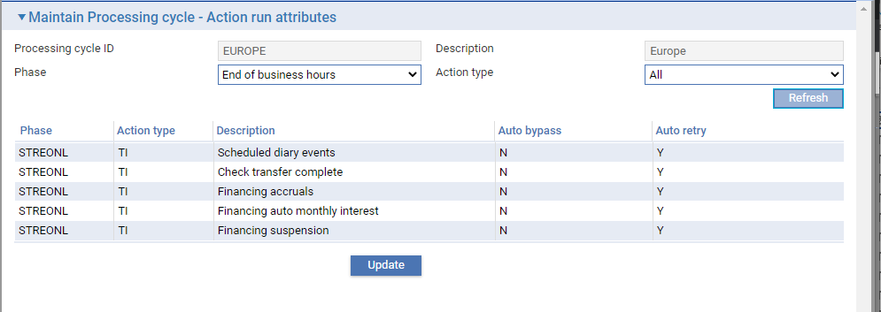

For each action, Trade Innovation shows:

* The phase in which the action may be included
* The type of action
* The action's description
* Whether it is already configured to be bypassed if it fails (Y) or not (N)
* Whether it is already configured to retry (up to a configured maximum) the action if it fails (Y) or not (N)

To flag an action to be bypassed, or to change the auto retry capability, select it and click **Update**.

Trade Innovation displays an additional pane, showing information for the selected item.

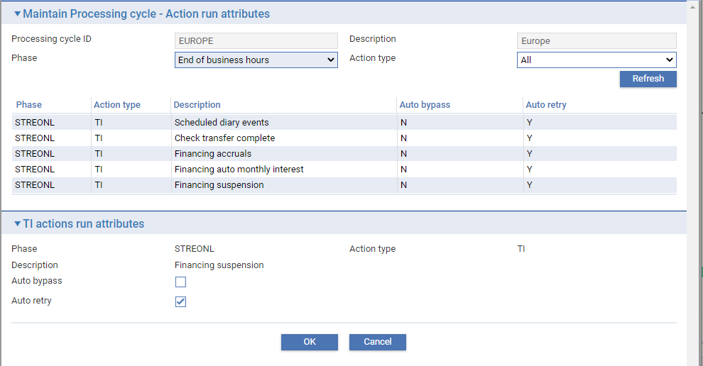

Check Auto Bypass and click **OK** to confirm that the selected action is to be bypassed if it fails. The status of the action shown in the Auto Bypass column changes to Y.

You can remove the flag from an action by selecting it, clicking **Update**, un-checking the flag and clicking **OK**.

The same applies to the Auto retry option.

1. If both fields are checked, then the step will auto retry on failure up to the maximum configured number of attempts and will then auto bypass.

Some Trade Innovation actions cannot be bypassed in this way. These are listed below:

* Account Branch and Deal Branch Changes
* Billing Settlements
* Check Transfer Complete
* CLOSE (for single cycle)
* Customer Mnemonic Changes
* Delete Booked off Masters
* Financing Auto Monthly Interest
* Financing Suspension
* Financing Suspension Clean-up
* Interest Consolidation Flag Reset
* Periodic Charge Accruals
* RELEASE (for single cycle)
* Release Extended Business Hours Events
* Set Next Profit Start Date
* SUSPEND (for single cycle)

### Maintaining Business Day Calendars

The business day calendars, define the days on which transactions can be processed against the behalf of branches falling within the main banking entities within the processing cycle.

Default calendars for the previous, current and next year will have been created on creation of the processing cycle. Existing and new business day calendars can be maintained for processing cycles by clicking **Business day calendars** available within Processing Cycles Maintenance.

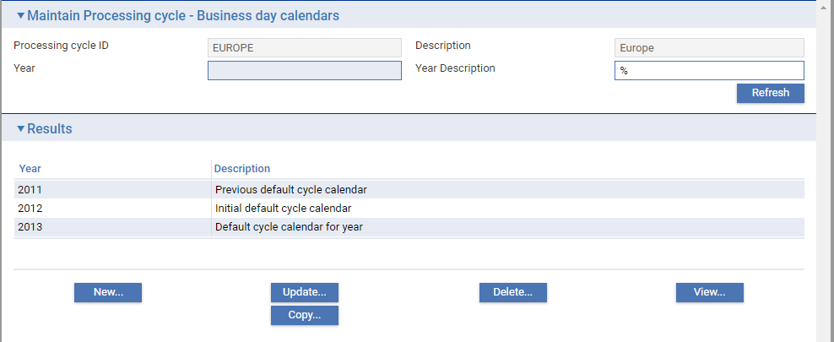

### Include Reports in Overnight Batch Processing

You can configure the Trade Innovation to be included in any of the processing cycle batch phases. For each report you can set up selection criteria and instructions governing when and how often the report is to be run and which printer it is to be sent to. You can also select the phase in which the report is to be run.

If you have the Trade Innovation’s multiple report copy functionality implemented, you can also specify multiple copies of reports to different printers. (This is controlled using the zone general option AllowMultipleReportCopies.)

Each such set of selection criteria and scheduling and printing instructions is termed a report profile. You can set up several report profiles for the same report, allowing it to be run in different cycles or at different times or to show different information.

1. Finastra recommend that you do not include reports in the start-of-business-hours or end-of-business-hours phases, since this may slow down your back office system's overnight processing.
2. You must include the Periodic Report Run action in every phase in which you want to run reports.

To set up a report profile, in the batch application select **Report Profiles** available within Processing Cycles Maintenance.

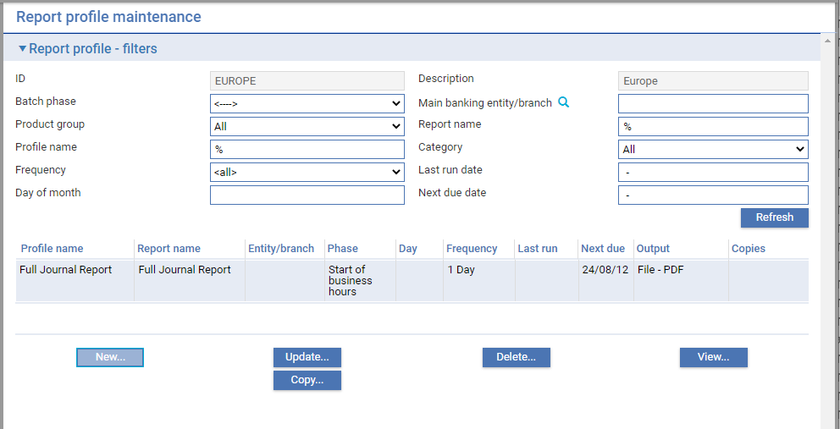

The window displayed lists all the report profiles set up to be run in the phase identified in the filter fields. The following filter fields are provided:

| **Heading** | **What it Shows** |
| --- | --- |
| ID | Selected processing cycle ID. |
| Description | Selected processing cycle description. |
| Batch Phase | Processing cycle batch phase in which report is run. |
| Main Banking Entity/Branch | Main Banking entity or branch filter used in report. |
| Product Group | The product group to which the underlying report belongs. |
| Report Name | The title given to the report when run using this report profile. |
| Profile Name | The report profile's unique name. |
| Category | The category within product group to which the underlying report belongs. |
| Day of Month | If the report profile schedules the report to run monthly or at a lesser frequency, the day of the month on which the report is to be run is shown here. |
| Frequency | The frequency at which the report profile schedules the report to be run. |
| Last Run | The date the report was last run using the report profile. |
| Next Due | The date the report is next due to be run using the report profile. |

For each report profile listed it shows the following additional information under the following headings:

| **Heading** | **What it Shows** |
| --- | --- |
| Output | The format in which the report is output by this report profile. |
| Copies | The number of copies to be produced. |

Use the filter fields in the usual way to control what is displayed. For example, the Next Due Date filter permits you to display reports that are next due to be run on a certain date only.

You can use the buttons in this window in the usual way to view, amend and delete report profiles.

To create a new report profile, click **New**.

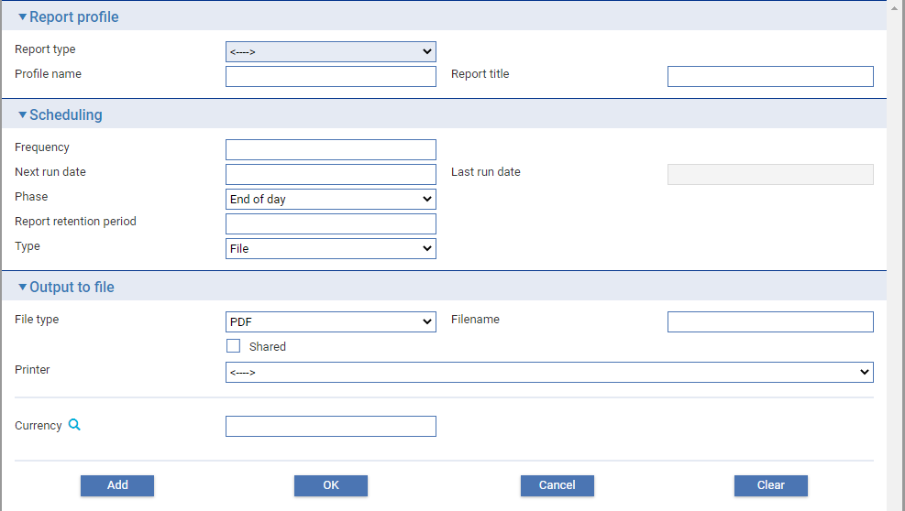

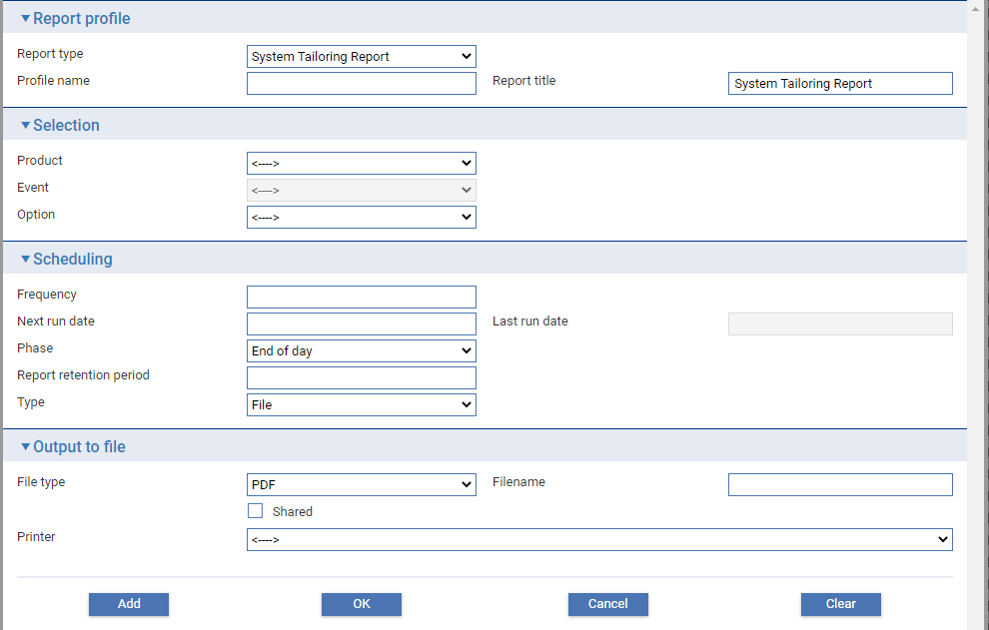

The report profile is set up using fields grouped into the following panes:

* The Report Profile Pane
* The Selection Pane
* The Scheduling Pane
* The Output to File Pane

#### The Report Profile Pane

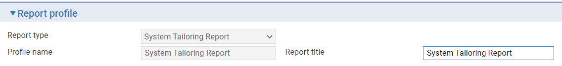

The Report Profile pane is used to name the report profile and identify the underlying report.

Select the underlying Trade Innovation report from those set up on your system in the Report Type field. You can use the same report in different report profiles, to allow that report to be produced using different selections or different output formats. Once you have made a selection in the Report Type field, Trade Innovation displays the name of that report as the default value in the Report Title pane, where you can amend it. The Report Title field provides the title to appear at the head of the report when it is run using this report profile.

Use the Profile Name field to enter a unique alphanumeric identifier for the profile.

#### The Selection Pane

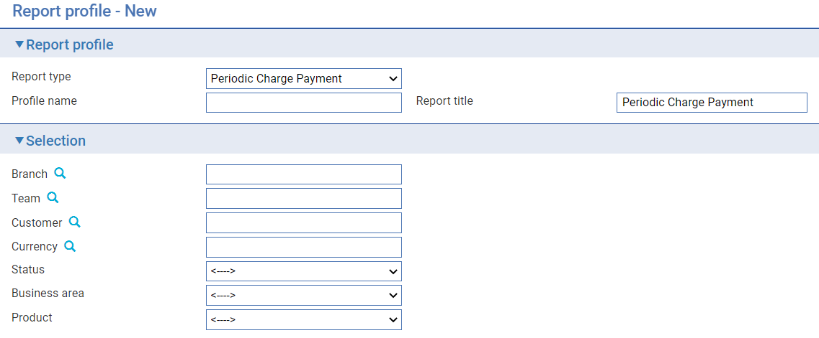

The Selection Pane appears once a Report type is selected. The selection varies depending on the Report type selected.

The Branch selector ? will only display and permit entities and branches within the processing cycle main banking entity scope.

The Customer selector ? defines all customers in their source banking business context. Only source banking businesses within the processing cycle scope are displayed and permitted.

#### The Scheduling Pane

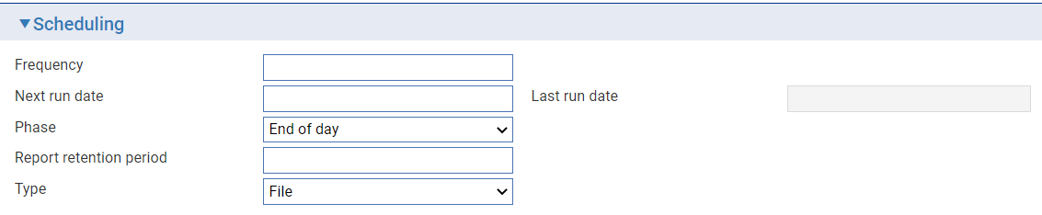

The Scheduling pane includes fields used to schedule the report and to control its output format. The following table lists the fields in this pane and explains what to enter into them:

| **Field** | **What to Enter** |
| --- | --- |
| Frequency | Define how often the report is to be run using this report profile. |
| Next Run Date | Trade Innovation calculates and displays the date on which the report is next to be run using this report profile, using the information entered into the Frequency and On Day In Month fields. You can overtype this date.  If the actual date calculated is not a business day or not realistic (for example 30th February or 31st September) Trade Innovation displays the date of the last business day before the calculated date instead.  All business days are calculated using the local run-day calendar. |
| On Day In Month | If the report frequency is monthly or a greater frequency, in the field that appears enter the day of the month on which the report is to be run. |
| Last Run Date | Once the report profile is in use, Trade Innovation displays the date the report was last run using this report profile. |
| Phase | Select the phase in which the report is to be run. This field defaults to "End of day" upon creation of new report profiles. |
| Report Retention Period | Enter the period the report is retained in the management system. For example 3d, 2w or 1m for periods of days, weeks or months. |
| Type | Select the format of the report - print or file. |

#### The Output to File Pane

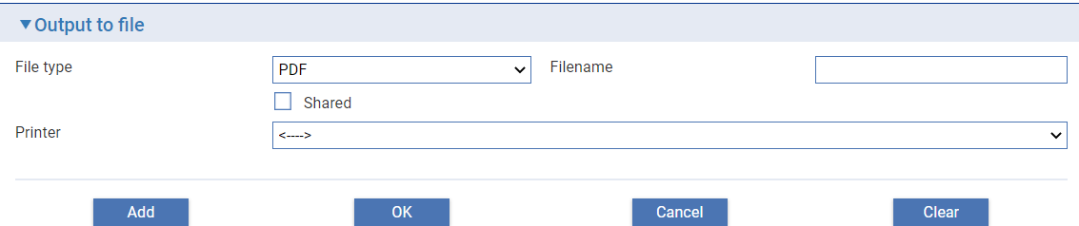

The fields in the Output to File pane allow you to define the report's output format and destination. The following table lists the fields in this pane and explains what to enter into them:

| **Field** | **What to Enter** | |
| --- | --- | --- |
| File Type | If the report is being written to a file, select the type of file, which can be one of the following: | |
|  | Excel | Microsoft Excel |
|  | Word | Microsoft Word |
|  | Text | ASCII text |
|  | CSV format | Comma-separated value format |
|  | PDF | Adobe Acrobat portable document format. |
|  | Rich text | Compatible with all word processors including Microsoft Word. |
|  | RPT | Crystal reports format. |
| Shared | Check the Shared field if the file is to be available to users other than yourself. If you check this field, other users will be able to list and view the report in the window used to monitor print jobs. | |
| Printer | If the report is to be printed, select the printer. Additional fields are displayed to allow you to define the print attributes. These will depend on the selected printer and the functionality it supports. | |

If the AllowMultipleReportCopies zone general option is set to Yes the Multiple Printers field is displayed in this pane. When you check it, additional functionality is enabled that allows you to produce the report on more than one printer.

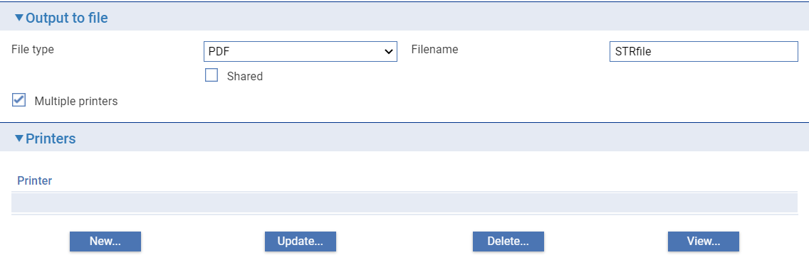

Click **New**, the window that appears allows you to select from the printers available on your network which one is to be used, and to control how the report is to be produced using the printer driver available for that printer. Once you select a printer additional fields are displayed to allow you to define the print attributes.

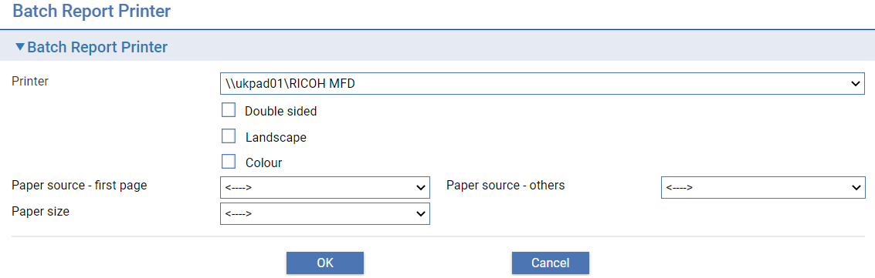

These will depend on the selected printer and the functionality it supports.

### Diary Entries and Overnight Processing

Trade Innovation is delivered with the Scheduled Diary Events action configured to take place during the start-of-business-hours phase. If left in this phase, the action will be performed for all events for all products within the cycle main banking entity scope.

However, you can configure processing cycles so that the action is performed for some events during the end-of-business hours phase, and for others during the start of business hours.

To configure a cycle so that the Scheduled Diary Events action is split across the start-of-business-hours and end-of-business hours phases, first use the functionality described in the previous section to include the Scheduled Diary Events action in both the start-of-business-hours phase and the end-of-business-hours phase. Then specify each of the events whose actions are to be included in the end-of-business-hours phase using the **Diary|Schedule Diary Event** menu option.

In the window that appears when you select this menu option, select the product. Trade Innovation lists all the events for that product.

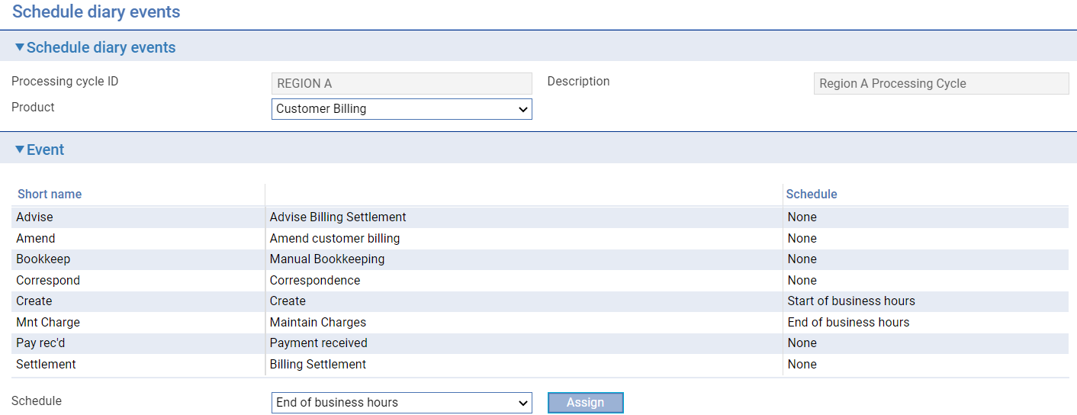

Select an event, then select the phase in which it is to be processed by the Scheduled Diary Events action from the drop-down list on the Schedule field. Then click **Assign**. Diary actions for that event and product will from that point on be carried out in the phase specified here.

Repeat this step for each relevant event. The Schedule column indicates whether an event has been selected and, if so, the phase in which it will be processed by the Scheduled Diary Events action.

To reverse the settings for all events so configured, simply remove the Scheduled Diary Events action from the end-of-business-hours phase (ensuring that it is still included in the start-of-business-hours phase). Trade Innovation will thereafter automatically process all diary actions as part of start-of-business-hours processing.

## Viewing Phases

Select the **Phases|Phases** menu option. Trade Innovation displays a window which allows you to view and change the names of phases; applicable to all processing cycles.

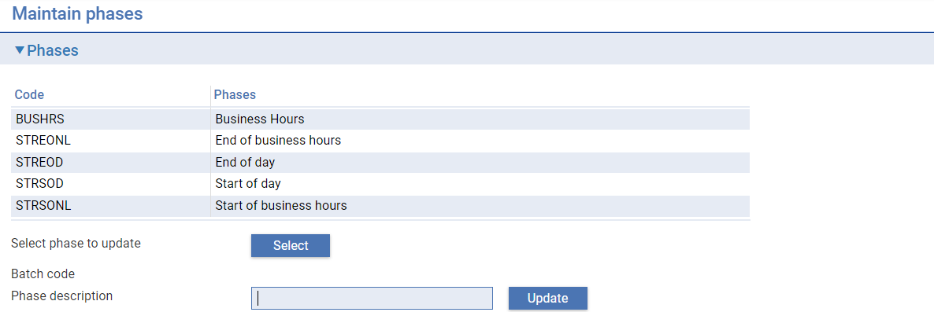

To change the name of a phase, highlight it then click **Refresh**. Trade Innovation displays the current values for the phase in the Phase Description and Batch Code fields. You can change the value in the Phase Description field. Click **Update** to save the change.

You cannot change the value in the Batch Code field.

|  |  |
| --- | --- |
| BUSHRS | For the business-hours phase. |
| STREONL | For the end-of-business-hours phase. |
| STREOD | For the end-of-day phase. |
| STRSOD | For the start-of-day phase. |
| STRSONL | For the start-of-business-hours phase. |

## Including Custom Control Actions in Batch Processing

Custom control actions are programs written by your bank for inclusion in end of day processing. They are defined using Spring resource files and deployed by your system administrator, who will provide you with the names to be used when defining them. They will be available to all processing cycles.

They are set up using the batch application's **Phases|Custom Control Actions** menu option.

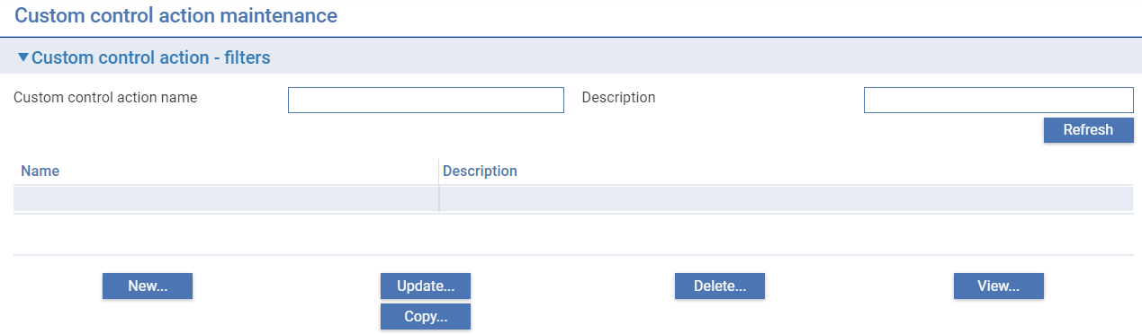

In the window that is displayed when you select this menu option use the filters and **Refresh** in the usual way to list any existing custom control actions. They are listed by unique name and description.

You can use the buttons in this window in the usual way to view, update, copy and delete existing custom control actions.

Click **New** to define a new custom control action.

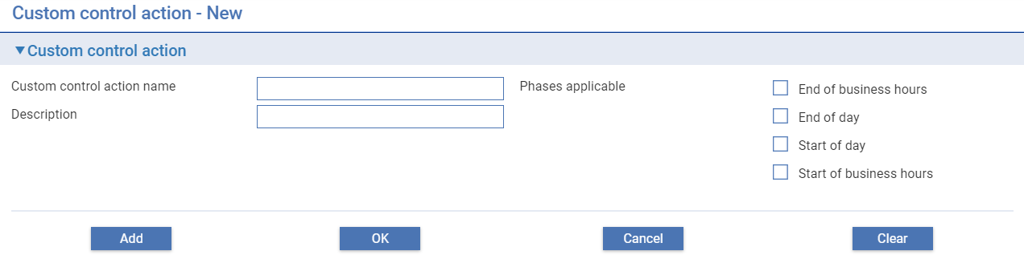

In the window that appears enter the custom control action's name and give it a meaningful description. The name can be up to ten characters long and must match the custom control action name given to it in the associated Spring resource file (defined as part of the control action deployment).

Select the phases in which it is to be run.

Once they have been set up, custom control actions are incorporated into the required processing cycle(s) using the **Batch Phase/Action Mapping** button available within Processing Cycles Maintenance. These can be mapped in a phase as either Pre TI Control Actions or Post TI Control Actions.

## Reversing the Effect of Interest Consolidation

The functionality used to reverse interest consolidation for specific customers and transactions is available only if you have Trade Innovation’s consolidated interest functionality implemented (this is controlled by the AllowAutoMonthlyInterest system option) and should be used before the start of day.

Interest consolidation is reversed by main banking entity using the batch processing application's **Special|Reverse Effect of Interest Consolidation** menu option.

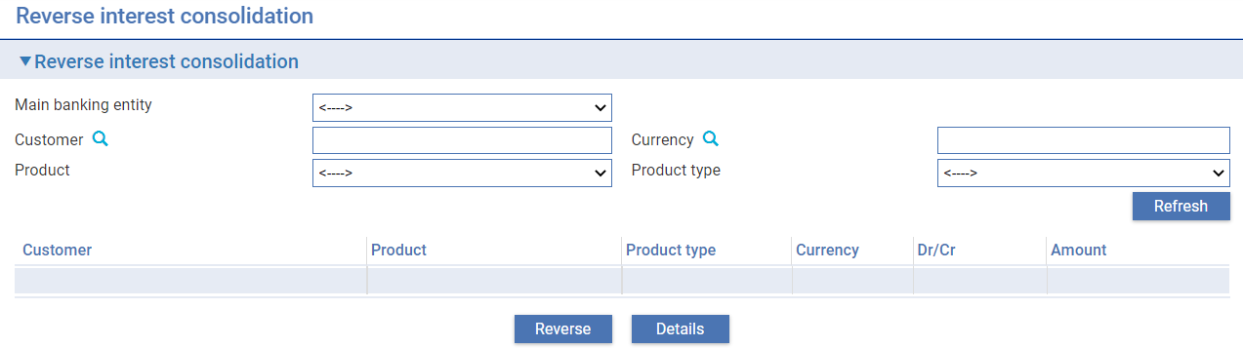

In the window that appears, specify the main banking entity, the customer, the currency, and the product or product and product type in order to identify the transaction(s) to be reversed. The Customer filter field is mandatory. Then click **Refresh**. The system retrieves all transactions matching the criteria entered and displays them.

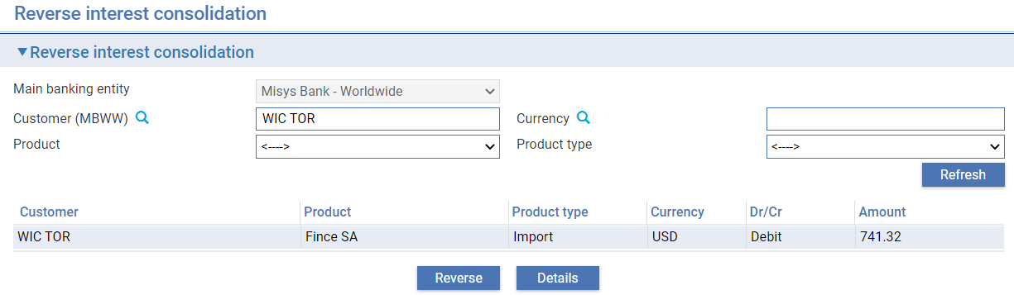

You can view details of an item by highlighting it and clicking the **Details** button.

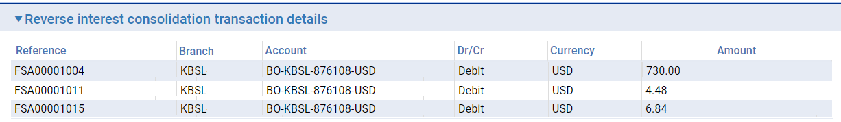

To reverse an item, highlight it in the Reverse Interest Consolidation pane and click **Reverse**. The system finds and reverses the effects of interest consolidation associated with that item.

# Running a Processing Cycle End of Day

## End of Day Processing

The Batch jobs application provides information that allows you to monitor and manage the progress of processing cycle end of days.

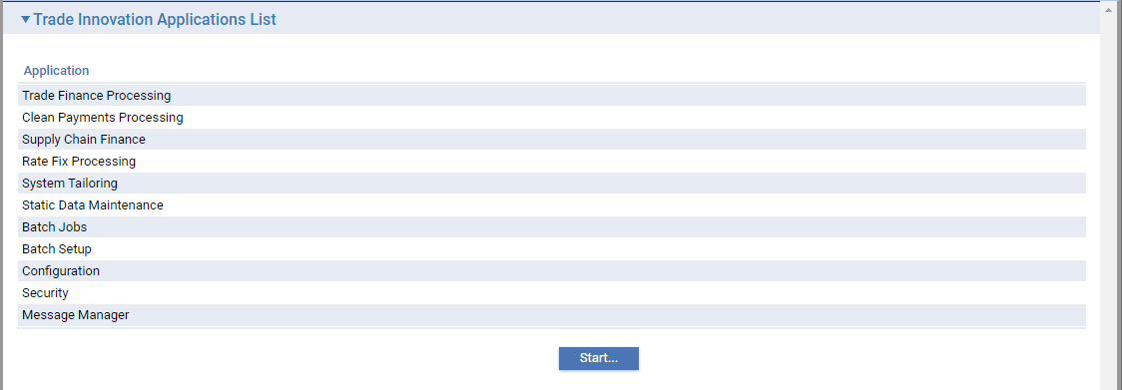

The Batch jobs application, accessed directly from the Batch Jobs application, provides a list of processing cycles defined within the zone.

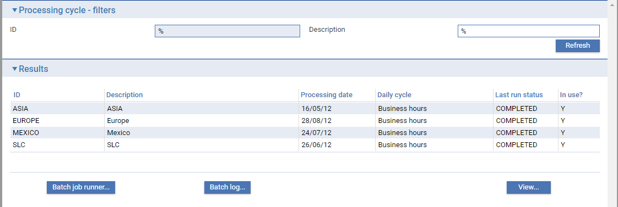

Information is shown under the following headings:

| **Heading** | **What it Shows** |
| --- | --- |
| ID | The processing cycle identifier. |
| Description | The processing cycle description. |
| Processing date | The processing cycle business day. |
| Daily cycle | The processing cycle state - business hours or end of day phase. |
| Last run status | The status of the running end of day or COMPLETED during business hours. |
| In use? | Yes - if at least one main banking entity is assigned to the processing cycle. |

### Batch Job Runner

End of day processing is initiated by selecting a processing cycle in the results list and clicking the **Batch job runner** button available within Batch jobs - Processing Cycles Selection.

In the window that appears Trade Innovation shows the status of the previous cycle end of day, listing each of the phases in the end of day for that cycle. Each of the actions set up within each phase are available from the collapse/expand icons and button.

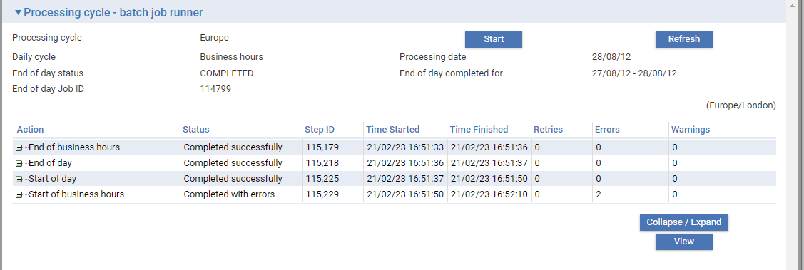

Information is shown under the following headings:

| **Heading** | **What it Shows** |
| --- | --- |
| Action | Initially the phase, then on expanding, the list of actions included in the phase. |
| Status | The status of the phase/action. This indicates whether the action was processed successfully, or whether it failed or completed with errors. |
| Step ID | The step identifier within the end of day job (for troubleshooting purposes, should the job step encounter problems). |
| Time Started | The date and time the phase/action was started. |
| Time Finished | The date and time the phase/action was completed. |
| Retries | The number of retry attempts made within this phase. |
| Errors | The number of errors encountered within this phase. |
| Warnings | The number of warnings encountered within this phase. |

### Using the Collapse/Expand Function

Details of mapped and subsidiary actions within an end of day phase are accessible by using the collapse/expand icons and button. See example:

Expand Start of business hours phase to see mapped actions in the phase.

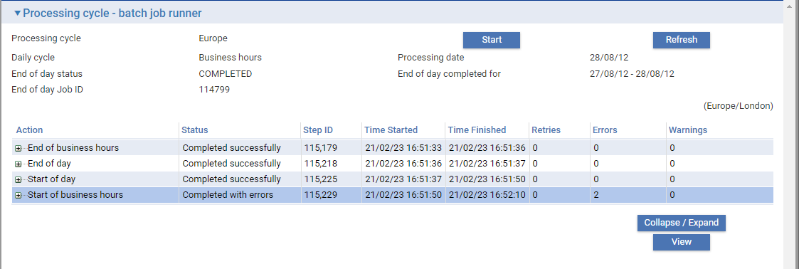

Expand Scheduled diary events to see main banking entity subsidiary actions.

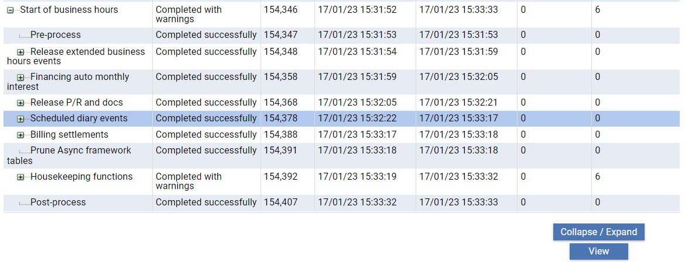

### Using the View Function

Details of mapped and subsidiary actions within an end of day phase are accessible by using the collapse/expand icons and button. See example:

Expand Spain main banking entity to see branch subsidiary actions.

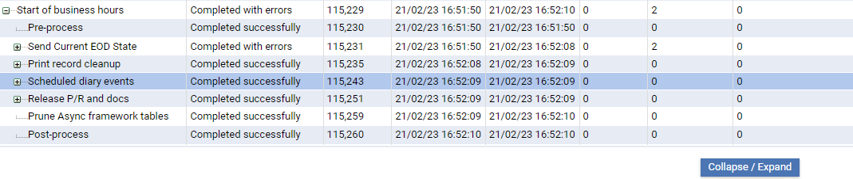

Note that consolidation steps are generated at each level to allow data consolidation for each set of parallel running actions, for example, consolidation of postings generated per branch.

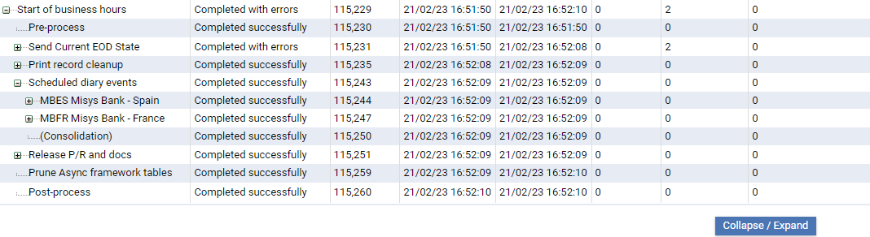

### Starting an End of Day

To initiate a cycle end of day click **Start**.

On starting the end of day, the cycle enters extended business hours. Additional text is shown in the header banner to inform the user that transaction input is available only for the following business day.

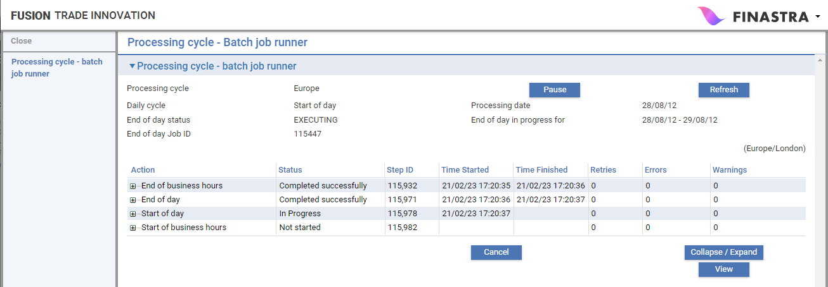

When executed each action may create a set of subsidiary actions configured by the system to run in parallel according the requirements of each action.

* An action may create parallel running actions for each main banking entity
* A main banking entity step may create parallel running actions for each branch

### Transaction Entry during Extended Business Hours

Transaction entry for behalf of branches is permitted throughout the time the branch is undergoing the end of day cycle, but as pre-input for the following business day. The user is warned that input is scheduled for the following day. On authorisation, release items are withheld until the Start of day phase (when the Release Extended Business Hours Events TI action runs).

### Pausing and Resuming an End of Day

The end of day can be paused after the current running step using the **Pause** button or mapping in a pause action into the end of day phases.

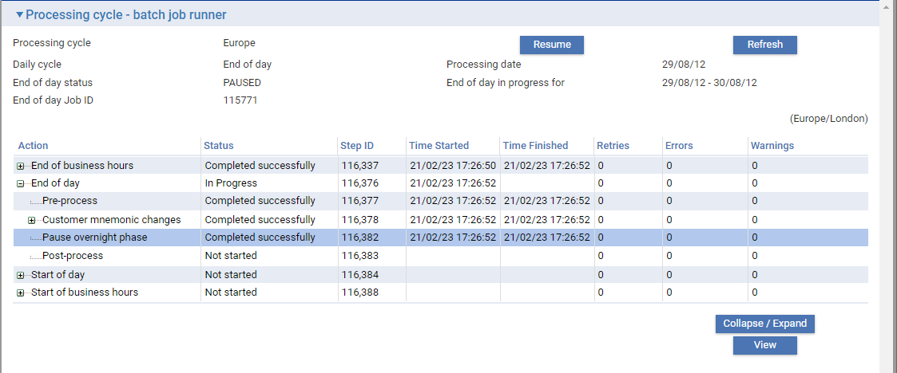

Click **Resume** to continue the end of day.

### Retrying or Bypassing a Failed Action

If an end of day action fails, on refresh, the screen automatically drills down to display the failed action.

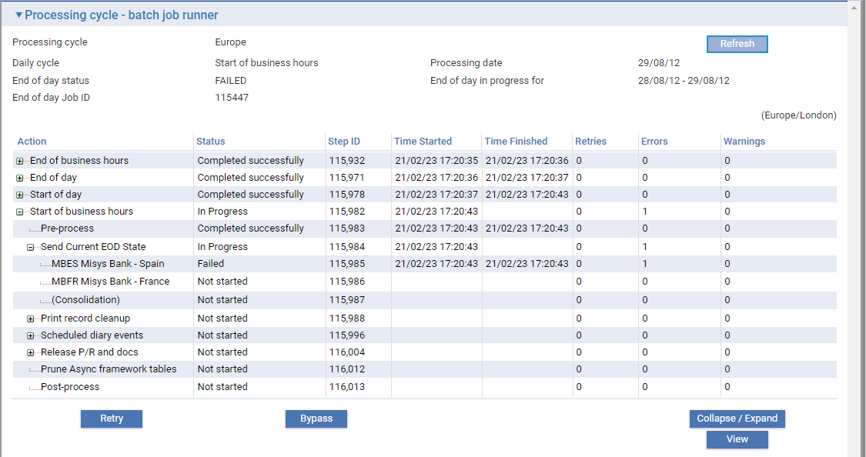

Click **Retry** to rerun the failed step or click **Bypass** to continue to the next step.

### Cancelling a Running Action

Under certain circumstances it can be identified that a running action should be cancelled. An issue with the action may be resolved but the action is looping or no longer required to finish. Here a cancel request to the action can be undertaken. Cancel is only permitted against a running action with no subsidiary actions running under it. The action status will change to Cancelled. The action can then be retried or bypassed in the same way as a failed action.

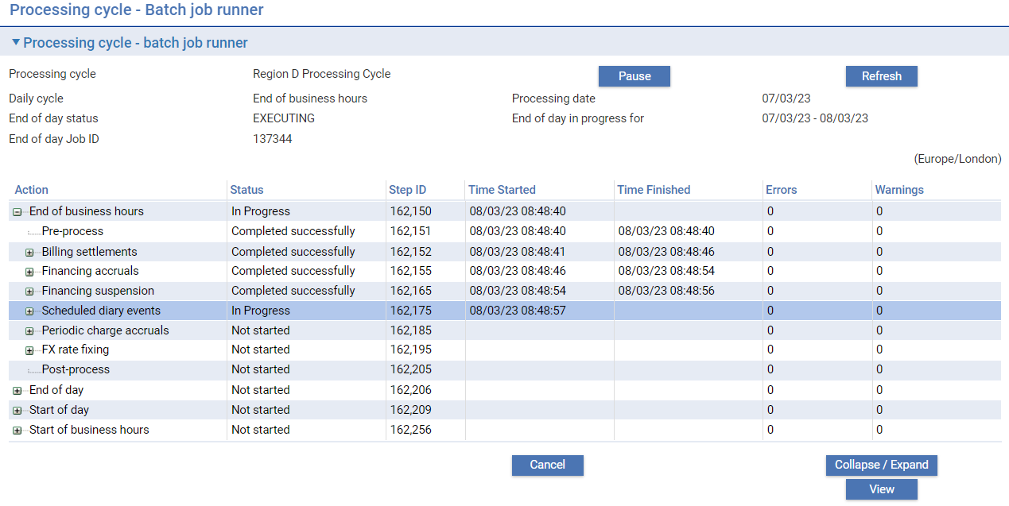

### Batch Log

Details of errors and warnings can be seen in the Batch log (accessed by selecting the Batch log button within Batch jobs - Processing Cycles Selection). Either click **Retry** after resolving the issues or **Bypass** if available for the action.

### Checking the Status of Individual Phases

Processing cycle end of day status information is accessed from the Batch log.

This displays a window that lists all the phases run during end of day processing. This window can be used to identify actions that failed.

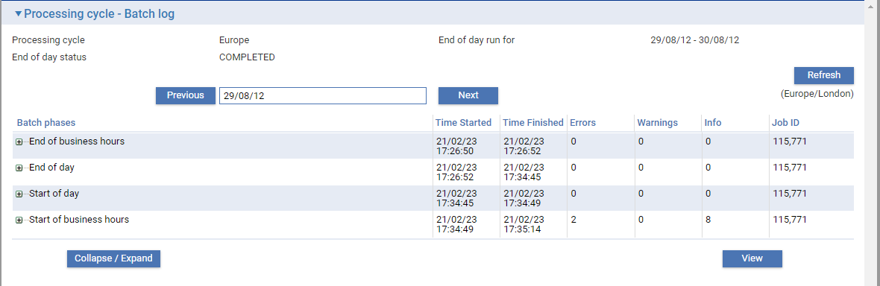

You can use the **Previous** and **Next** buttons by the date field to select the day for which you wish to see the log. This is the date end of day processing commenced. These buttons move the date displayed forwards or backwards one day at a time. The Zone General option ‘BatchLogPeriod’ sets the number of days for which batch error reporting information is retained.

Information is shown under the following headings:

| **Heading** | **What it Shows** |
| --- | --- |
| Batch phases | Initially the phase, then on expanding, the list of actions included in the phase. |
| Time Started | The date and time the phase/action was started. |
| Time Finished | The date and time the phase/action was completed. |
| Errors | The number of errors encountered during the phase/action. |
| Warnings | The number of warnings encountered during the phase/action. |
| Info | The number of information messages encountered during the phase/action. |
| Job ID | The End of Day job identifier (for troubleshooting purposes, should the job encounter problems). |

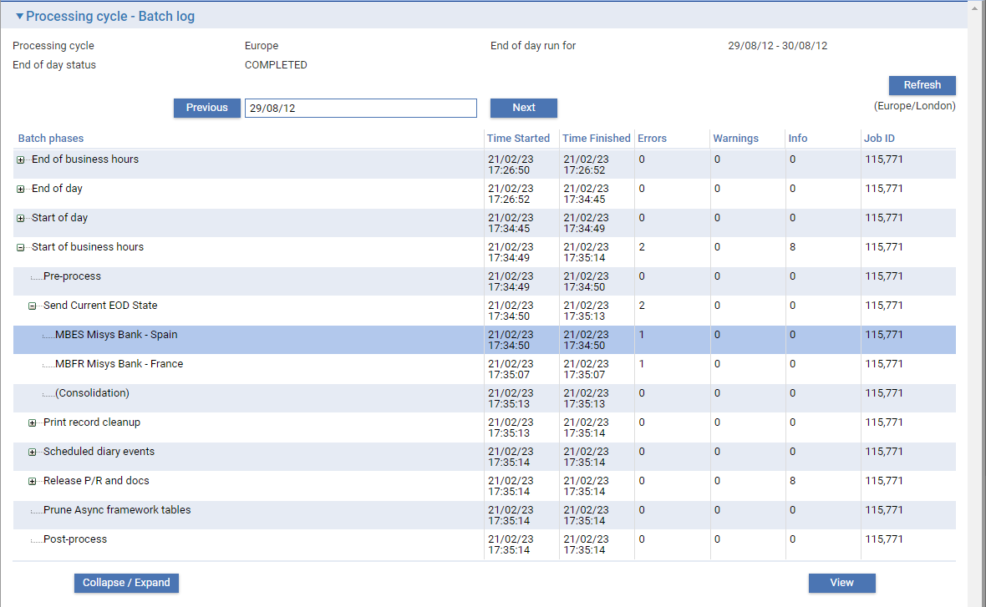

Details of errors and warnings are accessible by using the **View** button.

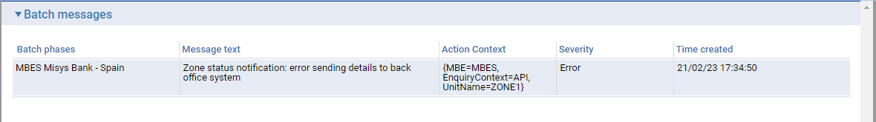

1. The action context column provides more information in relation to the message

### View Processing Cycle Details

Details of a processing cycle definition can be accessed from the **View** button within the Batch Jobs application.

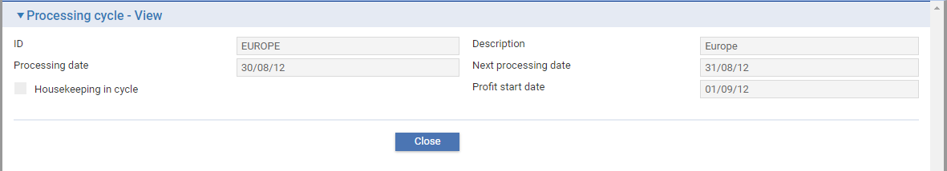

The full configuration details of a processing cycle definition can be accessed from the **View** button within the Batch Setup application.

## Logging Off Users under Single Cycle Zone Set-up

Under Global Processing Extended Business Hours allows user input to continue but as pre input for the following business day. Daily users are no longer required to log out as the end of day begins.

Banks who wish to retain the logging off functionality with the optional batch report display available under previous releases of TI can do so with Global Processing under the following conditions:

* Only one main banking entity is used in the zone
* Only one back office is linked to the zone
* Only one processing cycle is defined

The following TI actions are then made available to be mapped within the processing cycle. They are required to request the log out of daily users for the end of day:

* Map CLOSE at start of End of Business Hours phase
* Map SUSPEND after Check Transfer Complete at end of End of Business Hours phase
* Map RELEASE at end of Start of Day phase or beginning of Start of Business Hours.

1. If the Batch Report display is required to be displayed under a single processing cycle zone set-up, add the Zone General System Option ‘BatchErrorReportDisplayed’.

# Deletion of Booked off Masters

See chapter Introduction | Transaction Deletion after Book off for an introduction to synchronising audit backups with master retention periods.

A mandatory ‘Default Master Retention Period’ is configured as the default for all transactions across the zone. Where banks wish to retain categories of master details for longer, additional master retention periods can be defined by product scoped at any point in the branch hierarchy. These periods must be longer than the zone default.

See the following example:

All retention periods must be equal to or greater than the backup frequency.

**Zone General Option** – ‘DefaultMasterRetentionPeriod’ – 13 Months

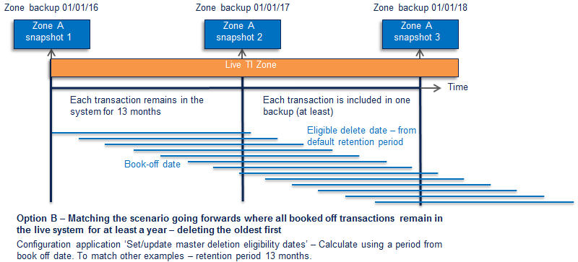

This guarantees that as masters are booked off on a daily basis and others become eligible for deletion, the master in booked-off state will be recorded in one back-up (at least) prior to deletion. All of the associated release item data for that master are available from the backup.

If the bank requires some transactions to remain in the live system longer, for audit access within the live system, this can be achieved using the following option.

**Branch Product System Option** – ‘MasterRetentionPeriod’:

* London Branch; Import Guarantees – 24 Months
* New York Branch; Export Guarantees – 15 Months

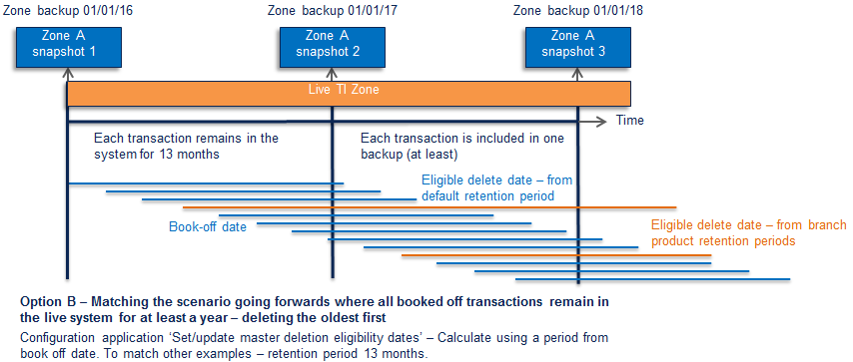

## Limiting the Number of Masters Deleted in End Of Day

### Example – Setting the Branch Daily Deletion Cap

A master deletion daily limit can optionally be set for any Main Banking Entity. Where there is a backlog of upgraded masters, this can smooth the catch-up of master deletion on a daily basis.

For the required entity set the branch trade finance option ‘DeleteMastersLimit’.

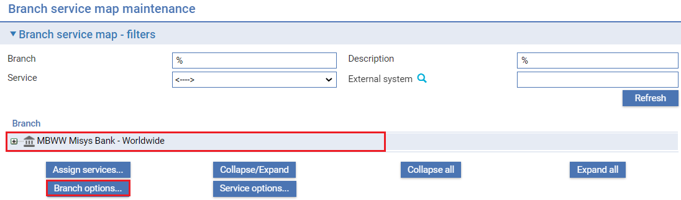

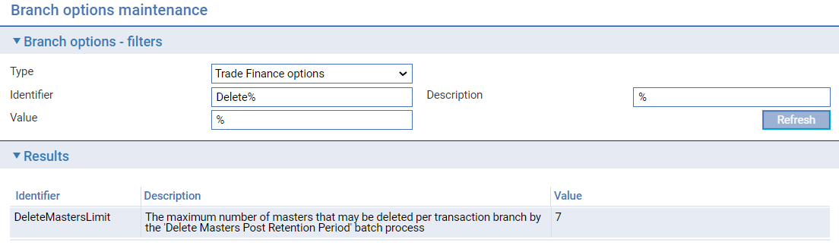

### Example – Subsequent Master Deletion in End of Day

A warning is presented where a limit is set and the number of masters eligible was greater.

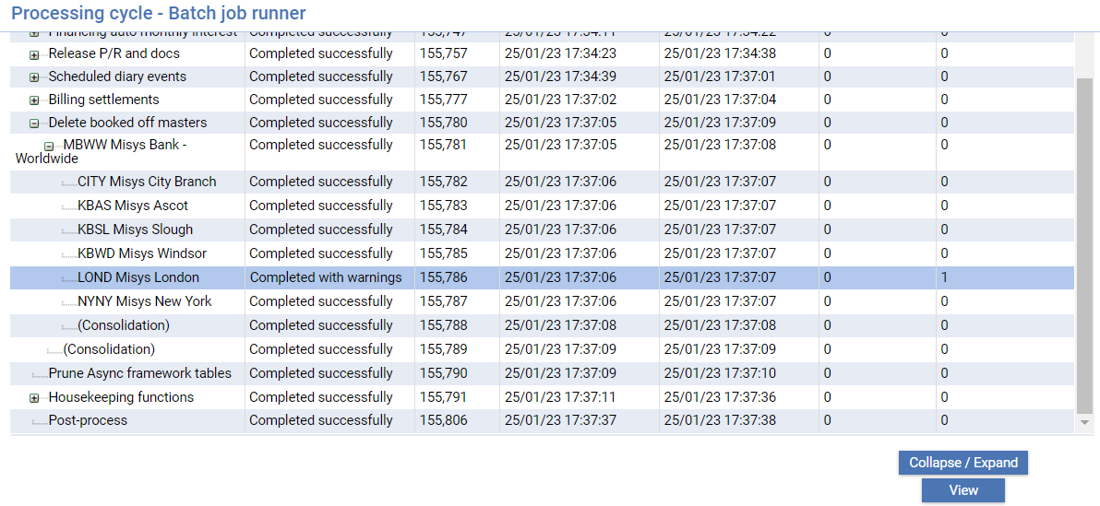

Double click or click **View.**

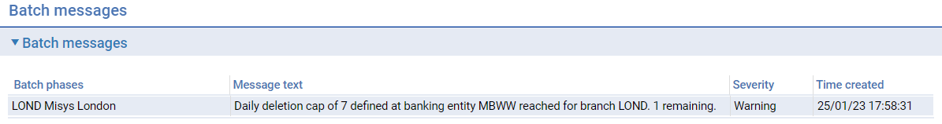

In this branch 8 masters were eligible. The warning indicates the number deleted and the remainder left. The bank can monitor these figures and change the daily limit to manage the deletion of the backlog to trade off against two competing requirements:

* The delete booked-off masters action does not take too much time within an EOD.
* The backlog of booked off masters is reducing at an acceptable rate after each EOD run.

See the System Tailoring User Guide *– Trade Innovation.*

## Master Delete API check

The bank can optionally retain backups of previously booked off masters in a form available to be enquired upon. The API master delete can be implemented by the bank to check against each master in this data and return a parameter indicating the found status. This ensures that if the backups are not complete for any reason, the master deletion is not undertaken. For each unmatched booked off transaction a warning is provided in the EOD log.

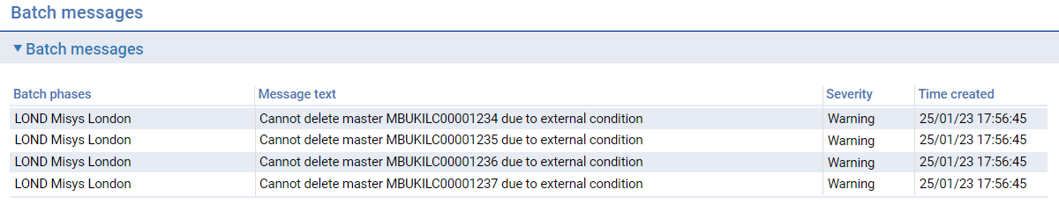

To enable this function refer to the SDK - System Interfacing Guide *– Trade Innovation.*

### Example – Master Deletion Limit in Conjunction with API Check

The example shows the branch entity daily limit applying to each branch below it in the branch hierarchy.

Where the Master Delete API is implemented, where the backup check for the master fails, this master is bypassed for deletion and the next master is selected (up to the daily deletion count if applicable).

For each unmatched booked off transaction a warning that this transaction was not deleted is provided in the EOD log.

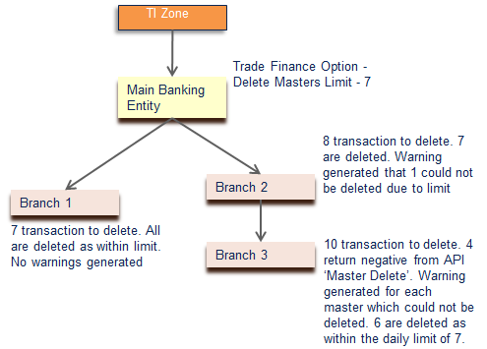

## Audit Notifications of Masters Deleted

Available disk space may be limited prior to deleting historic transactions. Providing a deletion audit within the database schema could reduce disk space further where there are many masters to process. Instead, the notifications mechanism provides the audit support. The notifications mechanism allows the recording of deletions to be sent to a location in a requested form. This data can be accessed as required by the bank. The following data is passed per master deleted:

* TI master reference
* Main banking entity
* Behalf of branch
* Product identifier
* Principal party identifier
* Principal party name and address
* Non-principal party identifier
* Non-principal party name and address
* Amount and currency
* Book off date
* Eligible for deletion date
* Actual deletion date

To enable this function refer to the SDK - System Interfacing Guide *– Trade Innovation.*

# Inward SWIFT Messages

This chapter explains how to use the Trade Innovation message manager application to view and process inward SWIFT messages and incorporate them into the Trade Innovation work-flow. It covers:

* How messages are mapped against products and events to allow them to be incorporated into the work-flow automatically wherever possible
* How to incorporate inward SWIFT messages into the Trade Innovation workflow
* Inward SWIFT message statuses

See the System Tailoring User Guide *– Trade Innovation* for information on how to view and amend SWIFT message mapping information.

The Appendix provides a list of SWIFT messages supported by Trade Innovation, showing which inward messages are used to create master records and events.

The functionality described in this chapter can be accessed from within the transaction processing Masters window and the SLA Dashboard, which indicate when there are messages needing to be incorporated into the Trade Innovation workflow manually.

## Incoming SWIFT Messages in Trade Innovation

Incoming SWIFT messages are received from the network by your bank's SWIFT Interface Device (SID). The SID operator extracts those message types that are of interest to Trade Innovation so that they can be imported into Trade Innovation. Multiple messages (such as MT412) are divided into single messages, and linked messages (such as MT700 and MT701) are joined together. The messages can then be read and incorporated into the Trade Innovation workflow, either automatically or manually, using the Trade Innovation’s message manager application, via your own program written to link to the Trade Innovation interface service messages.

Incoming messages can be automatically processed and incorporated into the Trade Innovation workflow as they are received by Trade Innovation according to the branch associated with the SWIFT message. The message will be allocated to the relevant team for processing, based on the branch, transaction and any specific event/team mappings.

### The Trade Innovation Message Manager Application

The Trade Innovation message manager application is a Trade Innovation application that allows you to view incoming SWIFT messages and then use them to create master records or events on the Trade Innovation database. To facilitate this, the Trade Innovation message manager application uses a map delivered with Trade Innovation which specifies which SWIFT message types can create which system events. You can specify that a SWIFT message type is to be processed automatically; and, where an incoming message type can be used to create more than one event, you can specify the system which is to be created by default. Further rules-based mapping can be created (for example to determine which event is to be created) depending on certain codes or phrases in specific tags within the message. See the System Tailoring User Guide *– Trade Innovation* for information on using the rules facility to set up mappings of this sort.

Using this map, the Trade Innovation message manager application can process many of the messages automatically; the messages themselves provide the information needed to create master records or to identify the master records to which the individual events should be attached. The resulting events are created at the step specified for that event; the step's status is set to Pending so that the details appear on a browser of outstanding steps to process for that event.

It is also possible to set up certain message types (for example MT740 Authorisation to Reimburse messages) so that they are processed straight through, from receipt of the message to release of the event, provided no errors are encountered in mapping the message.

Your bank can also configure the system so that Correspondence events are automatically created to advise customers of the SWIFT acknowledgement number (ISN) and timestamp and the response code or error response code when acknowledgement is received of an outward SWIFT message. This can be controlled by customer, message type and product. See the System Tailoring User Guide *– Trade Innovation* for information on defining which products and messages are to produce automatic acknowledgements and the Static Data Maintenance User Guide *– Trade Innovation* for information identifying which customers require acknowledgements.

### Incorporating Messages into the Work-flow Manually

Some SWIFT message types may need manual intervention. For example, general message types (such as MT799 and MT999) may need to be manually mapped to different events depending on the content of the individual message. In this case, the user can select the event to be created from a list of events mapped to that message type.

Also, if the information contained in a SWIFT message does not permit an event of the default type to be created automatically, the message is flagged as requiring manual intervention. You can then use the Trade Innovation message manager application to select from the other events linked to this message type the one that the message is to be used to create.

Individual messages (as opposed to SWIFT message types) may also require manual intervention in certain circumstances, for example where the message has multiple destinations, contains data in certain fields that cannot be interpreted automatically or is recognised as a possible duplicate.

The transaction processing Masters window and the SLA Dashboard indicate when there are incoming SWIFT messages needing to be incorporated into the Trade Innovation workflow manually.

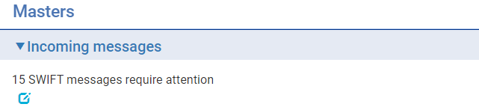

### Routing Incoming SWIFT Messages to Teams

For transactions created from incoming SWIFT messages, the system initially determines the behalf of branch to which the transaction belongs by matching the SWIFT message BIC to the bank’s branches. If the branch cannot be determined, the message remains as unprocessed and the item must be manually updated with the required branches and team, where a branch is set, then the system uses event/team mappings to determine which team the transaction is to be allocated to. Where there are no specific mappings the system will assign the transaction to a team that can process the transaction on a ‘round robin’ basis, in addition, where the SWIFT message creates a new master record, the system assigns this team as the responsible team for the master. Where there are no event team mappings or suitable team found, the system will assign the transaction to the default team for the product or to the SWIFT repair team.

Your bank can also configure the system using event/team maps so that incoming SWIFT messages are routed to the team or user that last worked on them, to preserve continuity.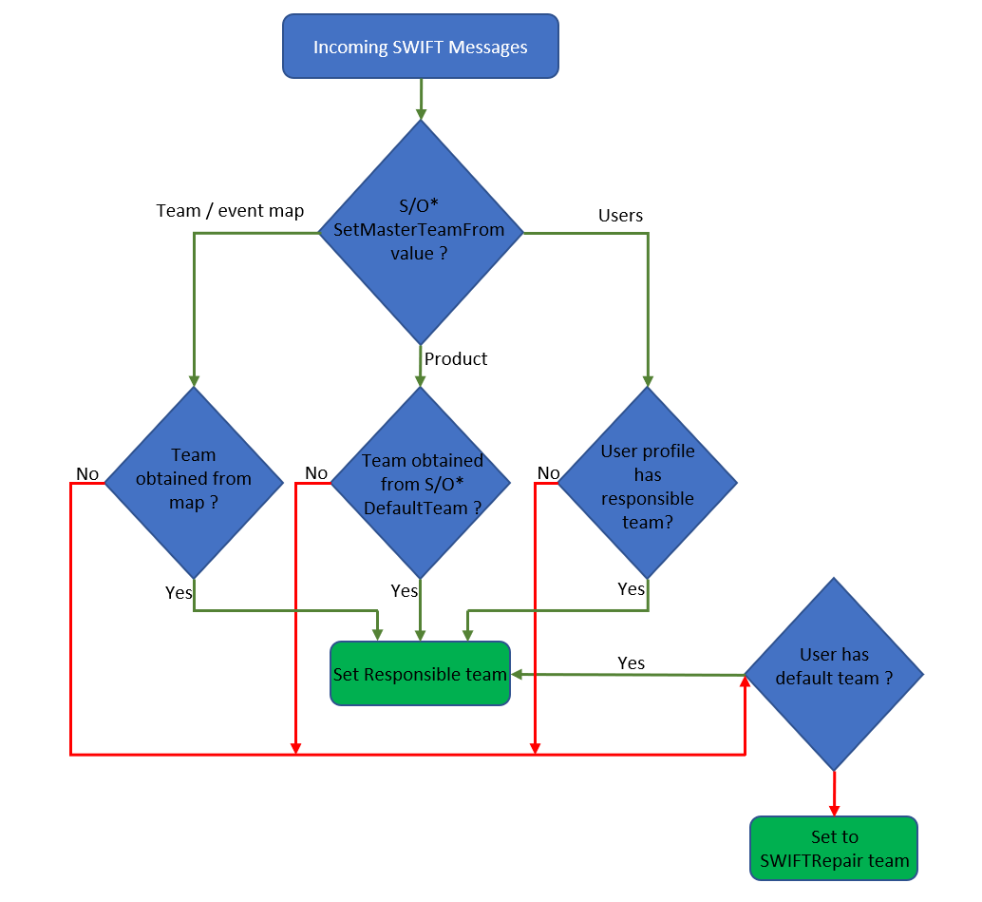

## Processing Incoming SWIFT Messages

Incoming SWIFT messages are incorporated into the Trade Innovation workflow through a combination of automatic processing and manual processing using the **SWIFT|Incoming Messages** menu option.

Select theSWIFT|Incoming Messages menu option to list all messages received that are to be incorporated into the Trade Innovation workflow. Messages within the user’s branch scope are shown.

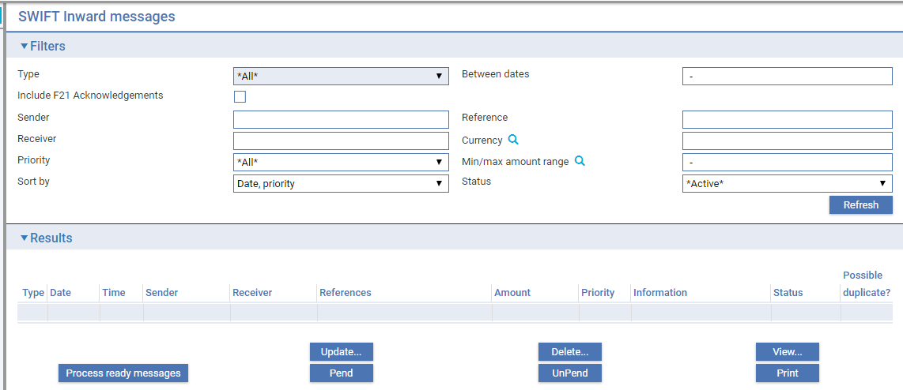

The window displayed is initially blank. The filter fields allow you to specify the range of messages to be listed, as explained in the table in this section.

For the Reference field, the use of wildcard characters is enhanced to provide more powerful search facilities. In the Open Master browser they work as follows:

|  |  |
| --- | --- |
| The all-characters wildcard % | %ABC% will find anything that has ABC at the beginning, in the middle, at the end or an exact match.  ABC% will find anything with ABC at the beginning.  %ABC will find anything with ABC at the end. |
| The single-character wildcard * | A*C will find all three character details starting with A and ending in C.  *BC will find all three character details ending with BC.  AB* will find all three character details starting with AB. |
| Combinations | Where ILC and ELC are used as the respective prefixes *LC% will find all import and export letters of credit. |

Click **Refresh** when you have completed input into these filter fields. Trade Innovation lists all the incoming SWIFT messages that fit the criteria currently set in the window's filters. Messages are still available, and will be displayed if the filters are set appropriately, until the master record to which they relate has been deleted from the system. There may therefore be large numbers of messages on the system with a status of 'Processed', which no longer require any attention. You can avoid displaying these by setting the Status filter to 'Active'.

| **Field** | **What it Controls** |
| --- | --- |
| Type | Used to select a specific message type, a range of types - to display all 7xx series messages, for instance - select '7xx messages' from the list - or all types. |
| Between Dates | Used to specify that messages received between two dates are to be displayed. For example, you could enter 01/01/2012 – 31/03/2012 to view all messages received during the first three months of the year 2012. The default value for this field is blank, in which case Trade Innovation displays all inward messages that were received on or before the current processing date. |
| Include F21 Acknowledgements | A flag is provided which, if checked, enables the ‘SWIFT Acknowledgements – F21’ dropdown list. This is used to filter for positive (SWIFT ACK) or negative (SWIFT NAK) responses to outgoing messages transmitted by your bank.  The dropdown list includes the following options:   * < ---- > Returns results for all incoming messages * Only ACKs Returns results for outgoing messages that have been acknowledged * Only NAKs Returns results for outgoing messages that have a negative acknowledgment or errors |
| Sender | Used to select a specific sender. You can type part of a name, using the wildcard characters, to show messages from all branches of one bank: WALL% would pick up both WALLGB2L and WALLUS9L, for example. |
| Reference | Used to specify a SWIFT transaction reference number (TRN), to display only messages with that number in the message header. |
| Receiver | Used to select a specific recipient. |
| Currency | Used to select the currency of the messages (if applicable). |
| Priority | Used to select a specific SWIFT transmission priority – Normal, System, or Urgent, or All. |
| Min/max amount range | Limits the display to transactions whose amount falls within the range specified. Note that the results include transactions in currencies other than the one specified, unless a specific currency is defined in the ‘Currency’ field. |
| Status | Used to specify that only messages of a particular status should be displayed (see Inward SWIFT Message Statuses. |
| Sort By | Use this field to select how the retrieved messages are to be sorted:   * By message type within priority within date received * By message type within input time within date received |

1. When you click **Refresh**, any new inward messages are pre-processed automatically unless the Zone system option DisableSWIFTAuto is set to *Yes*.

When the messages are displayed in the SWIFT Message In Manager window, you can undertake:

* Using the **Process ready messages** button to automatically process messages of those types Viewing and Processing a SWIFT Messagethat have been set up to be incorporated automatically into the Trade Innovation workflow
* Viewing and Processing a Message
* Assigning a Returned SWIFT Message to a Different Master
* Printing a SWIFT Message
* Pending a Message

### Auto Processing SWIFT Messages

Your system administrator can define whether each type of SWIFT message is eligible for automatic processing or not. Messages that are eligible for automatic processing are displayed with a status of Ready. When you click **Process ready messages**, Trade Innovation creates the appropriate master or event for each message flagged for automatic processing and feeds it into the Trade Innovation workflow without requiring any further manual intervention. For example, a message might advise of a new letter of credit; processing it would create a new master record (unless a master had already been created by a Pre-advise event).

If processing a SWIFT message fails for any reason, Trade Innovation produces an error message, which you can view by selecting the message and clicking **View**. The error message is displayed in the Information field.

If message processing has failed, it is returned to the inward queue and you can assign it to a different master (see Assigning a Returned SWIFT Message to a Different Master).

### Viewing and Processing a SWIFT Message

If a message cannot be processed automatically because of errors you will need to process it manually.

Select the message and click **Update**. (The **View** button displays the same window, but the information is display only and the processing buttons are not shown.)

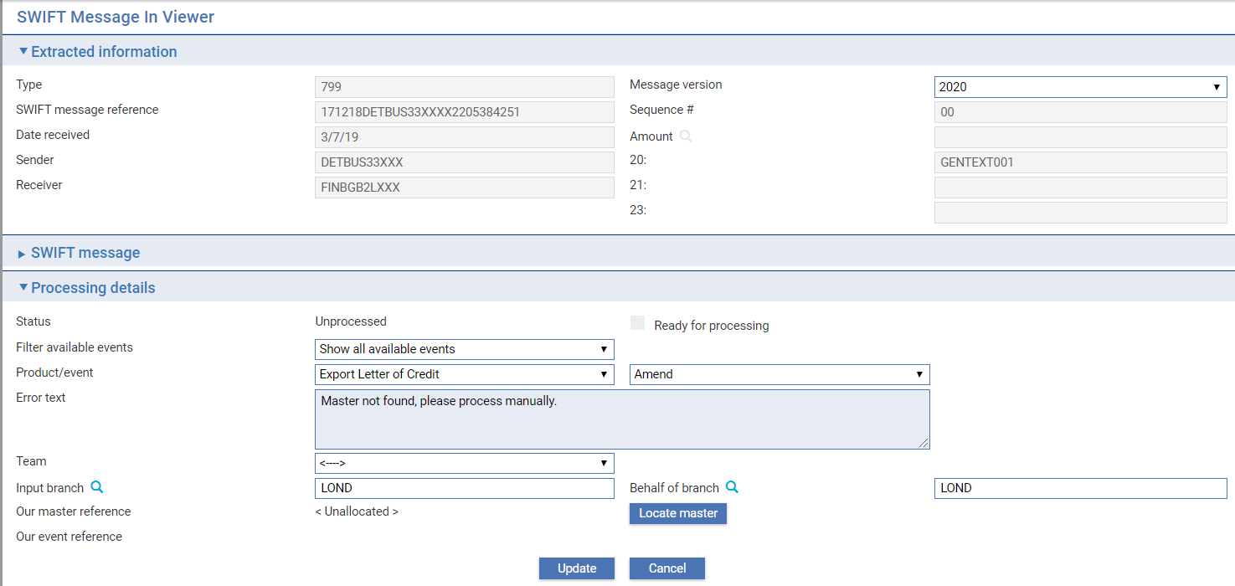

The following table explains what the fields in this window show:

| **Field** | **What it Shows** |
| --- | --- |
| Type | The SWIFT message type. This field is display-only. |
| Message version | The current SWIFT version is held in the Zone General option SWIFTVersion. The version of the incoming message is shown as older messages of a previous version held in the incoming queue may be delayed and need to be processed after the transition to the new version. |
| SWIFT Message Reference | The unique Message Input Reference generated for the message by SWIFT. This field is display-only. |
| Sequence # | If this is one of a sequence of linked messages, its number in the sequence. This field is display-only. |
| SWIFT gpi service type identifier | Applicable to MT 1* and MT 2* payment messages only. Reference included in messages sent by gpi member banks. |
| Reference (121) | Applicable to MT 1* and MT 2* payment messages only. Unique end-to-end transaction reference (UETR) to track payments between banks to the creditor. |
| Date Received | The date the message was received. This field is display-only.  This field is display-only, unless the message has a status of 'Error' or 'Unprocessed', in which case it is enabled for you to enter a new date. |
| Amount | The amount of the transaction. This field is display-only. |
| Sender | The sender of the message. This field is display-only. |
| Receiver | The receiver of the message, This field is display-only . |
| Reference (20) | Sender’s ref). |
| Reference (21) | Receiver’s ref. This field is display-only. |
| Reference (23) | Alternative ref. This field is display-only. |
| Status | The current status of the message (see Inward SWIFT Message Statuses ). |
| Ready for processing | Check this box when the message is ready to be processed. |
| Filter available events | The dropdown has the following values:   * Show all available events – shows all events available regardless of rules - this is standard behaviour * Show events matching SWIFT mapping rules – restricts to show only events where rules have matched * Exclude events not matching SWIFT mapping rules - excludes events not matching the SWIFT mapping rules. |
| Product/event | These fields provide a drop-down list of valid products and events with which this message can be associated. |
| Error Text | If the message is in error, this field provides a description of the error. |
| Team | The team the transaction is to be assigned to for processing at the next event step |
| Input branch | The input branch for the transaction |
| Behalf of branch | The behalf of branch for the transaction |
| Our Master Reference | Your bank's reference for the transaction to which this message belongs, which Trade Innovation identifies using the sender's reference. |
| Our Event Reference | If found, the reference of the event to which the message relates or the event it created. |
| Formatted | On the details screen. Allows you to toggle between showing the message with or without SWIFT message tags (the default is set using a system option). Check the field to see the alternative layouts.  The Printer Friendly button shows how the information will look when printed.  Note that the ‘SWIFT message pane may be expanded (to display the message details) or collapsed (to hide them). |

If a message is received with Errors and it’s necessary for you to edit and process it manually, it’s possible to assign a different Team, Input branch and Behalf of branch in the ‘Processing details’ pane.

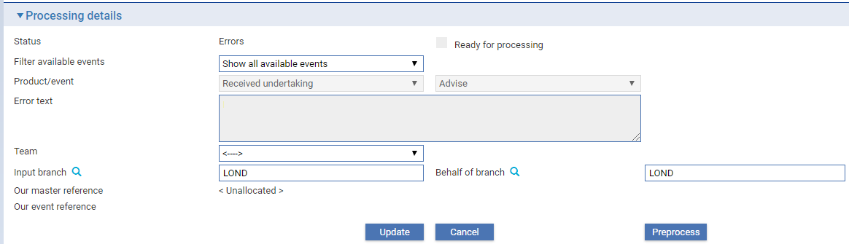

In the above example, a Team has not been assigned to the incoming message. You can filter for the team or manually input this if known.

1. A **Preprocess** button is available. When the appropriate changes have been input (e.g. Team, Input branch etc.), clicking the **Preprocess** button sets the message as ‘Ready’ for processing.

Depending on the status of the message, the following buttons are available so that the message can be viewed, processed, or deleted:

Matched: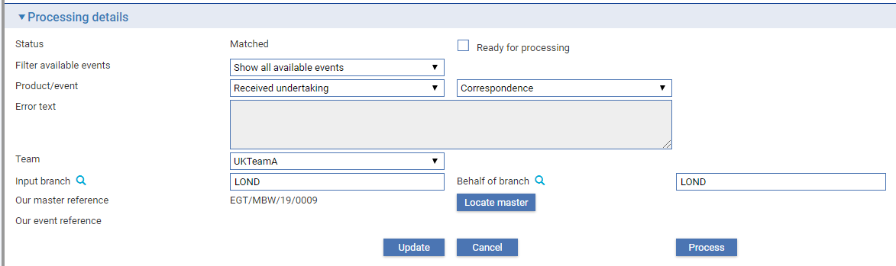

Processed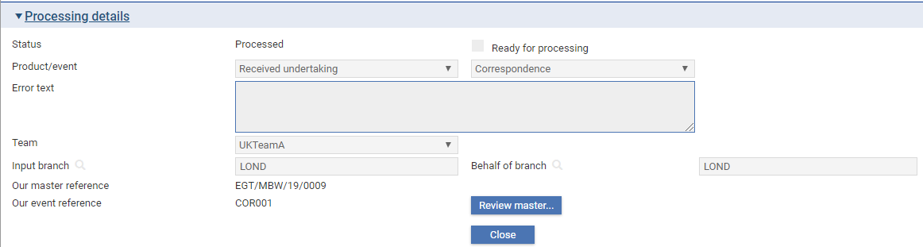

Selected for deletion:

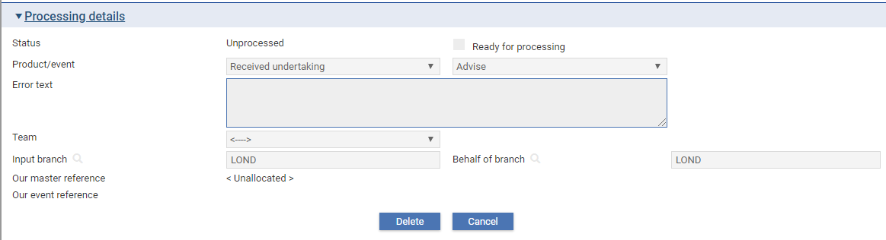

| **Field** | **What it Shows** |
| --- | --- |
| Locate master | Opens the ‘Master For Inward Messages – Master Records browser. Enables searches for the appropriate master record to which the message is mapped. |
| Review master | Opens the Master Summary screen of the master to which the message is mapped. |
| Process | Automatically processes the message. This is reflected by the status. |
| Pre-process | Sets the message status to ‘Ready for processing’. The user may then process the current message, or return to the SWIFT Inward messages screen where the status is set to ‘Ready’. The message may then be processed with other ‘Ready’ messages by clicking the ‘Process ready messages’ button. |
| Update | Saves any changes made to the mappings etc. |
| Cancel | Returns the user to the SWIFT Inward messages screen without updating the record. |
| Delete | Sets the message status to *Deleted*. |

Clicking the ‘Process’ button automatically processes the message, or alternatively, if your bank processes messages in batches, you can click the ‘Update’ button which returns you to the SWIFT Inward messages screen and sets the message Status as ‘Ready’.

When you subsequently click the ‘Process ready messages’ button in the SWIFT Inward messages screen, the message that has been updated and any other outstanding messages with a status of ‘Ready’ are then processed.

Your system may be configured to prevent you from amending incoming SWIFT messages. If this is the case and you receive a SWIFT message in error, print out the message and use the information to create the event manually, cutting and pasting the relevant information from the SWIFT message into the event fields.

Depending on the message type, this window also allows you to assign an incoming message to a different master (see Assigning a Returned SWIFT Message to a Different Master).

### Assigning a Returned SWIFT Message to a Different Master

If an event created by an incoming SWIFT message is aborted, Trade Innovation does not allow reassignment of the message to a new master or different master for the incoming message. However, there is provision to re-create a new event for the original master record.

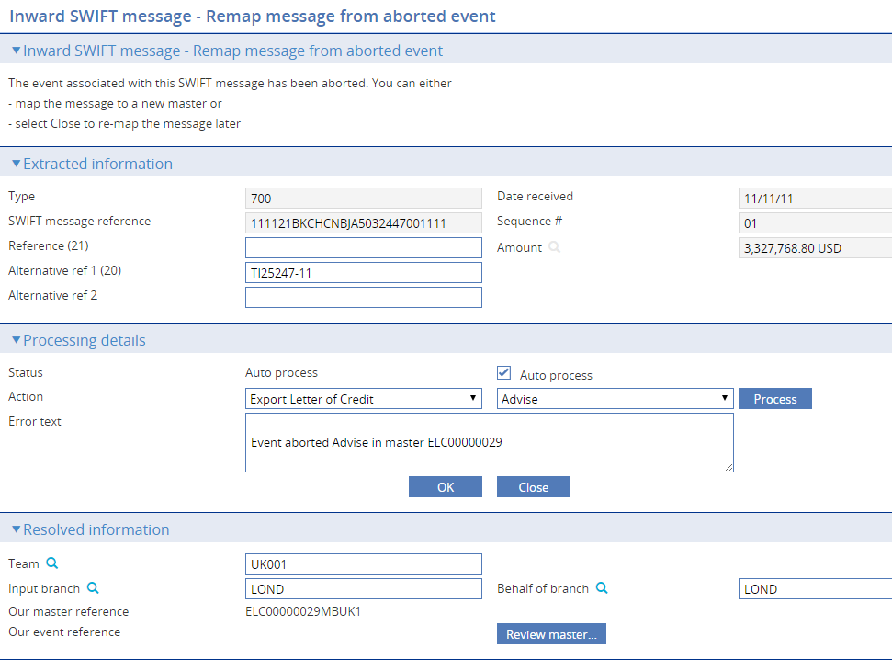

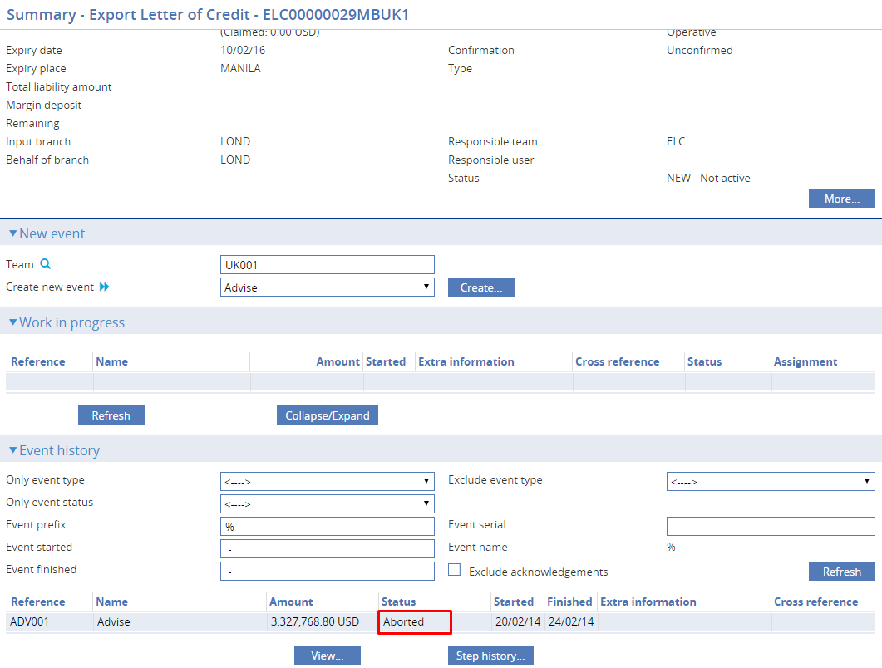

### Printing a SWIFT Message

To print the text of a message, select the message you want printed, and click **Print**. In the window that is displayed select one of the options below and click **Print**.

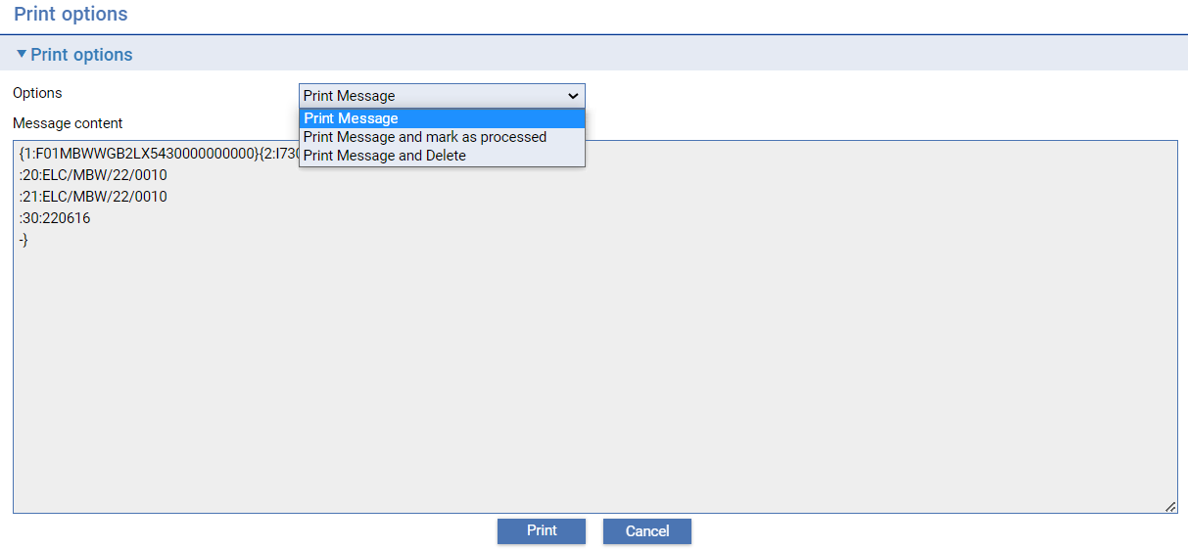

| **Option** | **What it Shows** |
| --- | --- |
| Print message | This prints the selected message. Use this option in normal cases. |
| Print message and mark as processed | This prints the selected message and marks it as processed in the SWIFT application. The message will be deleted during batch processing.  This is a suitable way of dealing with messages which for some reason Trade Innovation cannot process. |
| Print message and delete | This prints the message and marks it as to be deleted. The message is then deleted during Trade Innovation 's overnight batch processing. |

### Pending a Message

You can set a message’s status to ‘Pended’ by selecting it and clicking **Pend**. This allows you to remove a message from the list of active messages, while saving it for later processing. Messages can be pended if their status is ‘Active’, ‘Incoming’, ‘Unprocessed’ or ‘Autoprocess’. A pended message can be returned to its previous status by selecting it and clicking **UnPend**.

## Inward SWIFT Message Statuses

The following table lists valid statuses for inward SWIFT messages and explains what they indicate:

| **Status** | **What it Indicates** |
| --- | --- |
| < ---- > | All messages. |
| *Active* | This status includes all messages that need any type of processing, including the Unprocessed, Errors, Incoming and Unsupported statuses. |
| Incoming | The message has been received, but not yet processed in any way. |
| Unprocessed | The message is of a type not defined as suitable for autoprocessing, and is awaiting individual review and processing. If a Ready message failed to be processed its status is also changed to ‘Unprocessed’. |
| Ready | The message is of a type that has been defined by the bank’s system administration as suitable for automatic processing and is awaiting autoprocessing. |
| Processed | Processing of the message has been completed. |
| Unsupported | The message is of a type not supported by the system. Such messages can only be printed and manually processed. |
| Errors | Errors have been detected on the message. These errors must be corrected and the message re-processed. |
| *Merged* | Used for incoming messages (other than continuation message) that has been combined. The individual messages are flagged as ‘Merged’ and a new message is generated representing the combined message. |
| *Incomplete* | Any incoming message that forms part of a multiple but where further parts have not yet been received from the SWIFT device. |
| *Printed* | Printed and marked as actioned. |
| *Deleted* | Printed and marked for deletion. |
| Matched | Matched with an existing master. |
| Merge/Processed | Used for incoming combination messages that have been combined to produce a single MT700 message. The MT700 message is flagged as ‘Processed’, while the MT701 messages are flagged as ‘Merged/Processed’. |
| Pended | The message has been pended manually for processing at a later date. |
| *Outstanding* | Any message requiring processing. |

### SWIFT ACK/NAK Functionality

In the SWIFT Inward Messages Browser, a flag named ‘Include F21 Acknowledgements’ is available:

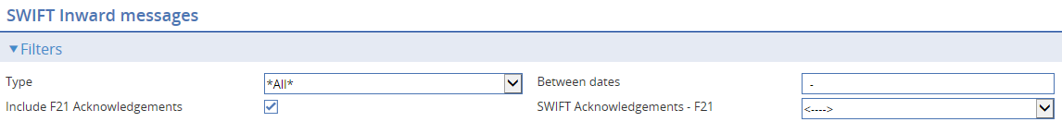

Checking this flag enables the ‘SWIFT Acknowledgements F21’ dropdown list which provides you with a choice of filtering on those messages that have been transmitted by your bank and subsequently acknowledged (ACK), have resulted in a negative acknowledgement (NAK), or on all messages received, including ACKs and NAKs.

The dropdown options available are as follows:

| **Filter** | **What it Indicates** |
| --- | --- |
| < ---- > | Returns results for all categories of message. |
| Only ACKS | Returns results for all messages that have a positive acknowledgement. |
| Only NAKS | Returns results for all messages that have a negative acknowledgement or errors. |

The message ‘Type’ is displayed in the ‘Type’ column in the ‘Results’ table. This indicates either the category of SWIFT message, whether the message is a positive acknowledgement of an outgoing message, or whether the message is a negative acknowledgement of an outgoing message:

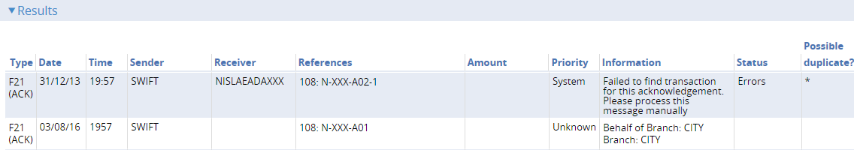

The user may, of course, set additional filters to further restrict the number of results returned.

#### Acknowledgements for Outgoing SWIFT Messages Addressed to non-Trade Innovation Customers

Where your bank wishes to transmit a SWIFT message and receive an acknowledgment but the addressee is not a customer on your bank’s database, or your Customer Information File; setting the following System Option (in System Tailoring | Branch Options | Services mappings | SWIFT – Back office | Services options) still allows you to receive acknowledgements:

##### **‘SWIFTAcknowledgements’**

* If the value of this System Option is set to 'None' - SWIFT Acknowledgements are not required.
* If the value of this System Option is set to 'All' - SWIFT Acknowledgements are required for all message types defined in System Tailoring for specific products.
* If the value of this System Option is set to 'Primary Customer' - SWIFT Acknowledgements are required for all message types defined in System Tailoring, where the transaction's Primary Customer requests a SWIFT Acknowledgement.

# Outward SWIFT Messages

This chapter explains how SWIFT messages are generated by Trade Innovation, and how to use the Trade Innovation message manager application to view and transmit outward SWIFT messages generated by Trade Innovation.

See the Appendix for a list of all the SWIFT message types supported by Trade Innovation.

## Outward SWIFT Messages and Trade Innovation

If your bank is connected to the SWIFT communications network, then it will use a SWIFT interface device (SID) to transmit its outward messages to the SWIFT network and to receive messages from that network. Trade Innovation sends messages in SWIFT format to the SID, and receives messages from it.

Outward SWIFT messages are generated automatically by Trade Innovation at the point at which an event is released. The messages generated are defined by the document types linked to the event. Trade Innovation takes information from the event and formats it to create a valid SWIFT message. Outward messages can be viewed using the Trade Innovation message manager application before being transmitted to the SID for onward transfer.

The system can be set up to send messages automatically at a user-defined frequency, as explained in the Security Guide – Trade Innovation. Alternatively, outward SWIFT messages generated by Trade Innovation may be held as awaiting transmission until you choose to send them.

Trade Innovation performs comprehensive checks on SWIFT messages as they are released during transaction processing to reduce the chances of a transmission failure, but in the event of such a failure, Trade Innovation facilities allow you to re-send a message.

## Viewing, Re-sending, and Deleting Messages

Selecting the **SWIFT|Outgoing Messages** menu option displays the SWIFT Message Out Browser window. This window can be used to list SWIFT messages that are awaiting transmission, and SWIFT messages that have been transmitted but not yet deleted. It also allows you to re-send and delete messages.

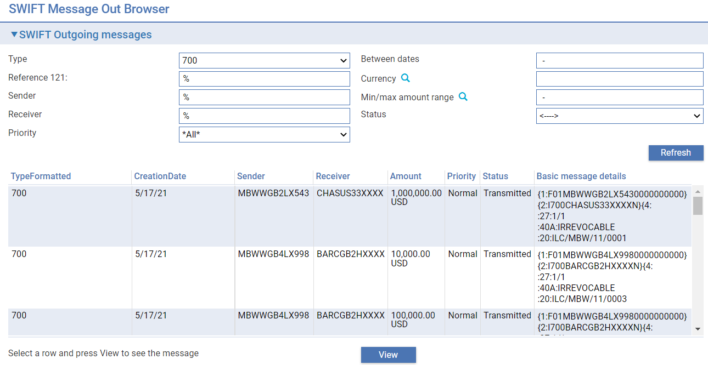

The browser provides the following filters:

* Type – either message type or category
* Status – either ‘ACK received’, ‘NAK received, ‘Awaiting acknowledgement’, 'Awaiting transmission', ’In progress’, ‘Failed’, 'Transmitted' or 'Resent'
* Reference 121 – the unique end-to-end transaction reference (UETR) in header block 3 – available within MT 1* and 2* payment messages.

For each message the window shows:

* The message type
* The status of the message
* The message header. From this header information, a user familiar with SWIFT can identify the message type and the addressee

You can view the content of a message by selecting it and clicking **View**. The message is displayed in full in the Selected Message panel.

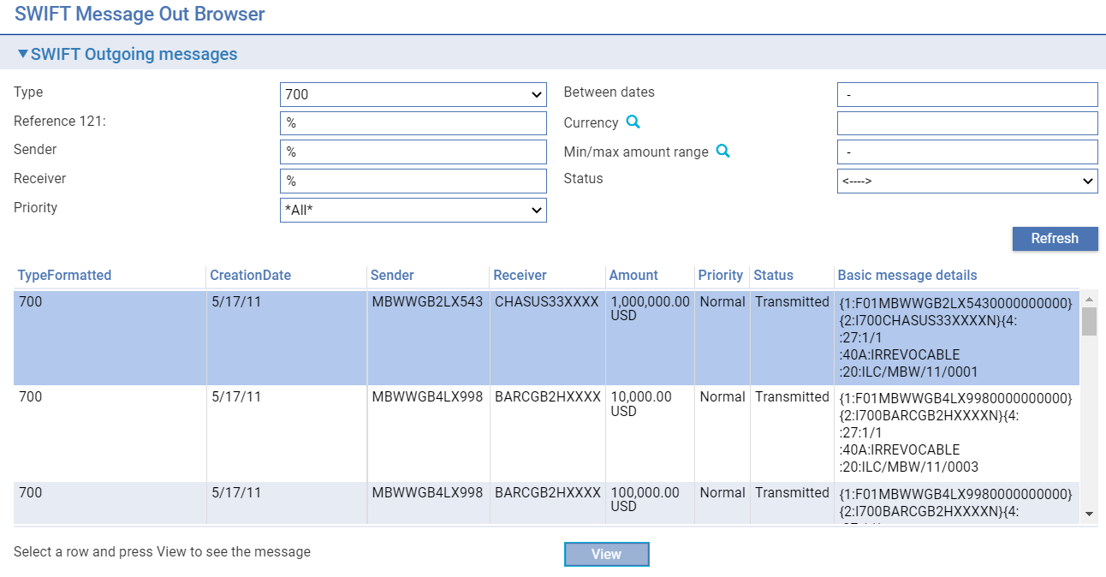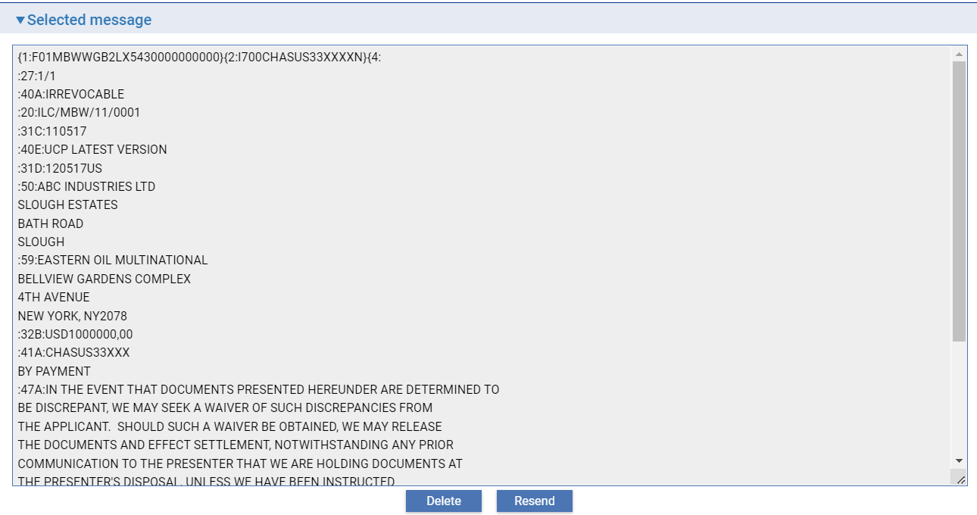

By clicking **Delete**, you can delete the selected message.

If a message has been unsuccessfully sent, the message can then be re-sent to the SID if required by selecting the message and then clicking **Resend**. Trade Innovation re-transmits the message and creates a duplicate entry for the message in this window.

# Processing Customer Gateway Interface Service Requests

This chapter explains how to use the Trade Innovation message manager application to process messages received via customer gateway interface service, and how to view general, security, static, tailoring and transaction messages.

1. This chapter is relevant only if you have Trade Innovation’s customer gateway interface service implemented.
2. The transactions available to your corporate customers via Trade Innovation's customer gateway will depend on the customer access system that your bank has installed.
3. The functionality described in this chapter can be accessed from within the transaction processing Masters window and the SLA Dashboard, which indicate when there are messages needing to be incorporated into the Trade Innovation workflow manually.

## Overview

Trade Innovation permits authorised customers of your bank to transmit messages to your bank in electronic format via Trade Innovation's customer gateway interface service. The customer gateway interface service supports incoming messages for static data, security data, system tailoring data (charges schedules and interest schedules) and transaction data such as letters of credit, standbys and guarantees, clean payments and collections.

As transactions are received, they are processed automatically, creating the required event (at the configured event step) and assign them to an appropriate team. Each transaction message must have a behalf of branch specified and may optionally have a team supplied. Where a team is included, the system will assign the transaction to that team providing it is able to process the transaction for the event type, step and branch. Where no team is received, the system will assign it to an appropriate team as follows:

* The event/team mappings where defined,
* The available valid teams on a ‘round robin’ basis if available - either auto-allocate team or standard team,
* The default team for the product if defined or
* A gateway repair team.

If a message is received which cannot be processed successfully, the message will appear in the Gateway Message In Manager window with a status of 'Errors'. The transaction processing Masters window and the SLA Dashboard indicate when there are incoming customer gateway interface service messages needing to be incorporated into the Trade Innovation workflow manually.

The customer gateway interface service is also used to handle internal messages from within your bank, such as messages containing scanned documents held or documents held in an external document management system.

## Special Considerations when Incorporating Legacy Transactions into Trade Innovation (Data Take-on)

The customer gateway interface service may be used to incorporate transactions from a legacy system into Trade Innovation. For each legacy transaction, Trade Innovation receives a customer gateway interface service message, which is incorporated into the Trade Innovation database and then used to create a master record.

The mechanism for creating the customer gateway interface service messages will have been designed by your bank, based on the published message layouts (XSDs) delivered with Trade Innovation.

Currently this functionality is reserved for use with:

* Export guarantees
* Export letters of credit
* Import guarantees
* Import letters of credit

It creates and releases a data take-on event for each message successfully processed (an Advise Take-on event for export letters of credit and guarantees, and an Issue Take-on event for import letters of credit and guarantees). The master record is given the status 'LIV' or 'EXP', as relevant.

Customer gateway interface service messages of this type may fail for the usual reasons. In addition, Trade Innovation expects the required static, security and system tailoring data to have been set up within Trade Innovation to support the events created. This includes, for example:

* Postings to handle current outstanding liability and residual margin
* Master-level tracer types and their schedules
* Charge types and their default schedules
* Note types

1. If any critical data is missing or in error (for example, a duplicate master record reference is provided, or a default periodic charge schedule is missing), the message fails to create a master record and is held in the customer gateway interface service queue for manually processing.

See the System Tailoring User Guide – Trade Innovation for instructions on setting up the items listed above.

## Viewing Inward Gateway Interface Transaction Messages

In the Trade Innovation message manager application select the **Gateway|Transaction messages** menu option.

This browser provides the user with the ability to filter on gateway messages which relate to FTI transactions, such as the TFILCAPP.xml, used to request issuance of an Import Letter of Credit.

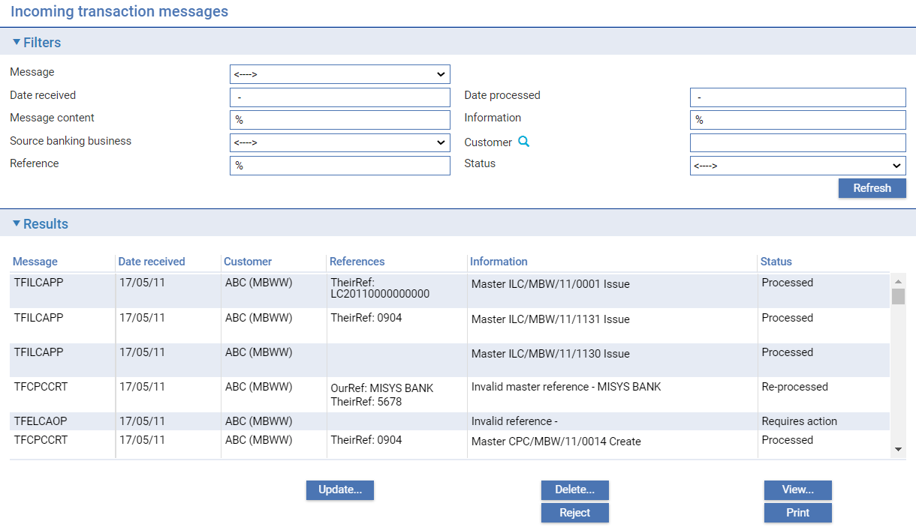

Trade Innovation displays a window that allows you to list messages received via the customer gateway interface service. Initially it is blank. The following information is shown:

| **Status** | **What it Indicates** |
| --- | --- |
| Message | Gateway message type. |
| Date received | Date gateway message received. |
| Date processed | Date gateway message processed in Trade Innovation. |
| Message content | Selected XML message text to filter messages. |
| Information | Processing information relating to the message. |
| Source banking business | If the zone holds multiple Customer information files (CIFs), entry of the banking entity of the required Customer information file can be entered here. |
| Customer | Customer ID where the gateway message is associated with a customer. This filter also allows selection of the Source banking business. |
| Reference | The sender’s reference. |
| Status | Messages can have one of the following statuses:   * Active - Messages waiting to be processed. * Processed - Messages which have been accepted and incorporated into the Trade Innovation workflow. * Errors - Messages which have not been processed because they contain errors. * Rejected - Messages which have been rejected. * Requires action - Messages which are eligible for reprocessing by the system e.g. where the team is invalid and the item needs to be corrected and resubmitted. In this case, the original details from the message are resubmitted as a new message together with overlay information for the reprocessing. Once the item is resubmitted it is flagged as Re-processed. * Re-processed - An item requiring action that has been corrected and has been resubmitted for processing. The original details from the message are resubmitted as a new message together with overlay information for the reprocessing. |

You can use the **Print** button to print full details of a message.

Where a message has the status 'Errors', you can rectify the cause of the error (which will typically be because another event is in progress against the same master) and re-process the message.

**Delete** permits you to remove a message from the message list.

**Reject** allows you to set the status of a message to 'Rejected'.

**View** allows you to see details of the content of a message.

**Update** allows details relating to the customer, team, branches, reference and transaction type to be overridden where a transaction requires reprocessing.

### Viewing and Processing a Message

Clicking Update or **View** opens a window that displays details of the message.

The Incoming message pane shows Service, Operation – Message type, Date, Status and Error information.

The Processing details pane allows you to:

* Create a new master for the specific message type such as TFILCAPP, TFCOLNEW

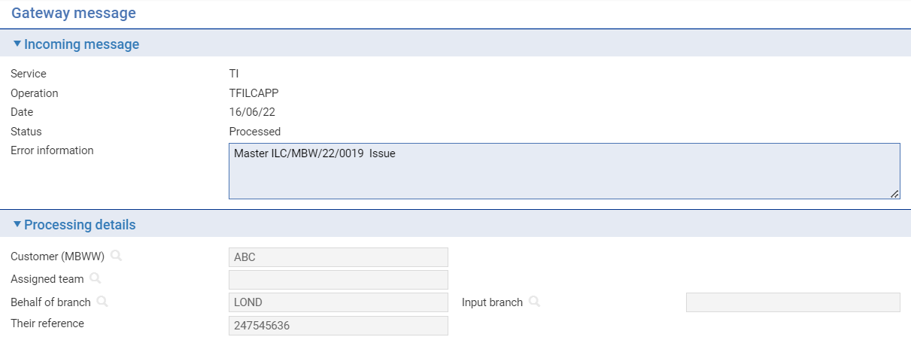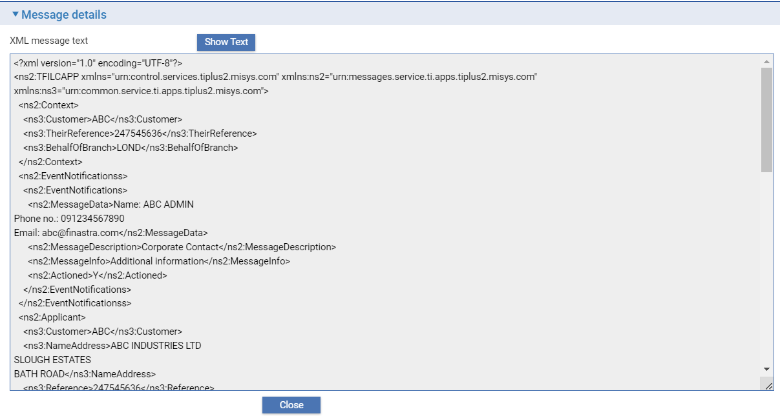

* Create a new master with initial event under a message such as TFILCAPP or all documents to any event under a general message such as TFRCVDOC

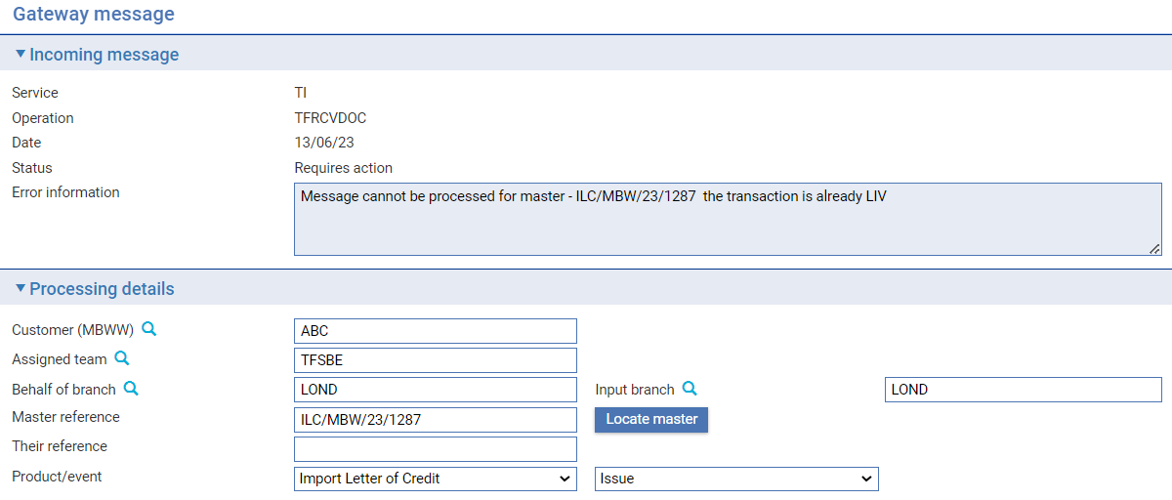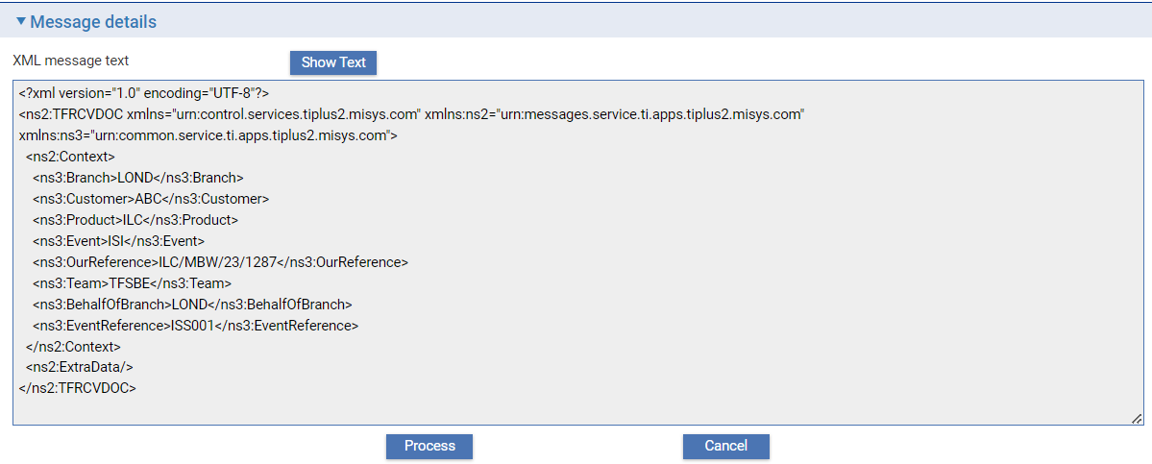

* Create a new event against an existing master for a specific message such as TFILCCOR

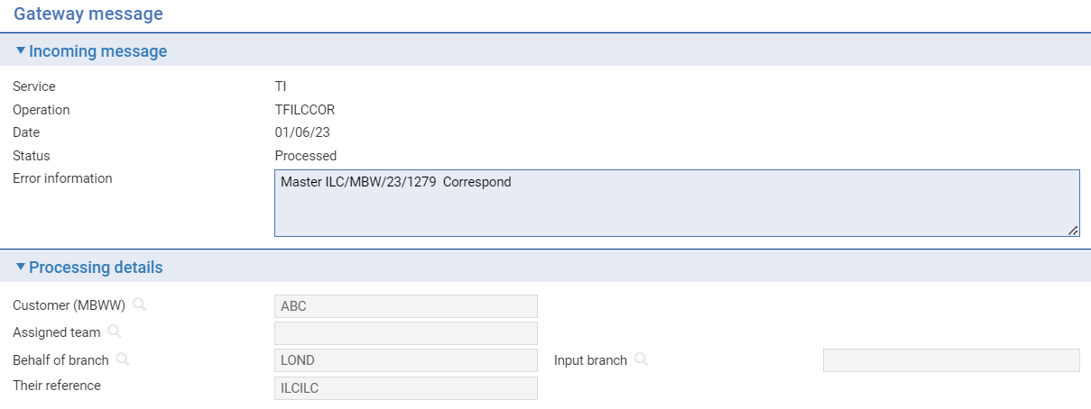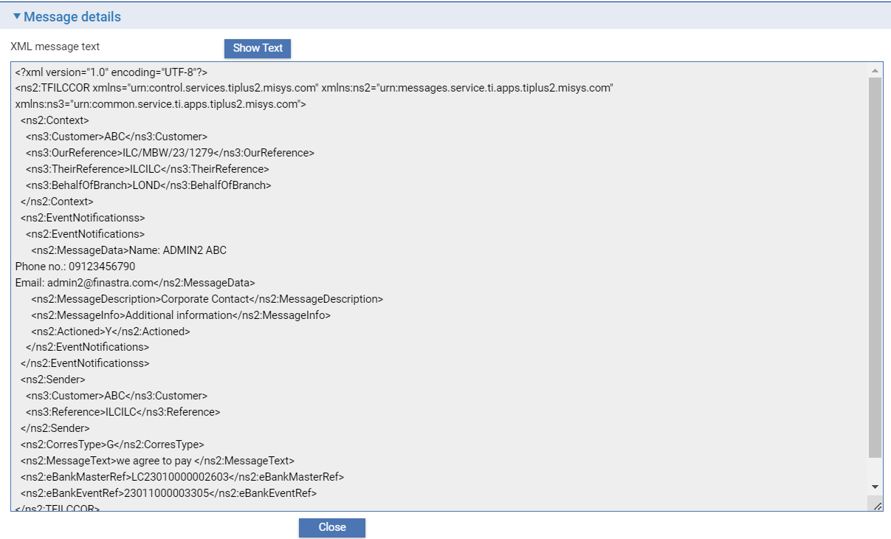

The Message details pane shows the text of the message. The **Show Text/Show XML** button allows you to toggle between showing the message as text or in xml format.

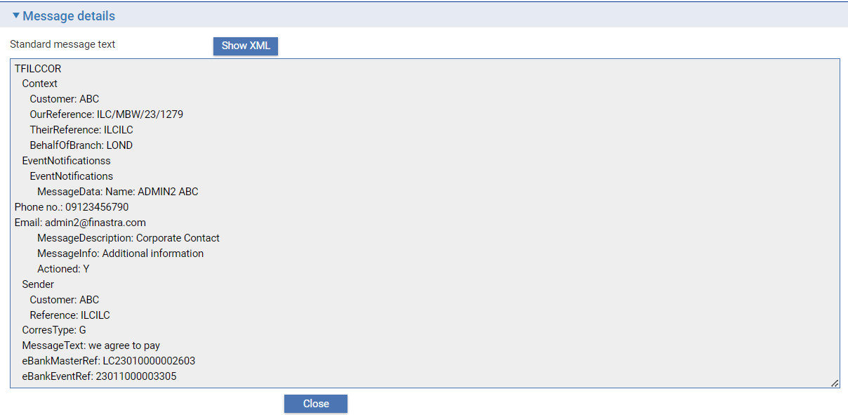

The **Locate Master** button is enabled if the message pertains to an existing master record and allows you to identify it. Clicking this button opens a browser window, which you can use to locate the relevant master.

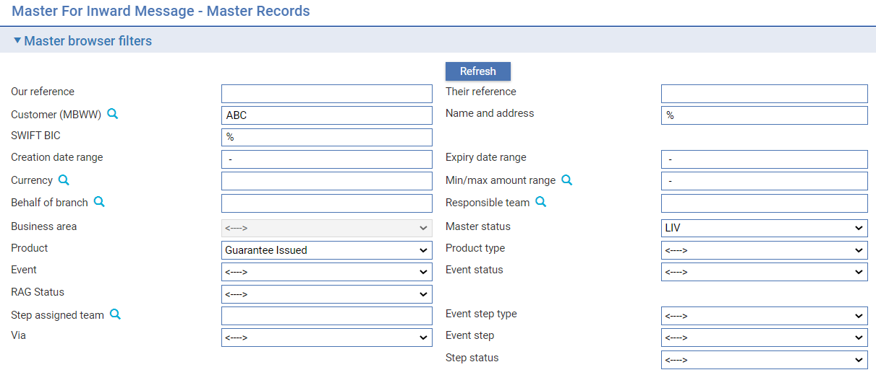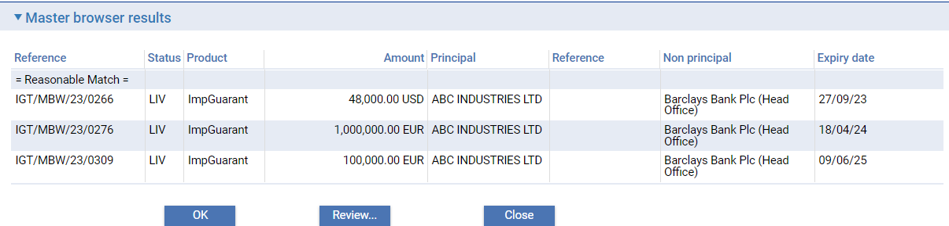

You can see details of each of the master records that are found before you select the required one by highlighting each entry in turn and clicking **Review**. This opens the Master Summary window for the master record, which allows you to see full details of the transaction and its history.

To select the master, highlight it and click **OK**.

To assign the message to the selected master click **OK**.

## Viewing Inward Gateway Interface Security, Tailoring, Static and Batch Messages

In the Trade Innovation message manager application select the **Gateway|Security/tailoring/static/batch messages** menu option.

This browser provides the user with the ability to filter on gateway messages relating to functions included in these applications. The messages may be received, for example, during system configuration (e.g. where data has been imported from the Configuration Management Tool - CMT).

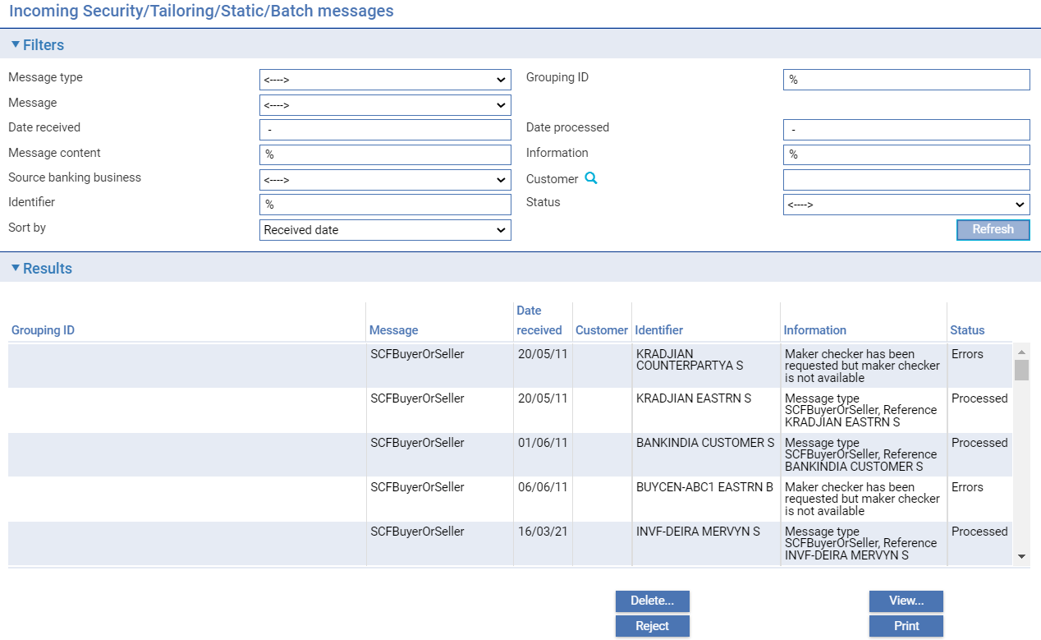

Trade Innovation displays a window that allows you to list messages received via the customer gateway interface service. Initially it is blank. The following information is shown:

| **Status** | **What it Indicates** |
| --- | --- |
| Message type | Message types can be one of the following:   * Batch. * Security. * Static data. * Tailoring |
| Grouping ID | A common grouping ID assigned to set of static or system tailoring data e.g. where data has been imported from the Configuration Management Tool (CMT). |
| Message | Message type. |
| Date received | Date gateway message received. |
| Date processed | Date gateway message processed in Trade Innovation. |
| Message content | Selected XML message text to filter messages. |
| Information | Processing information relating to the message. |
| Source banking business | If the zone holds multiple Customer information files (CIFs), entry of the banking entity of the required Customer information file can be entered here. |
| Customer | Customer ID where the gateway message is associated with a customer. This filter also allows selection of the Source banking business |
| Identifier | The sender’s reference. |
| Status | Messages can have one of the following statuses:   * Active - Messages waiting to be processed. * Processed - Messages which have been accepted and incorporated into the Trade Innovation workflow. * Errors - Messages which have not been processed because they contain errors. * Rejected - Messages which have been rejected. * Requires action - Messages which are eligible for reprocessing by the system e.g. where the team is invalid and the item needs to be corrected and resubmitted. In this case, the original details from the message are resubmitted as a new message together with overlay information for the reprocessing. Once the item is resubmitted it is flagged as Re-processed. * Re-processed - An item requiring action that has been corrected and has been resubmitted for processing. The original details from the message are resubmitted as a new message together with overlay information for the reprocessing. |
| Sort by | Sort by can be one of the following:   * Received date * Grouping ID |

You can use the **Print** button to print full details of a message.

Where a message has the status 'Errors', you can rectify the cause of the error (which will typically be because another event is in progress against the same master) and re-process the message.

**Delete** permits you to remove a message from the message list.

**Reject** allows you to set the status of a message to 'Rejected'.

**View** allows you to see details of the content of a message.

### Viewing a Message

Clicking **View** opens a window that displays details of the message.

The Incoming message pane shows Service, Operation – Message type, Date and Information.

## Viewing Inward Gateway Interface External Review and Exchange Step Messages

In the Trade Innovation message manager application select the **Gateway|External review/Exchange step messages** menu option.

This browser provides the user with the ability to filter on gateway messages relating to Advanced Trade Innovation workflow only. It enables incoming messages from external systems to be incorporate into the FBTI workflow, in response to review and exchange step outgoing messages

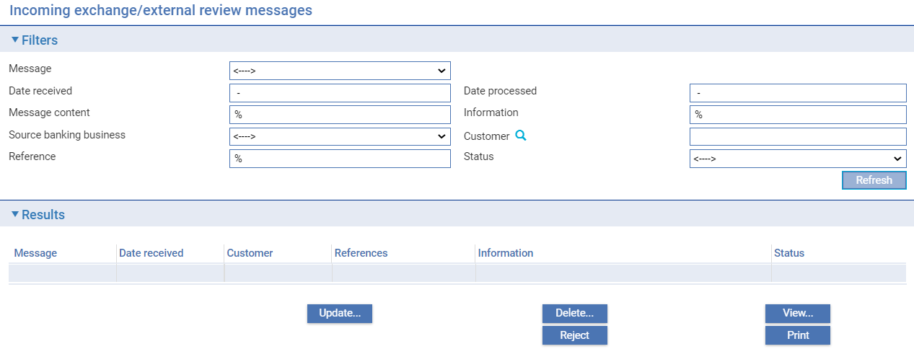

Trade Innovation displays a window that allows you to list messages received via the customer gateway interface service. Initially it is blank. The following information is shown:

| **Status** | **What it Indicates** |
| --- | --- |
| Message | Message type. |
| Date received | Date gateway message received. |
| Date processed | Date gateway message processed in Trade Innovation. |
| Message content | Selected XML message text to filter messages. |
| Information | Processing information relating to the message. |
| Source banking business | If the zone holds multiple Customer information files (CIFs), entry of the banking entity of the required Customer information file can be entered here. |
| Customer | Customer ID where the gateway message is associated with a customer. This filter also allows selection of the Source banking business |
| Information | Processing information relating to the message. |
| Status | Messages can have one of the following statuses:   * Active - Messages waiting to be processed. * Processed - Messages which have been accepted and incorporated into the Trade Innovation workflow. * Errors - Messages which have not been processed because they contain errors. * Rejected - Messages which have been rejected. * Requires action - Messages which are eligible for reprocessing by the system e.g. where the team is invalid and the item needs to be corrected and resubmitted. In this case, the original details from the message are resubmitted as a new message together with overlay information for the reprocessing. Once the item is resubmitted it is flagged as Re-processed. * Re-processed - An item requiring action that has been corrected and has been resubmitted for processing. The original details from the message are resubmitted as a new message together with overlay information for the reprocessing. |

You can use the **Print** button to print full details of a message.

Where a message has the status 'Errors', you can rectify the cause of the error (which will typically be because another event is in progress against the same master) and re-process the message.

**Delete** permits you to remove a message from the message list.

**Reject** allows you to set the status of a message to 'Rejected'.

**View** allows you to see details of the content of a message.

**Update** allows details relating to the customer, team, branches, reference and transaction type to be overridden where a transaction requires reprocessing.

### Viewing and Processing a Message

Clicking **Update** or **View** opens a window that displays details of the message.

The Incoming message pane shows Service, Operation – Message type, Date, Status and Error information.

## Viewing Inward Gateway Interface Messages in Error

In the Trade Innovation message manager application select the **Gateway|Messages in error** menu option.

This browser provides the user with the ability to view and/or delete gateway messages which have been received in error.

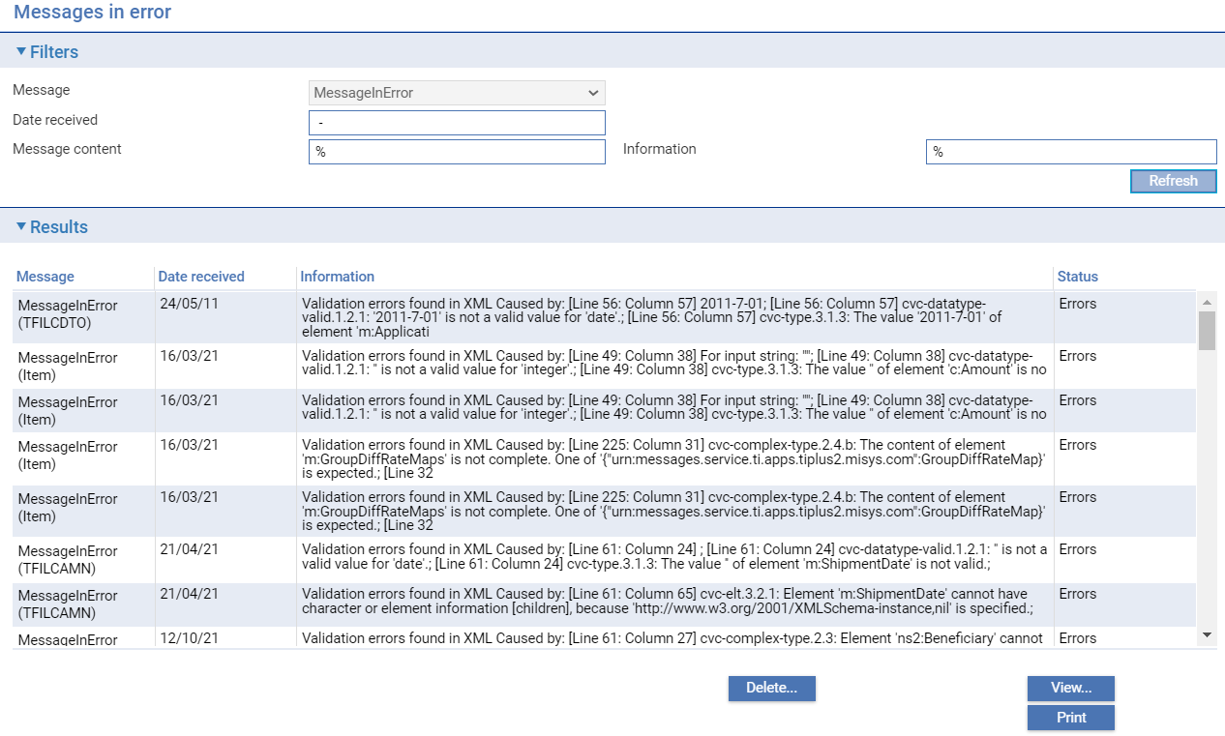

Trade Innovation displays a window that allows you to list messages received via the gateway interface service. Initially it is blank. The following information is shown:

| **Status** | **What it Indicates** |
| --- | --- |
| Message | Message type. |
| Date received | Date gateway message received. |
| Message content | Selected XML message text to filter messages. |
| Information | Processing information relating to the message. |

You can use the **Print** button to print full details of a message.

Where a message has the status 'Errors', you can rectify the cause of the error (which will typically be because another event is in progress against the same master) and re-process the message.

**Delete** permits you to remove a message from the message list.

**View** allows you to see details of the content of a message.

### Viewing a Message

Clicking **View** opens a window that displays details of the message.

The Incoming message pane shows Service, Operation – Message type, Date, Status and Error information.

## Customer Gateway Interface Services Outward Messages

Messages that have been sent out via the customer gateway interface service can be listed by selecting the **Gateway|Gateway Output** menu option from the Trade Innovation’s message manager application.

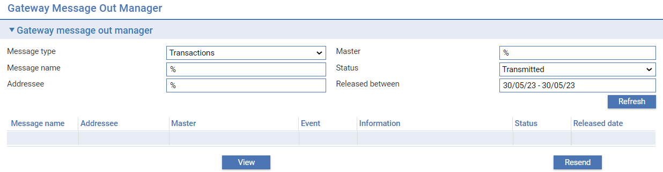

The window displayed allows you to list messages that have been sent out via the Customer Gateway for any specified date. The Message Type drop-down list allows you to select:

* All, to show all types of customer gateway interface service message
* Static downloads, to show static data download messages only
* Transactions, to show transaction-related messages only

You can use the Status filter to limit messages displayed to those with a particular status.

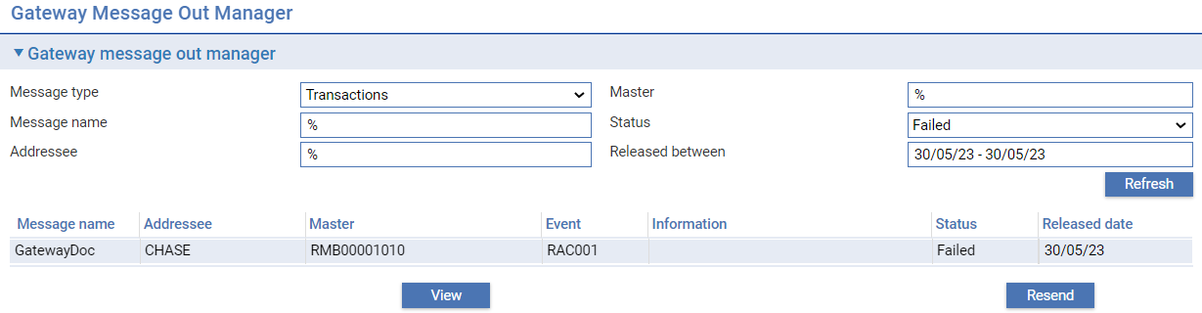

Messages are displayed by message name within release date. You can:

* View a message
* Resend a message

When you select View, a window is displayed allowing the message to be reviewed.

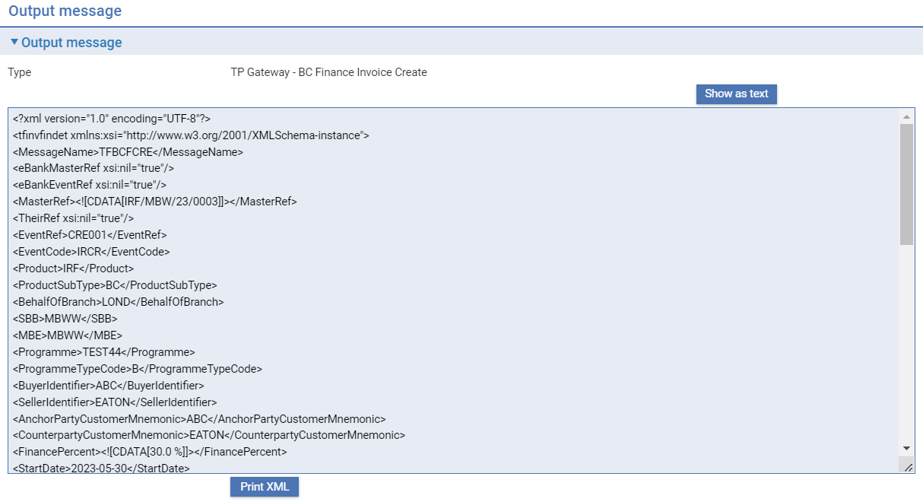

The details of the message can be displayed in either text or XML format and the **Print** button allows you to print the contents on the message.

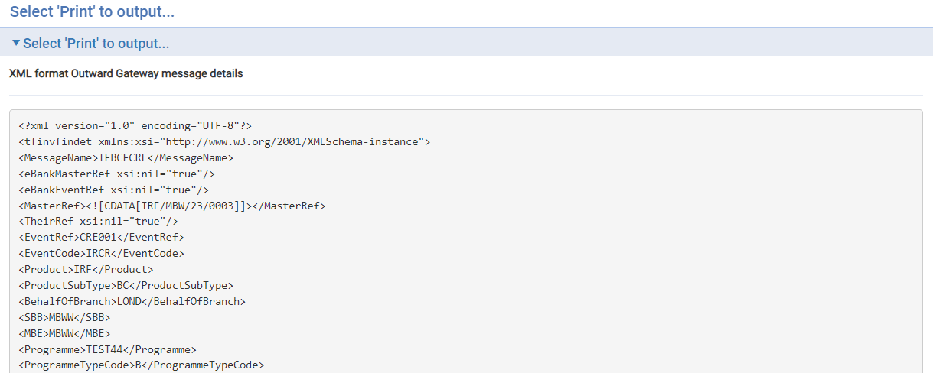

# Attaching Scanned Images of Documents Received

As your bank receives commercial and financial documents supporting trade finance transactions you may scan them in and save them to a local server or upload the resulting image files into a document management system (DMS) you run in conjunction with Trade Innovation.

You can then reference these details to create transactions in Trade Innovation via the Attached Documents function in the Trade Innovation message manager.

When the option is selected, you can identify each document or a set of documents for upload and you can specify the master they are to be used to create or the master record against which the event is to be created. You can also upload attachments such as spreadsheets, .pdf files, email and other such supporting documentation and attach them to master records.

If your bank uses a DMS external to Trade Innovation (for example, a head office repository) you can upload, or link to, images stored in that DMS. If you link to a file, rather than uploading it, the image file remains in the DMS and is not uploaded into the Trade Innovation database.

Once you have used the message manager to enter details of the document(s) and the event to be created, Trade Innovation creates a customer gateway message (of type TFATTDOC) which is then transmitted to Trade Innovation, and creates the required event at an input step.

As you use the message manager to enter details of documents to be uploaded and the event they are to create, you can also enter additional information for the input clerk. This will be displayed as one or more actions at the top of the window when the input clerk opens the resulting event.

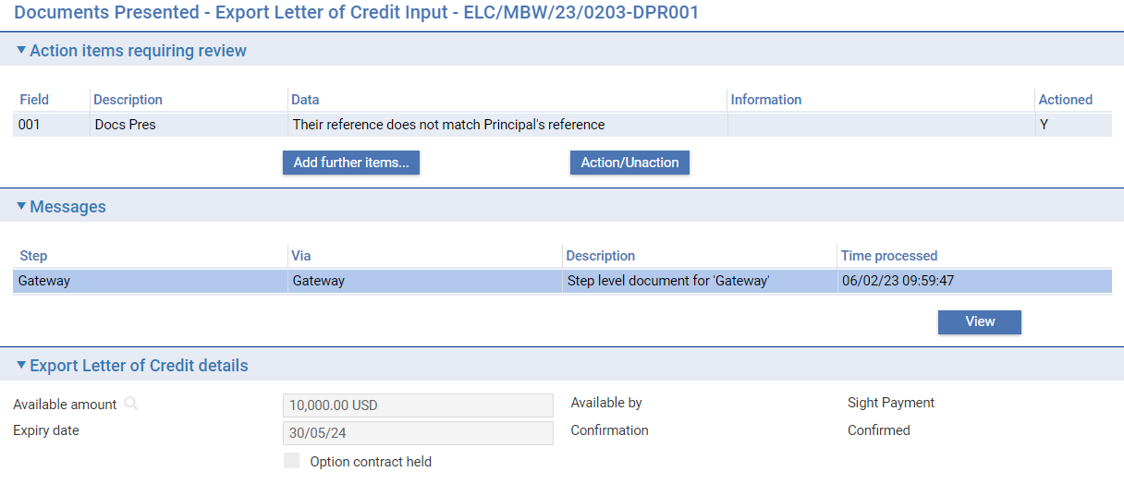

## Attaching Scanned Images to a Master Record

Select the Trade Innovation message manager's **Internal transaction messaging|Attached Documents** menu option.

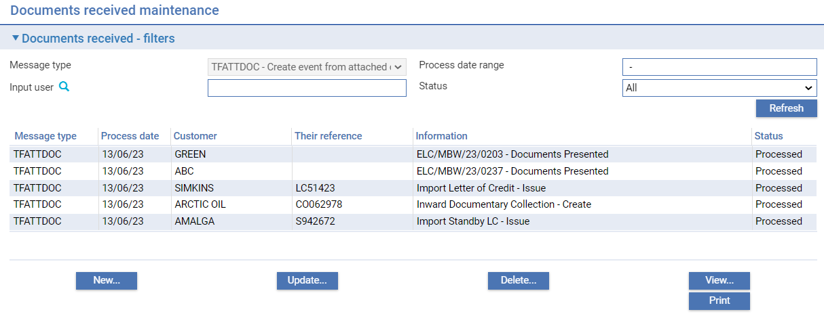

Trade Innovation displays a window that allows you to list previous entries. Initially it is blank. When you click **Refresh**, Trade Innovation displays a list of scanned images already linked or uploaded.

The following table explains what the filter fields control:

| **Field** | **What it Controls** | |
| --- | --- | --- |
| Process Date Range | Enter two dates, separated by a space, then a hyphen, then a space, to identify a date range, within which the entry must have been entered. For example:  12/12/12 - 15/12/12  The date format used by your system may be different from that shown above. | |
| Input User | Select a user to limit the display to entries made by a specific user. Leave this blank to display entries made by all users.  Access to this filter field is controlled by the security capability GatewayIn. | |
| Status | Select a status to limit the display to entries with a particular status, or select 'All' to display entries with any status. An entry's status may be one of the following values: | |
|  | Pended | information has been entered, but not yet processed to create a customer gateway message. |
|  | Errors | information has been entered and processed but the system could not create a customer gateway message due to errors. |
|  | Processed | information has been entered and successfully processed to create a customer gateway message. |

For each entry, Trade Innovation shows the following information.

| **Field** | **What it Shows** |
| --- | --- |
| Message Type | The customer gateway message type. |
| Process Date | The date the entry was made on the system. |
| Customer | The principal customer for the related transaction. |
| Their Reference | The principal customer's reference for the related transaction. |
| Information | Either the product/event the entry is set up to create; or the reference of the master record and the event to be created. |
| Status | The status of the entry - see the table above. |

The **Update**, **Delete** and **View** buttons can be used in the usual way. You can print details of an entry by highlighting it and clicking **Print**.

To create a new entry, click **New**.

### Making a New Entry

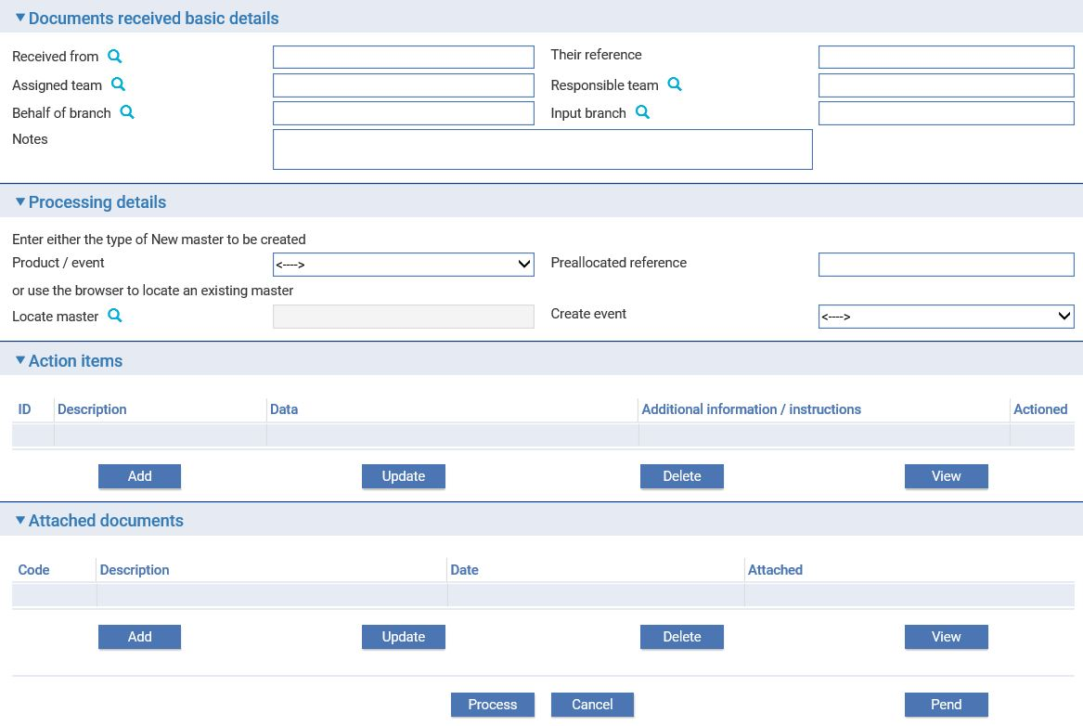

The table below explains what to enter into the fields in this window to create a new entry. When you have completed input, clicking the **Process** button causes the new event (or master record and event) to be created, provided the resulting customer gateway message is processed without errors. You can instead use the **Pend** button to save input for completion later.

1. You must enter a Received From party, and you must either specify a product/event combination or enter a master reference and then choose an event to be created.

The Action Items pane allows you to enter additional information and instructions for the input clerk (and amend and delete them in the usual way). When the event resulting from this entry is opened, the information is displayed at the top of the window as actions.

The Attached Documents pane permits you to add one or more document image files to the entry.

| **Field** | **What to Enter** |
| --- | --- |
| Received From | Identify the party from whom you received the documents. |
| Their Reference | The reference provided by the party from whom you received the documents for the transaction to which they relate. |
| Assigned Team | The team to which the event created by the customer gateway message will be assigned as part of processing the event. |
| Responsible Team | The responsible team when creating a new master. |
| Behalf Of Branch | The behalf of branch for the transaction as entered by the user or set from the incoming SWIFT or gateway message. The behalf of branch determines the parameter sets that are to be used to generate charges, documents, postings etc. during transaction processing. The branch can be changed to any other branch within the same main banking entity that shares the same parameter sets. |
| Input Branch | The input branch to be assigned to the event created by the customer gateway message. |
| Notes | Any notes concerning the document(s) or the master/event being created. |
| Product/Event | If the document entry is to create a new master record, select the product and the event to be created. |
| Preallocated Reference | If the document entry is to create a new master record either enter a pre-allocated number for the transaction, or leave this field blank (in which case Trade Innovation will use the next number available for that product). |
| Locate Master | If the entry is to create a new event against an existing master, identify the master. |
| Create Event | If the entry is to create a new event against an existing master, select the event to be created. |

### Setting Actions

When you click **Add** in the Action Items pane Trade Innovation displays a window that allows you to enter additional information and instructions for the input clerk.

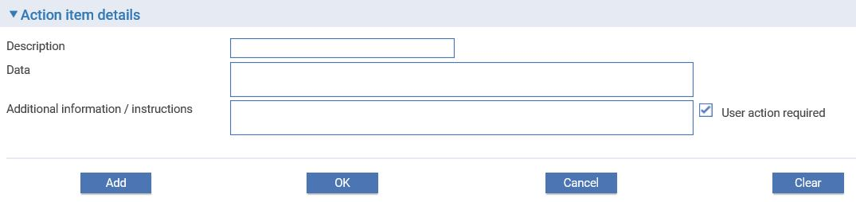

In the window that is displayed use the three fields to enter the required information. Your bank will have devised its own system for categorising the information that should go into each of the three fields. The content of all three fields are displayed during transaction processing.

### Adding Document Image Files

When you click **Add** in the Attached Documents pane Trade Innovation displays a window that allows you to identify each of the documents in the set.

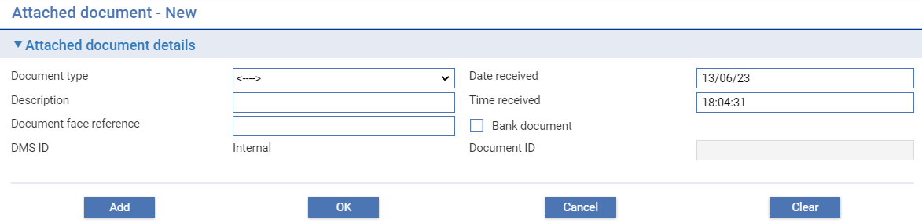

This window allows you to identify documents in two ways:

* For a document that you have scanned in, click **Upload**. The system opens a window that you can use to locate the electronic image file. Trade Innovation then allocates the image a unique ID within the DMS assigned for attachment type documents. The Attachment Document Management System is an external system mapped as a service to the banking entity hierarchy. The internal FTI zone DMS can also be assigned. The internal or external DMS as configured is displayedin the Attachment ID field.

The following table explains what to enter into the fields in this window:

|  | **Field** | **What to Enter** |
| --- | --- | --- |
|  | Document Type | Select the type of document from those set up on your system. |
| P2515C7T45#yIS1 | Description | Enter a meaningful description of the document. If you select a document type in the previous field Trade Innovation displays its name here, where you can amend it. |
|  | Document face reference | e.g. identifier / number of exchange bill, invoice etc... |
|  | Bank document | Y/N flag indicating whether the document is for internal bank use |
|  | DMS ID | If the document image is being provided from an external DMS, once you select the document Trade Innovation displays the name of the DMS here. Otherwise ‘Internal’ is presented. |
|  | Date received | The date when the document was received. |
|  | Time received | The time when the document was received. |
|  | Document ID | The ID assigned to the document in the Trade Innovation DMS. This is provided automatically once a document file has been uploaded. |

### Uploading the File

When you click **Upload**, Trade Innovation displays a window that allows you to locate the image file to be uploaded.

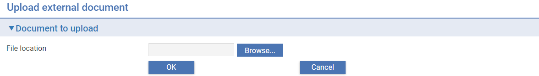

# Foreign Exchange Rate Fixing

This chapter explains how to use Trade Innovation’s Rate Fix Processing application to enter foreign exchange rates during business hours and to apply them to transactions at the processing cycle level that are awaiting rate fixing.

## Overview

Trade Innovation supports the entry of foreign exchange rates received from the central bank during business hours. Currency spot rate and buy/sell rates may be updated daily.

If your bank does this as part of its daily operations, your system may include transactions with events that cannot complete until the new foreign exchange rates have been entered. (These are held at the Rate Fixing step.)

Once the FX rates have been entered they are applied to the events that are awaiting rate fixing, which can then proceed to release.

Where a bank operates globally in multiple regions, foreign exchange rate fixing may be run at the processing cycle level by Main Banking Entity and the rate fix process must therefore be parameterized at the Main Banking Entity level in each case. Other Main Banking Entities within the zone may operate normally during this period.

Where a branch is performing an end of day cycle, Trade Innovation enables extended hours processing of transactions. Consequently, any transactions requiring rate fixing can be started, or work can continue on already entered ones during end of day processing. The processing is carried out as if the user is now processing on the next processing date. In other words, processing for the next date may commence prior to completion of the current end of day cycle. Transactions cannot be fully released until the end of day processing cycle is complete.

To support this functionality your bank will have identified the foreign exchange rate codes that will be affected by rate changes during business hours, see the *Static Data Maintenance User Guide – Trade Innovation*. For each rate code, your bank will have specified whether any events using that rate code are to be updated using the current processing day's rate, or the rate entered on the following business day. If your bank has the ExtendedRateFixingAllowed system option set to Yes, then rate codes can be set up with a rate fixing type of, 'To be negotiated', in which case you can specify a rate manually, or set via gateway message FXDealSetNegotiatedRate.

Your bank can determine whether or not FX rate reconciliation needs to be carried out prior to FX rate fixing and whether FX rate fixing is carried out manually during the day, or during overnight processing. This is done using system options, as described in the next section.

* If your bank does require that FX rate reconciliation be carried out prior to rate fixing, then the FX rate fixing process must be run manually during business hours and the procedure described in this chapter followed
* If your bank does not require that FX rate reconciliation be carried out prior to rate fixing, then the FX rate fixing process can be run manually during the day or scheduled to run during overnight processing using the FX Rate Fixing action mapped in business hours phase or in the end of day processing (see Available TI Actions), or both.

### What the FX Rate Fixing Process Does

The new FX rates are applied in the following way.

The system identifies each event awaiting rate fixing in turn and uses the rate code's rate fixing type to determine how it should be processed, as shown in the following table:

| **Rate Fixing Type** | **Effect** |
| --- | --- |
| Fix rate today | The rate code involved requires the event to use the current business day's rate. Trade Innovation will calculate the amounts affected using the new rate code and update the master record for the transaction. |
| Fix rate next day | The rate code involved requires that the following business day's rate be used. Trade Innovation will flag the event to be updated after the next set of rates has been entered. |
| To be negotiated | The rate code involved requires that a negotiated rate be used. Trade Innovation will hold the event until a negotiated rate has been manually entered (see the *Common Facilities User Guide* – Trade Innovation). Then Trade Innovation will calculate the amounts affected using the manually entered negotiated rate. |

Recalculated deals are held back until the last foreign exchange deal has been fixed. Once the rate fixing process has completed - that is, when there are no more outstanding deals awaiting rate fixing - all the recalculated deals are released, along with their associated documents and SWIFT messages.

### Before you Begin

The functionality described in this chapter is implemented by setting the ‘FixingRequired’, System Tailoring – Branch options/Servicesmappings - Branch|Trade finance option to ‘Yes’, see the System Tailoring user Guide – Trade Innovation.

If your bank operates at the Global level, this system option must be set for each Main Banking Entity where rate fixing is to be run.

You must then decide whether FX rate fixing is to be carried out during business hours:

* If it is to be carried out during business hours, set the Branch/Trade finance system option FXRateFixingInBusinessHours to ‘Yes’ and configure business hours processing to include the batch action, ‘FX Rate Fixing’ (see Business Hours)
* If it is to be carried out only during overnight processing, set the Branch/Trade finance system option FXRateFixingInBusinessHours to No (or leave the value unchecked) and configure overnight processing to include the batch action, ‘FX Rate Fixing’ (see End of Day Processing)

Your bank can configure the FX rate fixing process so that it can be carried out manually during business hours if required; but that, if it is not carried out during business hours (if, for example, you forget to run the FX rate fixing process) it is carried out during overnight processing instead. Do this by setting the system option FXRateFixingInBusinessHours to Yes and configure overnight processing to include the Trade Innovation action FX Rate Fixing (see End of Day Processing). The changes Trade Innovation makes to the status of your system as the FX rate fixing process is run ensure that it will not be run twice within the same day.

Your bank then needs to decide whether FX rate reconciliation needs to be carried out before FX rate fixing. This is controlled by the Branch/Trade finance system option - FixingRateRecnNotRequired.

* If FX rate reconciliation is required set the system option FixingRateRecnNotRequired to No
* If FX rate reconciliation is not required set the system option FixingRateRecnNotRequired to Yes

1. If your bank configures FX rate fixing so that it is carried out during overnight processing with FX rate reconciliation required, then you need to ensure that FX rate reconciliation is carried out before overnight processing begins on each business day so that your system is at the appropriate status when the FX Rate Fixing action is run. If the FX Rate Fixing action fails during overnight processing, it may be auto-bypassed so that it does not halt overnight processing but errors and warnings are recorded and may be viewed in the Batch log for the relevant Processing cycle.

For information on the additional system options relating to foreign exchange rate fixing see the System Tailoring User Guide – Trade Innovation.

## Running the FX Rate Fixing Process During Business Hours

Before the FX rate fixing process is run, the new foreign exchange rates are entered into the database. They may be downloaded from a back office system or entered manually, depending on your system architecture. If entered manually, use the static data maintenance application's Rates|Spot rates menu option for entering spot rates and Rates|FX Rates menu option for entering buy and sell rates.

See the Static Data Maintenance User Guide – Trade Innovation for instructions.

The FX rate fixing process then has the following steps when run during business hours. These steps are described in detail in the rest of this section:

|  |  |
| --- | --- |
| 1. | Once the FX rates have been entered onto the Trade Innovation database, reconciling rates can begin prior to initiating the FX rate fixing process via the Rate Fix Processing application.  Prior to reconciling rates and if required, a message may be transmitted at the global level, to all users who are logged on to the system to request them to pend their work and continue after rate reconciliation is complete.  In the Rate Fix Processing application, each Processing cycle is listed in the results table, allowing a specific MBE to be selected, for which rate reconciliation and fixing may be run. |
| 2. | You then reconcile the FX rates by highlighting the appropriate Processing cycle and clicking the Reconcile Rates button. You may then filter for the MBE.  When the MBE is selected, its current rate fixing status is displayed. The Rate fixing status is updated accordingly, following reconciliation and rate fixing.  Various currency and rate code filters are available to enable you to search for those currencies where the rate is to be updated. It is possible to reconcile both Spot and Buy/Sell rates. |
| 3. | Once FX rate reconciliation has been completed, the rates are reconciled by clicking the ‘Reconcile’ button.  The ‘Rate fixing status’ changes to indicate whether the rates have been reconciled or if there are any differences. Rate reconciliation cannot proceed until the status of any rate that has been updated is the ‘Same’. This indicates that the rate entered matches the rate recorded in the Static data application.  When rates have been reconciled, click the ‘Confirm’ button. The status changes to indicate whether fix rates have been set. Click ‘Close’ to return to the Rate fixing – Processing cycle selection screen. |

The rate fixing status transitions as follows:

| **Daily Cycle of Rate Fixing** | **Rate Fixing Status change** |
| --- | --- |
| EOD action ‘FX rate fixing reset fix next day’ | Completed to Not fixed |
| New spot and FX buy/sell rates entered in Static Data | No change |
| Rate Reconciliation – optional | Not fixed to Fix rates set |
| Action ‘FX rate fixing running in business hours or EOD | Fix rates set to In progress |
| Action ‘FX rate fixing completed in business hours or EOD | In progress to Completed |

If your system is configured so that FX rate reconciliation is not required before FX rate fixing is carried out, then steps 2 - 3 are skipped.

### Initiating the FX Rate Fixing Process

The FX rate fixing process is manually initiated in the Rate fixing application by using the Run rate fixing button from within the Rate fixing – Processing cycle selection screen. It is initiated after the daily download, or manual entry, of FX rates into the Trade Innovation database has been completed.

If daily FX rate reconciliation is required, FX rate fixing cannot be run until it is completed.

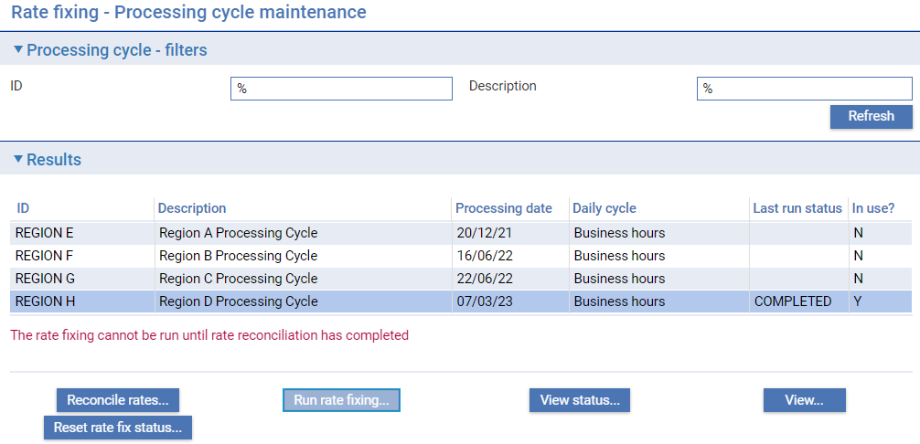

To view the current status of rate fixing for a processing cycle, highlight the specific processing cycle and , then click the **View status** button.

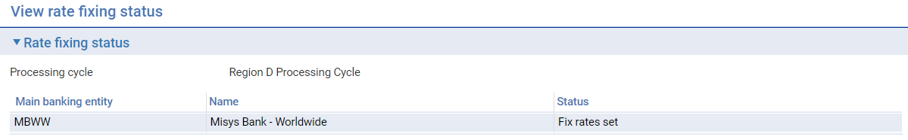

The window that is displayed shows general information about the selected Processing cycle and the current status of each MBE in that Processing cycle with regards to its FX rate fixing status.

If FX rate reconciliation is required, and so rate fixing is undertaken during the day, the system can be configured to send a message to all users, advising them that Rate reconciliation is about to be run for certain MBEs. Users should pend work in those MBEs until reconciliation is complete. (see the Security Guide – Trade Innovation).

### Reconciling FX Rates

1. Before Buy and Sell rates can be reconciled for a currency in the way described in this section, the rate code must have been set up for that currency, together with Buy and Sell rates. See the Static Data Maintenance User Guide – Trade Innovation for instructions on how to do this.

In the Rate fix processing application | Rate fixing - Processing cycle selection screen, select the processing cycle for which you wish to reconcile rates and click the **Reconcile rates …** button. ID and Description filters are provided to enable you to search for a specific processing cycle if required.

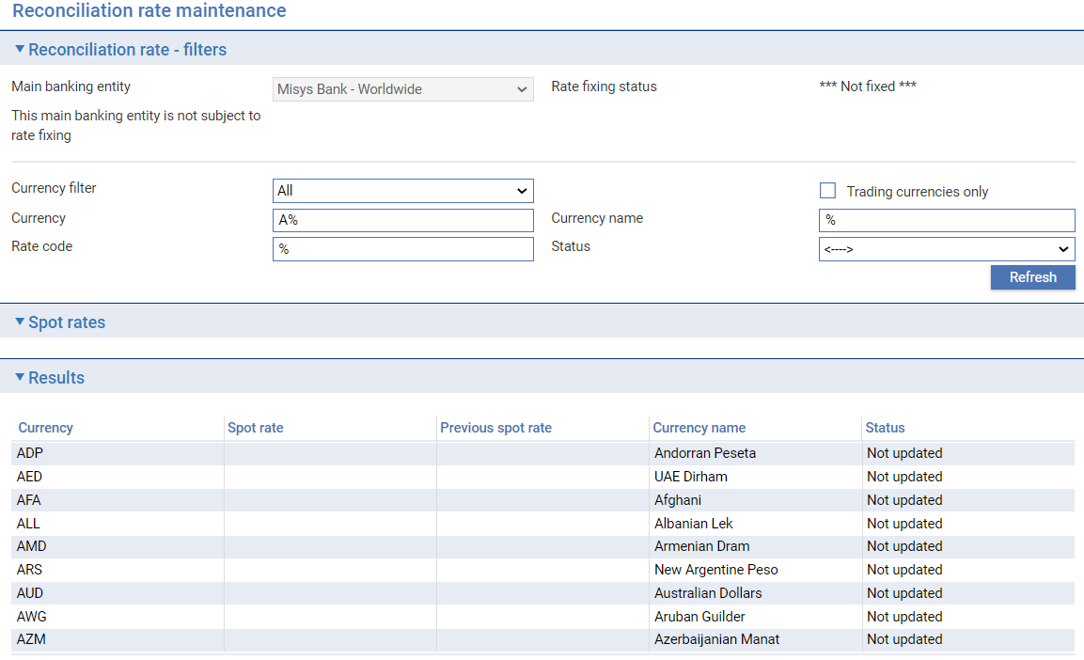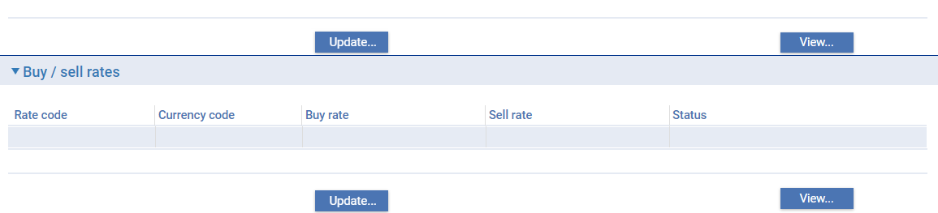

The window displayed allows a specific main banking entity to be selected and also displays the current Spot and Buy / Sell rates for the currencies set up on your system. You can use the filters on this window in the usual way to display rates for particular currencies.

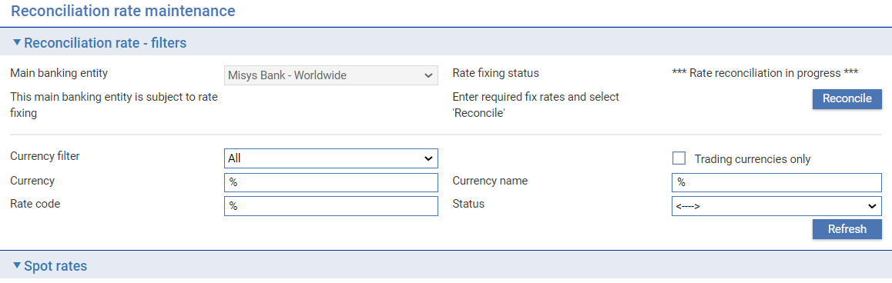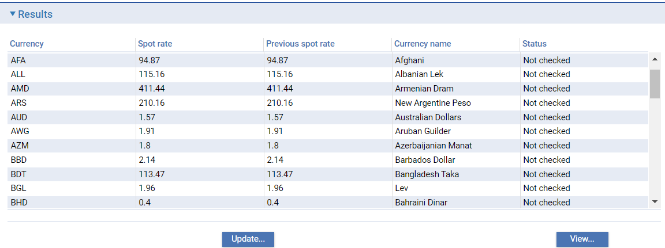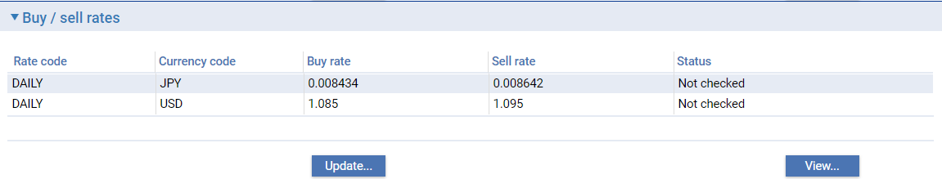The Status field indicates the status of each of the currencies shown. Possible values are:

|  |  |
| --- | --- |
| Not updated | The new rate has not been entered for reconciliation. |
| Not checked | The new rate has been entered but not checked. |
| Different | The new rate differs from the rate downloaded, entered using the static data application (that is, it has been amended). |
| Same | The two new rates entered have been reconciled. |

In this window you can re-enter and reconcile the new rates and then check them against the new rates that have already been downloaded or entered onto your system. This is an optional step.

Select each of the currencies whose rate has changed in turn and enter the new rate for it into the Spot Rate field. Click the **OK** button to save the new rate.

When you have made all the checks and changes required, click the **Reconcile** button. Trade Innovation checks the rate entered for each of the currencies in turn. Any currencies where the values do not match are highlighted – the Status column is set to ‘Different’.

If a mismatch is detected, you must decide which the correct value is.

If it is the value originally downloaded or entered using the static data maintenance application, then you need to enter that value here and re-run the reconciliation process.

If it is the value you have just entered, then the original value must be corrected:

* If it was downloaded from the back office, it must be corrected in the back office and re-transmitted. The FX rate fixing process remains paused until the FX rates are successfully reconciled
* If it was entered using the static data maintenance application's Currencies|Spot Rates or Currencies|FX Rates menu option, use this menu option again to enter the correct value.
* You can then re-initialise the FX rate fixing process from the start.

To accept the new rates click the **Confirm** button. Trade Innovation changes the status of your system to 'Fix Rates Set'. The new rates can now be applied to the events awaiting them. If your bank has defined any reports to support FX rate fixing, this is the point at which they should be run. Use the batch setup application’s Rate Fixing|Run Reports menu option.

Once you have completed reconciling the FX rates FX rate fixing can be undertaken as described in the next section.

### Running the FX Rate Fixing Process and Checking its Progress

In the Rate fix processing application | Rate fixing - Processing cycle selection screen, select the processing cycle for which you wish to reconcile rates and click the **Run rate fixing …** button.

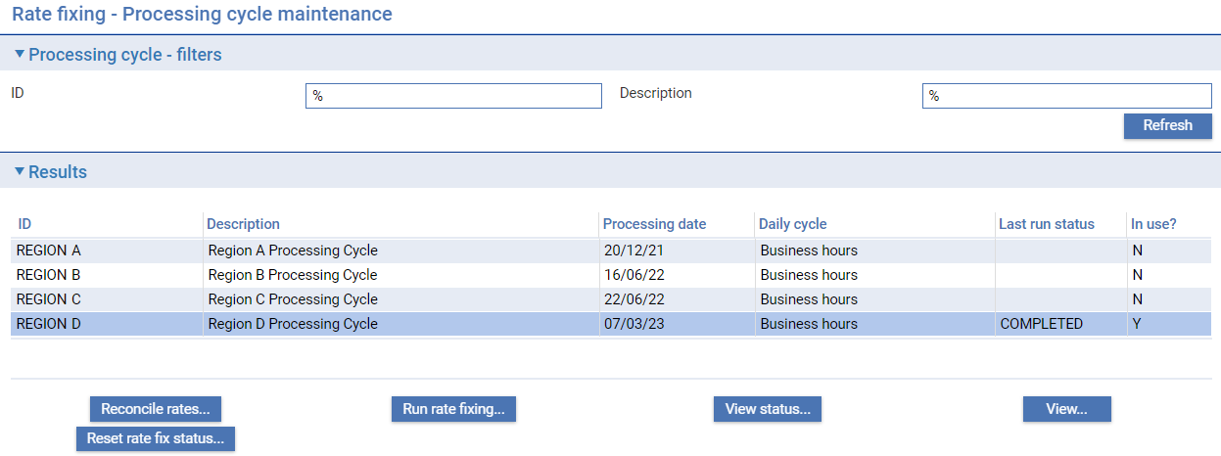

The FX rate fix status can be monitored in the FX rate fixing status screen. The rate fix status of each branch within each main banking entity is displayed, where rate fixing is being run. Where problems are encountered, this will be indicated against the particular MBE or transaction branch.

* Errors will cause the FX rate fixing process to fail. All transactions that could be updated will have been updated; those that could not will be detailed and will need to be fixed, as explained in the next section
* Warnings do not cause the FX rate fixing process to fail; the process will complete, but with warning conditions reported. These can also be fixed, as explained in the next section

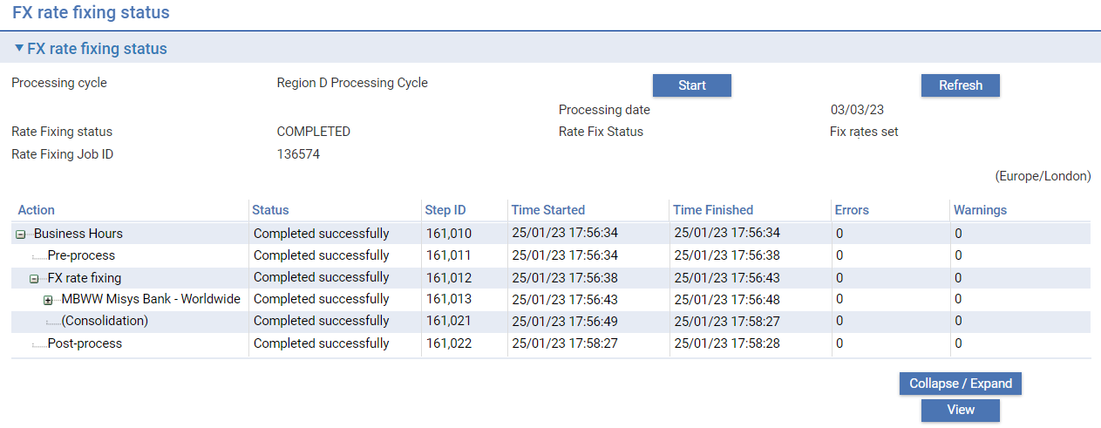

This window shows:

* The job ID of the FX rate fixing batch job (for troubleshooting purposes, should the job encounter problems)
* The status of the job
* The current processing date
* The status of FX rate fixing on this zone (it should be ‘Fix Rates Set’ at this point)

For each of the steps in the process it shows (amongst other information):

* The status of the step
* The step ID (for troubleshooting purposes, should the step fail)
* The time the step started and ended

When the FX rate fixing process has completed the Rate fix status is shown as ‘Completed’.

### If Problems Occur

Depending on whether you are running rate fixing during business hours or during the end of day process, the system indicates that problems have occurred. Errors and warnings are recorded against the MBE in which they occurred.

When running rate fixing during business hours, this is displayed in the FX rate fixing status window:

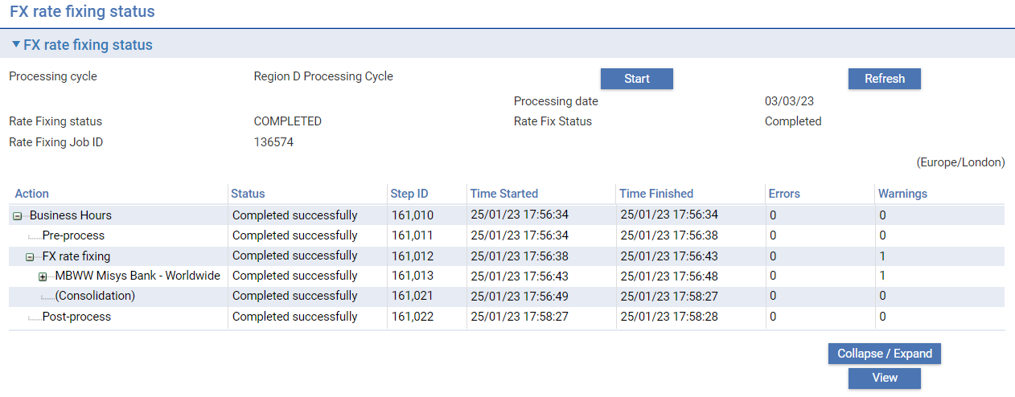

If you have scheduled rate fixing to run during the end of day process, the information is shown in the Batch job runner window:

To see full details of the error or warning, highlight the row where it is reported and click the **View** button.

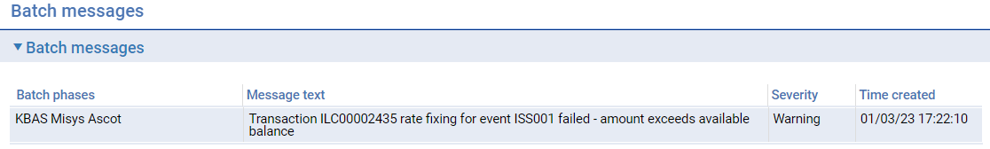

The window that is displayed provides further information about the error or warning.

#### For Errors and Warnings

A warning message is produced each time Trade Innovation is unable to successfully process a transaction awaiting rate fixing. The transaction must be amended using the transaction processing application accordingly.

The transaction processing application's diary facility informs users of transactions not processed as a result of rate fixing failure and this information is included on the Rate Fixing Batch Log within the business hours phase.

In each case you can open the relevant event using the transaction processing application and amend it as required.

If your system has the ExtendedRateFixingAllowed system option set to Yes, you will be able to amend certain details of foreign exchange deals at the Awaiting Rate Fixing step, or the manually entered negotiated rate. You can:

* Enter a new rate
* Enter a new rate code
* Waive or authorise the deal and amend the associated settlement instructions

Such deals are accessed by opening the event, then displaying the Settlements window. Select the settlements line showing the foreign exchange deal and click the **Edit** button to amend the rate code or the rate used, or waive the deal; and the Instructions button to amend the settlement instructions. For further details see the Common Facilities User Guide – Trade Innovation. For clean payments the deal may also be accessed from the main window.

Once you have corrected any errors you may resume the rate fix process. Trade Innovation will run only the FX rate fixing step (since FX rates will have already been reconciled, if required) and will apply it only to those transactions that caused errors.

When the FX rates have been successfully applied, Trade Innovation changes the rate fixing status to 'Completed'.

The Rate fixing application’s Rate fixing - Processing cycle selection screen includes a Reset rate fix status button that allows you to reset the status of FX rate fixing by MBE, from ‘Completed’ to 'Fix Rates Set', so that you can re-run the FX rate fixing process if required. Note that new rates may only be applied once a day though.

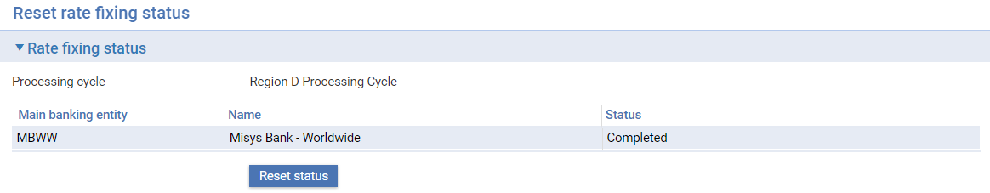

### Checking the Status of your System

Trade Innovation monitors the status of your system, permitting you to ascertain where in the daily rate fixing process your system is. It also prevents you from applying new rates more than once a day. The Rate fixing application’s Rate fixing - Processing cycle selection screen provides a ‘View status’ button that when clicked, shows the status, by MBE, of your system with regards to rate fixing.

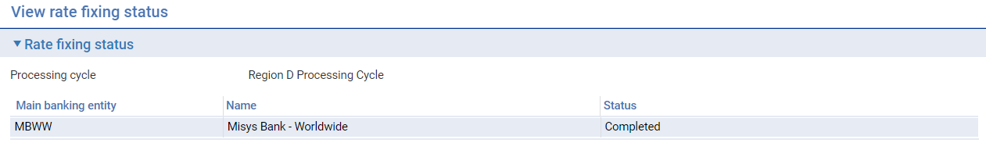

The table below lists the possible statuses of your system and explains what each means:

| **Rate Fixing Status** | **Internal Flag** | **What it Means** |
| --- | --- | --- |
| Not required | Q | Your system does not use the foreign exchange rate fixing facility- the Fixing Required flag is not set. |
| Not fixed | N | The new foreign exchange rates have not yet been entered on your system and reconciled for the current business day. |
| Fix rates set | F | The new foreign exchange rates have been entered onto your system and have been accepted by you as correct. |
| In progress | P | Indicates that the new foreign exchange rates are in the process of being applied to events awaiting the new rates. |
| Completed | C | Indicates that the process of applying the new foreign exchange rates has completed. |

1. EOD action FX Rate Fixing Reset Fix Next Day should also be mapped to the Start of Day or Start of Business Hours phase to reset the FX rate fixing status back to ‘Not fixed’ for the following day.

## Running FX Rate Fixing During Overnight Processing

When FX Rate Fixing action is run during overnight processing in End of Business Hours phase the FX rate fixing process proceeds automatically but may encounter problems that generate errors or warnings.

1. EOD action FX Rate Fixing Reset Fix Next Day should also be mapped to the Start of Day or Start of Business Hours phase to reset the FX rate fixing status back to ‘Not fixed’ for the following day.

#### For Errors

If an error message is produced under failing to successfully process a transaction awaiting rate fixing. Since the transaction processing application is unavailable during overnight processing, errors can only be resolved if you have the ExtendedRateFixingAllowed system option set to ‘Yes’. This system option may be used if your bank operates extended business hours processing. See the *System Tailoring User Guide* – Trade Innovation for more details.

If the system option is not used, errors can only be corrected during business hours.

Your bank must, therefore, configure the FX Rate Fixing action so that it can be bypassed if it fails and so does not halt overnight processing.

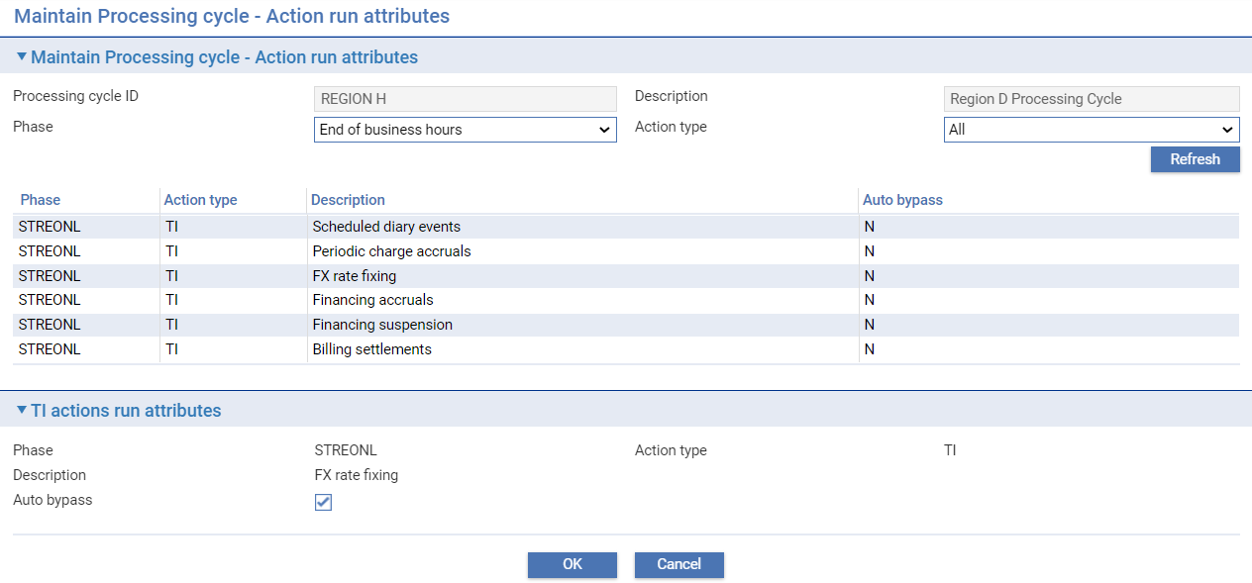

The transaction processing application's diary facility informs users of transactions not processed as a result of rate fixing failure, and this information is included on the End of Day Batch Log within the phase in which it is mapped.

It’s possible to view errors via the **View** button in the Batch job runner screen. Where an error is reported, highlight the row and click the **View** button.

#### For Warnings

If the FX Rate Fixing action encounters a problem that generates a warning message it will nevertheless continue to completion. The problem can then be addressed during business hours.

It’s possible to view warnings via the **View** button in the Batch job runner screen. Where a warning is generated, highlight the row and click the **View** button.

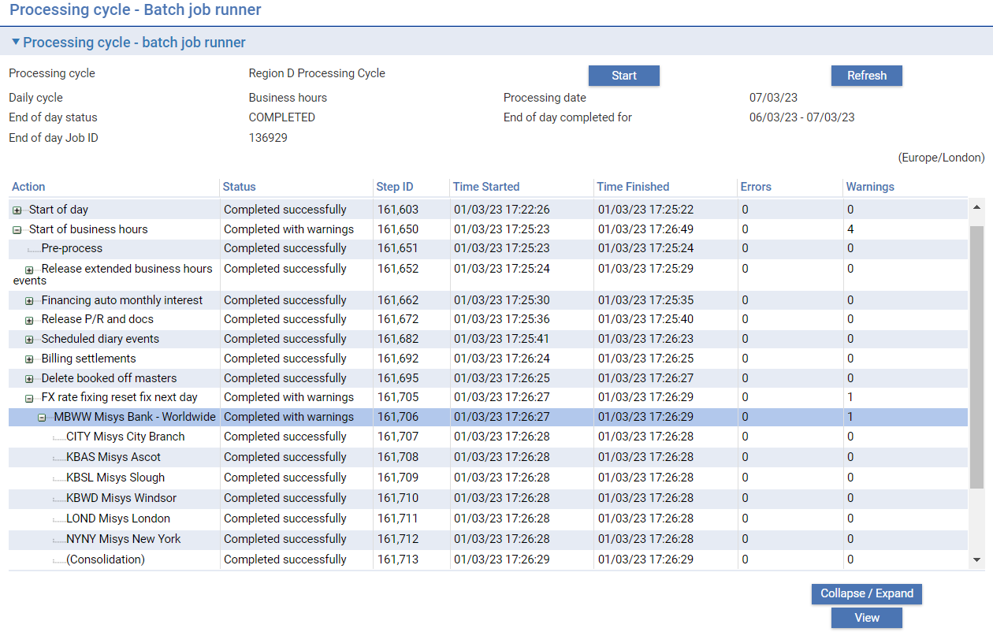

The reason why the warning was generated is displayed in the Batch Errors/Warnings screen that subsequently opens.

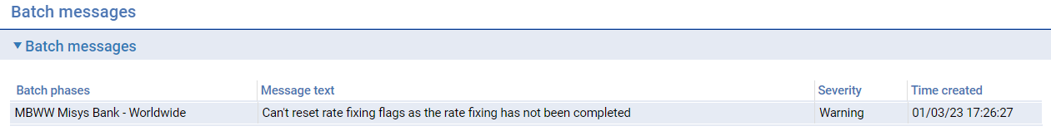

# Static Data Replication

Trade Innovation is delivered with a standard set of static data messages to permit you to download data to any corporate access system you support.

A single generic message is used to define the static data content to cover all Corporate Access Systems. It is the responsibility of the individual interfaces to accept, ignore or map data to their system as required.

This chapter explains how to use these static data messages to download static data to the e-Banking server. For instructions on how to amend the mappings of these messages see the Static Data Maintenance User Guide – Trade Innovation.

## Static Data Download Messages

Trade Innovation can be configured to download the following types of data to the bank’s Corporate Access Systems.

Basic static data:

* Account officers – details are downloaded to each corporate access system
* Account types – the following corporate access system option determines which account types are downloaded to the corporate access system
* GatewayAccountTypes – identifies account types. It can either be single (CV), or multiple (CV, CX, CY)
* Currencies – the following corporate access system options determines which currencies are downloaded to the corporate access system
* DownloadCurrencies – either Yes/No/End of Day only -- determines when currencies are downloaded to the corporate access system
* CurrenciesForGateway – a list defining the currency codes as part of currency and exchange rate static download. For example AUD, CAD, EUR, MAD
* Countries – details are downloaded to each corporate access system
* Customer types – details are downloaded to each corporate access system
* Code descriptions – language codes descriptions
* SCF programme sub-types – supply chain finance programme sub-types

Branch related data:

* Rate definition – the exchange rates held for each main banking entity. The bank can set the following system options for each corporate access systems
* DownloadFXRates – either Yes/No/End of Day only - determines when rates are downloaded to the corporate access system
* DownloadFXRatesFromBranch - whether exchange rates are to be downloaded from all main banking entities <ALL> or from one or more specified main banking entities
* Customers – the details of the customers who are users of the customer access system including address information and their customer types
* Accounts – the accounts that are downloaded are only those belonging to customer gateway interface service customers of the account type(s) specified using GatewayAccountTypes
* Pre-allocated references – details of references that have been assigned to a customer. The bank can set the following system option for each corporate access system
* SendPreallocatedReferences – either Yes/No/End of Day only - determines when references are downloaded to the corporate access system

Supply Chain Finance data:

* The following system options are used to control the downloading of data
* DownloadSCFProgrammeChanges – controls whether details of a specific data that are related to supply chain finance programmes (i.e. sub-types, buyers, sellers, relationships) are to be downloaded and sent to corporate access system.
* DownloadSCFProgrammesFromBranch – defines the source banking business from which the supply chain finance programme is required by corporate access system.

The following data can be downloaded:

* SCF buyers/sellers – supply chain finance buyers and sellers
* SCF programme – supply chain finance programmes
* SCF programme subtype – supply chain finance programme sub-types
* SCF relationship – supply chain finance buyer/seller relationships

Data is automatically downloaded to the relevant corporate access system(s) whenever a data item of the types listed above is updated (unless the system option is set to End of Day only).

Currency, Exchange rates and Pre-allocated references will be downloaded to the Corporate Access system during the end of day processing cycle for the relevant main banking entities where EOD only is set for the Corporate access system and the following batch actions are set:

* Currency download
* Exchange rate download
* Pre-allocated reference download

## Defining Message Mappings

The Download|Define Static Data Messages menu option allows you to add or amend the mappings of static data messages.

When you select the option a window is displayed which lists the static data messages.

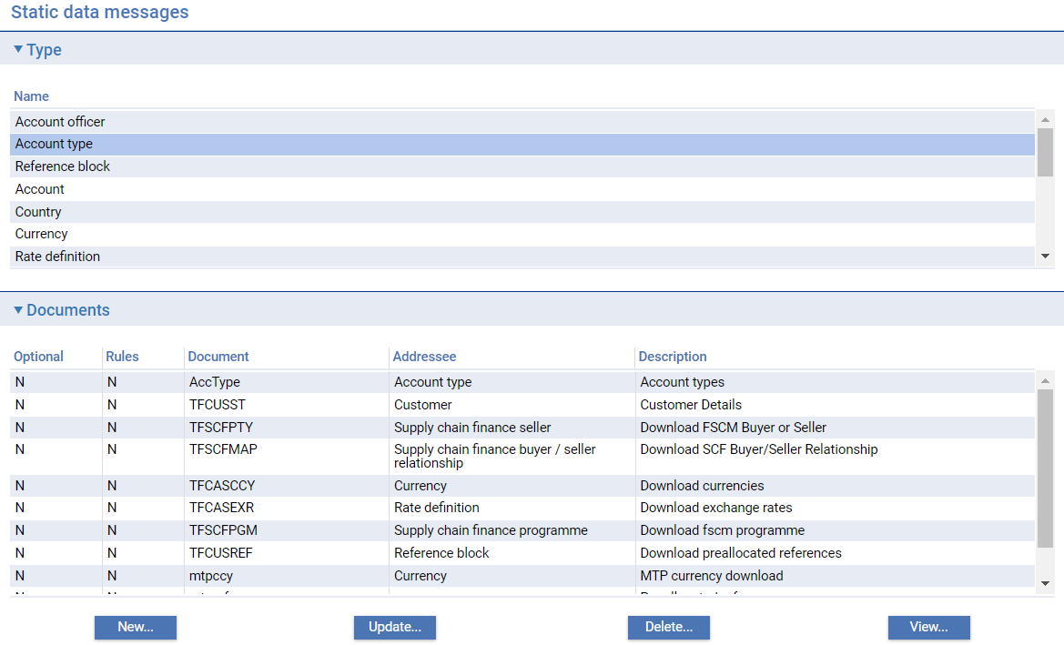

For each message the window shows the following information:

|  |  |
| --- | --- |
| Optional & Rules | Not applicable |
| Document | The unique ID of the message. |
| Addressee | Indicates the type of data the message is used to download. |
| Description | The message's description. |

If you select a message in the Documents column and click **Delete**, the message is removed and subsequently listed in the Type column.

To change a message's mapping select it from the Documents list and click **Update**. The window that appears permits you to view and amend the message's mapping.

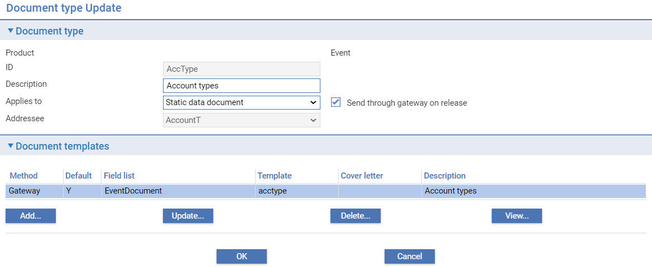

Leave the Send Through Gateway On Release field checked.

Select the item in the Document Templates column and click **Update** to view details of the message content.

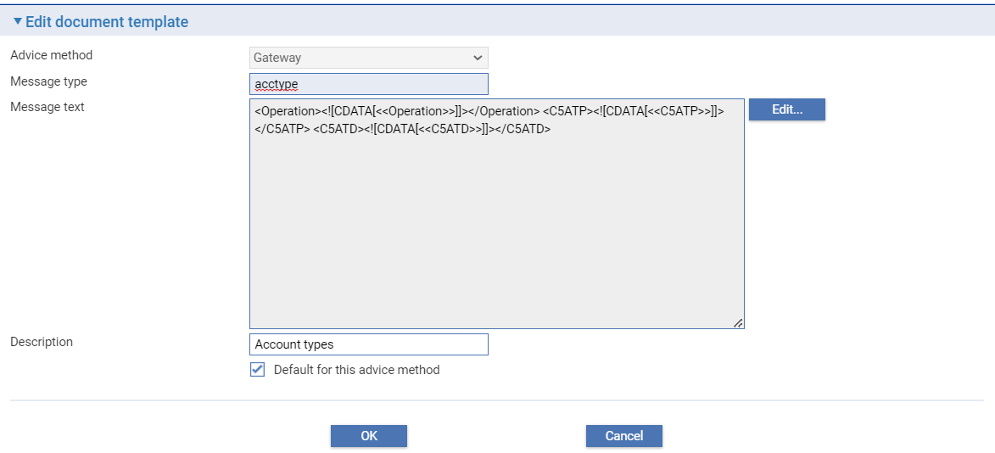

Leave the Default for This Advice Method checked. Click **Edit** to view details of the content of the message.

You can add items to the list of fields included in the message definition by selecting the item in the Description field and clicking **Add**. Click **OK** to save any changes you make.

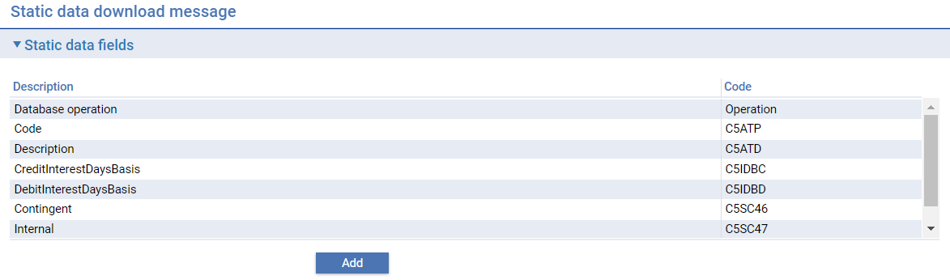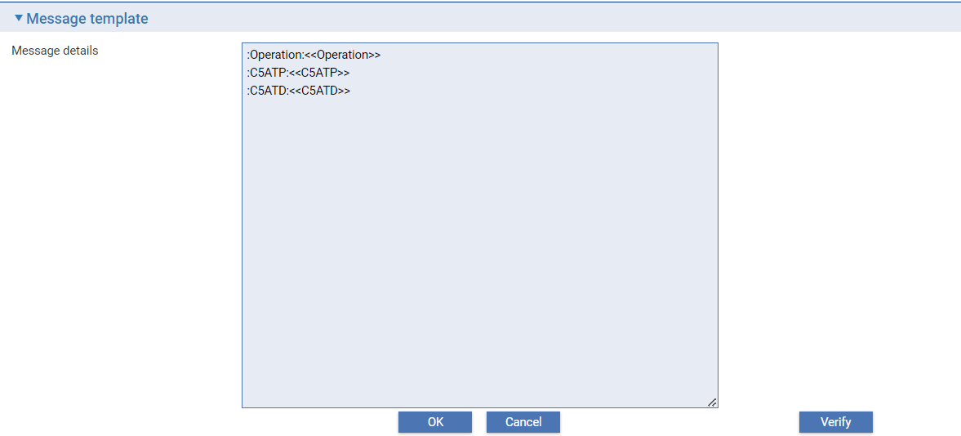

The **Verify** button allows you to confirm the message definition structured correctly.

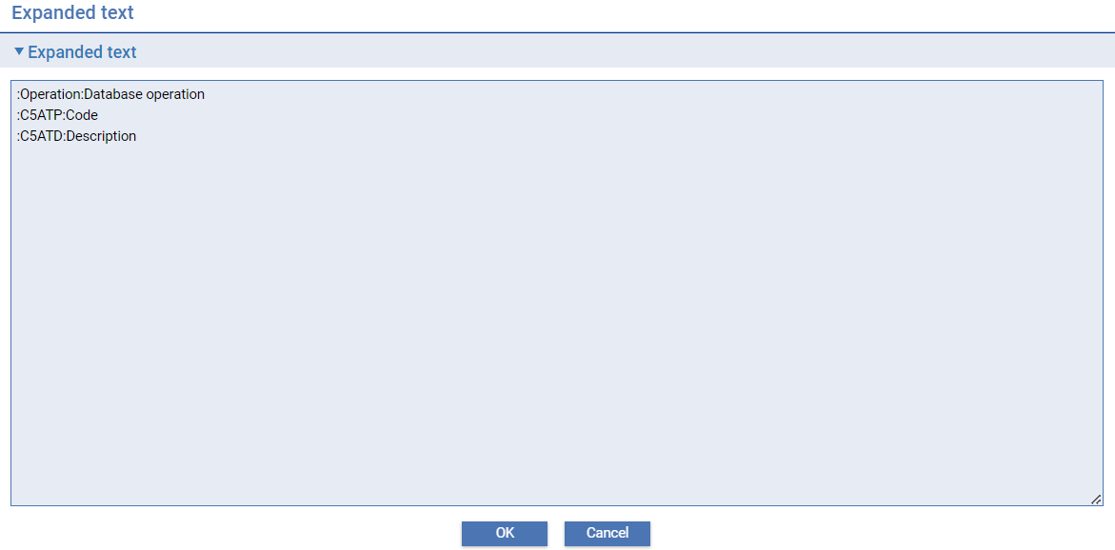

## Download Static Data

You can download static data using the static data application'sDownload|Download Static Data menu option, for example, to download data for the first time.

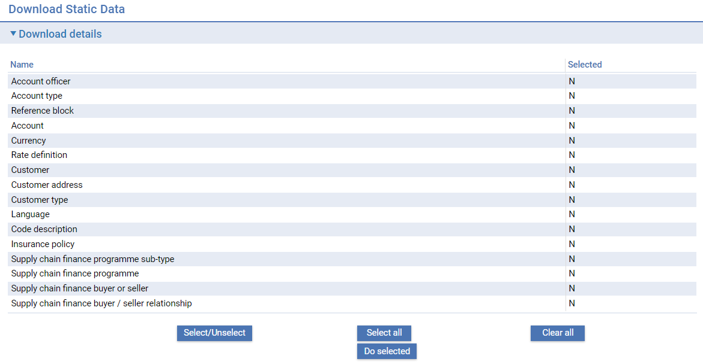

You can use the **Select** buttons to select the one or more items that you want to download and then Do selected. You will be prompted to confirm you want to proceed.

## Viewing Downloaded Static Data

The Gateway Message Out manager allows you to view all outgoing static data messages.

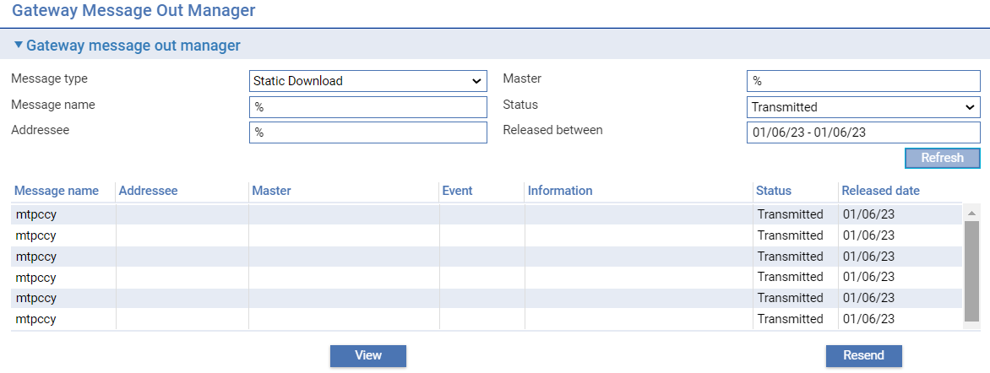

The filter fields allows you to select items matching the following:

Message name – if not specified all message types will be displayed

Status:

* Awaiting transmission
* In progress
* Transmitted
* Resent
* Failed
* Date range

The **Resend** button can be used to resend a failed message.

The **View/Edit** button allows the item to be viewed and printed.

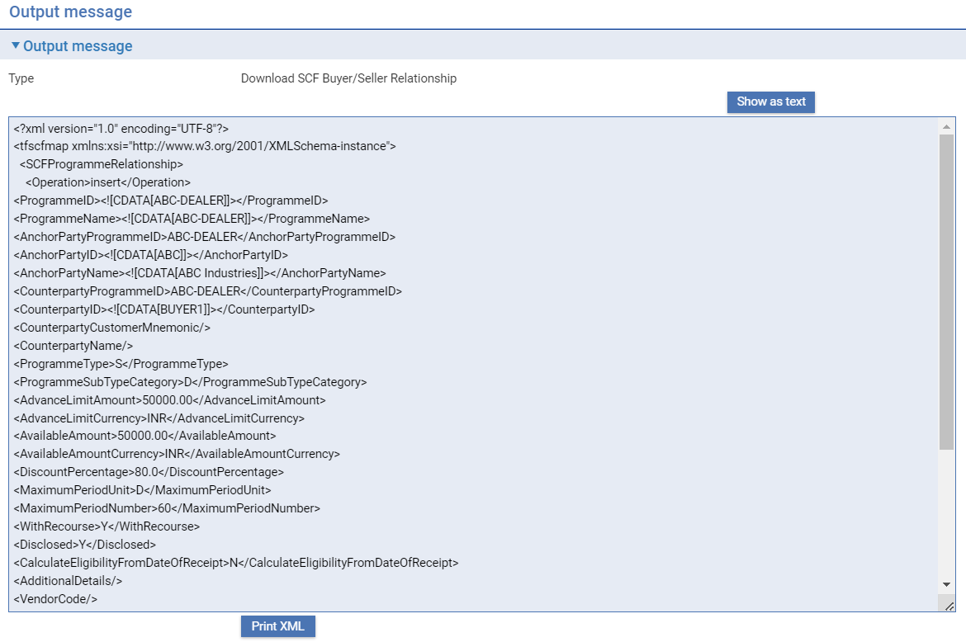

# Async Framework

## Control

By default, the Async framework is active when the application is running. It is possible to stop the Async framework while the application is still running. While stopped, jobs may still be submitted, but they will not execute. Once the Async framework is started, all waiting jobs will then be processed based on time submitted.

If the Async framework is stopped, and the application is restarted, the Async framework remains stopped, and must be started manually.

## Monitor

If the async monitor is enabled, it will run on a configured frequency looking to see if there are any stalled jobs, and if found, verifying if the job is actually still in progress. If a job is encountered where one or more steps are still in progress, but the steps are not actually registered as running, then the step status will be reset, and so re-submitted to continue where they left off.

An example where this could benefit is where the application is running in a clustered environment, and while some jobs are running, one of the server nodes fails. With the monitor active, any step that was running on that server will have their status reset and the job will continue running.

The behaviour is equivalent to cancelling an executing step and then retrying it.

## Restart Behaviour

When the application restarts, it is possible to configure the Async framework to automatically reset the configuration of any executing jobs so that they will continue where they left off.

If the Async framework was stopped before the application was restarted, then it will always remain in a stopped state upon restart.

If the application is deployed to a clustered environment, then a restart means that all servers in the cluster are stopped and then started. Restarting individual servers in the cluster will not trigger the resetting mechanism. This scenario is covered by the async framework monitor.

## Async Framework Enquiry

The Async framework enquiry provides a generic view of all types of job being managed by the Async framework. Ordinarily, those jobs submitted to the async framework have their own dedicated enquiry, which should be used where possible. For instance, an end of day is monitored through the Batch Runner.

The enquiry is available from the About page if the user has the capability ViewAsyncJobs assigned to them. When the link is taken, the Async Framework – Job Enquiry is shown.

1. The ViewAsyncJobs capability is available only for users with admin level roles including OPERATOR, SYS_ADMIN, USER_SECURITY, HELPDESK, and USER_ADMIN. It is not available to users with the Normal User role.

### Control

The async framework may be stopped and started while the application is running. In the Job Enquiry and the Step Enquiry, there is a section for controlling the state of the async framework.

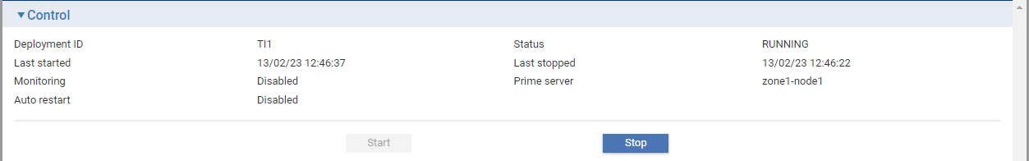

The details shown are:

| **Field** | **What it Shows** |
| --- | --- |
| Deployment ID | The deployment identifier |
| Status | The status of the async framework. This can be one of   * RUNNING * STOPPING * STARTING * RESETING * STOPPED |
| Last started | Time the Async framework was last started |
| Last stopped | Time the Async framework was last stopped |
| Monitoring | Async framework monitor status |
| Prime server | The server that acts as the decision maker while the Async framework monitor is active |
| Auto-restart | Auto restart status |

### Job Enquiry

When you access the Async framework enquiry, you are shown a list of the jobs that exist.

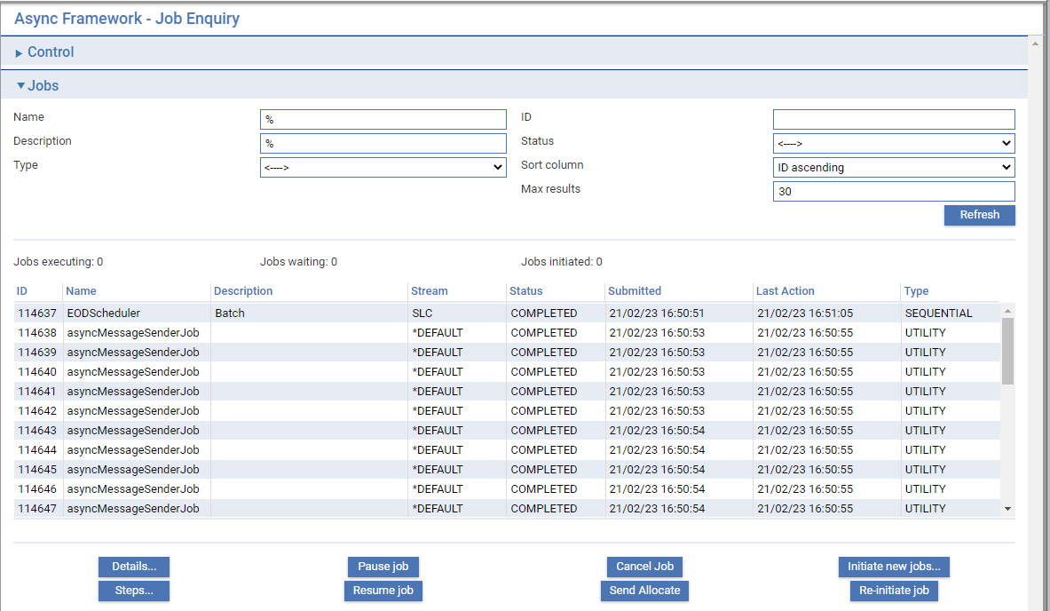

For each job it shows:

| **Heading** | **What it Shows** |
| --- | --- |
| ID | The unique job number. |
| Name | The name of the job. |
| Description | A description of the job. |
| Stream | What context the job will run in. For instance, sequential jobs cannot run at the same time if they are in the same stream. |
| Status | Status of the job. This can be one of:   * INITIATED * WAITING * EXECUTING * PAUSING * PAUSED * COMPLETED * FAILING * FAILED * CANCELLING * CANCELLED |
| Submitted | The time that the job was submitted. |
| Last Action | This is the time that something last happened to the job – for instance when the last step finished. |
| Type | The type of job. This can be one of:   * PARALLEL * SEQUENTIAL * UTILITY   Parallel jobs can run at the same time as other parallel jobs in the stream. Sequential jobs cannot run if any other parallel or sequential job is running in the stream. Utility jobs can run at the same time as other parallel or sequential jobs in the same stream. |

To find a particular job you are interested in, the following filters may be defined:

|  | **Filter** | **What to Enter** |
| --- | --- | --- |
|  | Name | Name of the job. |
|  | ID | Unique job number. |
|  | Description | Job description. |
|  | Status | Status of the job. |
|  | Type | The type of job. |
|  | Max results | Maximum number of rows to return. |

Once filter values have been entered, click the **Refresh** button to display the results.

When you have identified the job you are interested in, you can perform the following actions by selecting the row and clicking the relevant button.

| **Button** | **What it does** |
| --- | --- |
| Details… | This will display the full details of the selected job. |
| Pause job | This will initiate a request to pause a job that is currently executing. The job state will change to PAUSING, and once all steps that are currently executing complete, the job status will change to PAUSE. |
| Cancel job | For an executing job, this will initiate a cancel request for each step currently executing. The job state will change to CANCELLING, and once the currently executing steps have completed or acknowledged cancellation, the job state will be changed to CANCELLED. |
| Initiate new jobs… | This is a utility function which should only be used as directed by Finastra when needed. |
| Steps | This will display the Step enquiry for the selected job. |
| Resume job | Any job that is currently paused will change to a WAITING state until these are resources available to continue job execution. At this point, the job state changes to EXECUTING, and any steps that are eligible to start will be started. |
| Send Allocate | Send or allocate the job |
| Re-initialise job | Restart the job |

To exit from this enquiry, click the **Close** link on the left hand side of the page.

### Job Details

This enquiry shows the full details of the selected job.

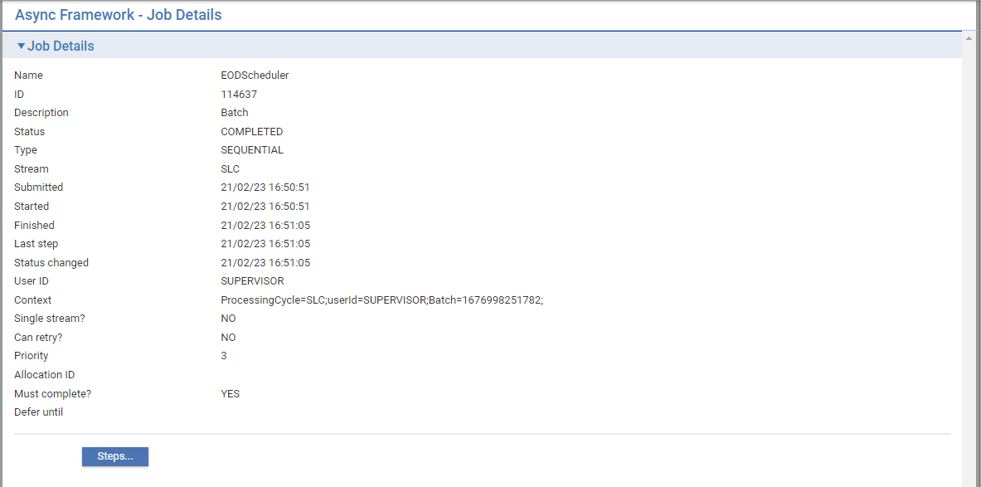

The information shown is as follows:

| **Field** | **What it Shows** |
| --- | --- |
| Name | Name of the job |
| ID | The unique job identifier |
| Description | The job description |
| Status | Status of the job. This can be one of:   * INITIATED * WAITING * EXECUTING * PAUSING * PAUSED * COMPLETED * FAILING * FAILED * CANCELLING * CANCELLED |
| Type | The type of job. This can be one of:   * PARALLEL * SEQUENTIAL * UTILITY |
| Stream | What context the job will run in. For instance, sequential jobs cannot run at the same time if they are in the same stream. |
| Submitted | The time that the job was submitted |
| Started | The time that the job started |
| Finished | The time that the job finished |
| Last step | The time the last step completed (others could still be running) |
| Status changed | The time that the status of the job last changed |
| User ID | User associated with the job |
| Context | Context information required by the job |
| Single stream? | Does the job only require a single execution slot to execute? This applies to jobs with a single step, or a set of steps that must be executed in sequence. |
| Can retry? | If the job fails, is it possible for the job to be re-attempted? Some jobs can be run multiple times without the effect of the job being repeated. |
| Priority | The priority of the job – the higher the number the higher the job priority, and the sooner it will be considered for execution. |
| Allocation ID | For an executing job, this is the identifier associated with the resources allocated to the job. These resources may change over the lifetime of the job. |
| Must complete? | A job must continue to the COMPLETED state before another job of the same type is executed in the stream. If a job fails, it must be retried until it completes. |
| Defer until | If the job cannot complete at this time, it may be postponed and re-attempted after a period of time. This is the time that the job will next be available to be executed. |

The **Steps...** button may be clicked, which will navigate to the Step Enquiry for this job. To exit from this enquiry, click the **Close** link on the left hand side of the page. This will return you to the Job Enquiry.

### Step Enquiry

For a given job, this enquiry will show all of the steps that must be executed in order for the job to complete.

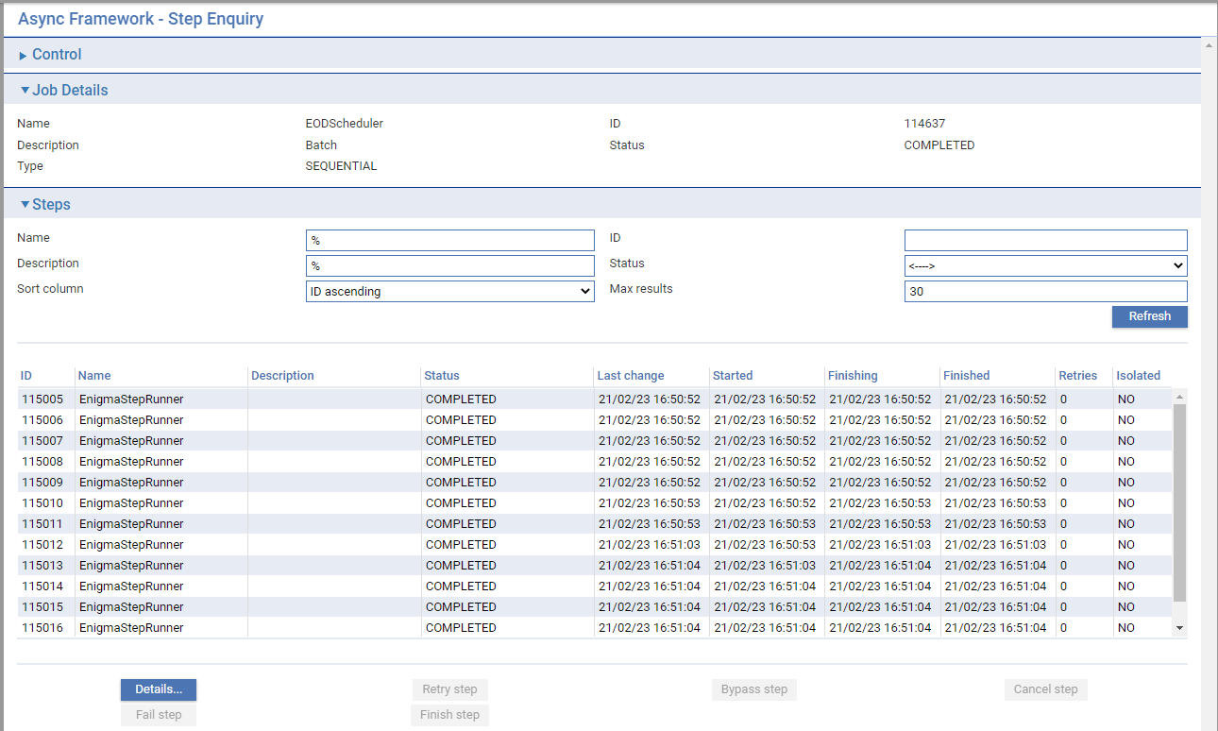

For the job the following details are shown:

| **Field** | **What it Shows** |
| --- | --- |
| Name | Name of the job |
| ID | The unique job number |
| Description | The job description |
| Status | The job status |
| Type | The type of the job |

For each step, the following details are shown:

| **Heading** | **What it Shows** |
| --- | --- |
| ID | The unique step number - this is unique across jobs rather than within them. |
| Name | Name of the step |
| Description | The step description |
| Status | The step status. This can be one of:   * INITIATED * DISPATCHED * EXECUTING (server where step is running) * WAITING * ELIGIBLE * COMPLETING * COMPLETED * FAILING * FAILING_NO_RETRY * FAILED * FAILED_NO_RETRY * CANCELLING * CANCELLED * BYPASSED * BYPASSING * POSTPONING |
| Last change | The time that the step indicated that it had done something. For some long running steps, after processing a certain number of items, this time is updated to provide an indication that the step is still processing items. It is during these updates that a check is made to see if the step has been requested to cancel. |
| Started | The time the step started |
| Finishing | The time the step processing finishes |
| Finished | The time the step completed |
| Retries | The number of times a step has been retried |
| Isolated | Does this step need to be run when no other steps are running? |

To find a particular step you are interested in, the following filters may be defined:

|  | **Field** | **What to Enter** |
| --- | --- | --- |
|  | Name | The name of the step |
|  | ID | The unique step number |
|  | Description | The description of the step |
|  | Status | The step status |
|  | Sort column | The column used for sorting:   * ID descending * ID ascending * Last change descending * Last change ascending * Started descending * Started ascending * Finished descending   Finished ascending |
|  | Max results | The maximum number of rows to return |

Once filter values have been entered, click **Refresh** to display the results.

When you have identified the step you are interested in, you can perform the following actions by selecting the row and clicking the relevant button.

| **Button** | **What it does** |
| --- | --- |
| Details… | Displays the full details of the selected step. |
| Retry step | For a step that has failed or has been cancelled, this will cause the step to execute again. |
| Bypass step | For a step that has failed or has been cancelled, this will cause the step to be marked as BYPASSED and the next step will be executed. |
| Cancel step | For an executing step, this will request the step to be cancelled. If the step is long running, and updates its progress every so often, it will react to the cancellation request and finish where it is up to. The step status will then become CANCELLED. If a step does not update its progress, then it will simply continue until it is complete. |
| Fail step | In cases where a step is marked as EXECUTING, but it is known that nothing is running for that step, it may be marked as failed. In this case the state of the step will become FAILED_NO_RETRY. |
| Finish step | Where a step is in one of the following states:   * CANCELLING * COMPLETING * BYPASSING * FAILING * POSTPONING   And if you know that the step is not executing, and there is no backlog on the job execution queue, then this action will send the message to finish the step again, and so help the job to continue. |

To exit from this enquiry, click the **Close** link on the left hand side of the page. This will navigate back to the Job Enquiry.

### Step Details

This enquiry will show the full details of the step.

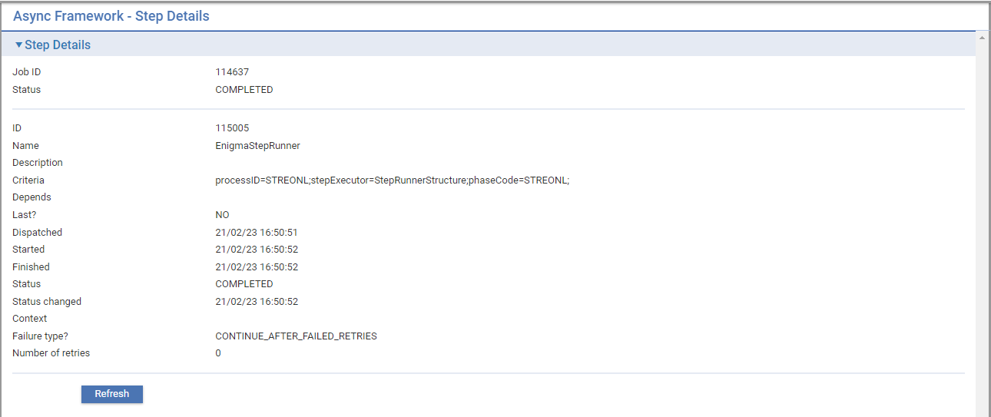

The information shown is as follows:

| **Field** | **What it Shows** |
| --- | --- |
| **Job Details** |  |
| Job ID | The unique job number |
| Status | The status of the job |
| **Step Details** |  |
| ID | The unique step number |
| Name | The name of the step |
| Description | The step description |
| Criteria | Criteria associated with the step. For instance a step mat be focused to execute for a particular branch. The criteria may contain the branch mnemonic. |
| Depends | The unique step number of the step that must finish before his step starts. |
| Last? | If set to Y, then where multiple steps depend on the same step to complete, the step with this set will execute last of that set. |
| Dispatched | The time the step was allocated to start |
| Started | The time the step started |
| Finished | The time the step finished |
| Status | The step status. This can be one of:   * INITIATED * DISPATCHED * EXECUTING (server where step is running) * WAITING * ELIGIBLE * COMPLETING * COMPLETED * FAILING * FAILING_NO_RETRY * FAILED * FAILED_NO_RETRY * CANCELLING * CANCELLED * BYPASSED * BYPASSING * POSTPONING |
| Status changed | The time the step status changed last |
| Context | This contains the context of the step when it completed. This may contain information that will be available to subsequent steps. |
| Failure type? | If this step fails, will it cause the job to fail or will it be automatically bypassed? |
| Number of retries | The number of times a step has been retried |

# Configuring Audit and Diagnostic Log Files

This chapter explains how to set the logging level used to record information about the system for auditing and use in analysing problems.

## Log Files

As Trade Innovation runs, it writes information to log files. These log files provide

* Audit information associated with your system
* Diagnostic information used by your local Finastra support branch to help identify problems with your system.

Trade Innovation logs messages generated by the application servers to two files in a central location. These are:

* Audit logs, which primarily contain the security-based events– alternately extended security logs may be enabled which cover a wider set of events
* Local system logs which contains activity logs specific to the deployment

The logging is defined in configuration files (log4j.xml) which are inside the installed package. This may be overridden for each deployment – see the *Installation Guide* – Trade Innovation for more details.

The log files have the following names, by default.

For the global application:

* platform-global-audit.log or platform-global-extended-audit.log
* platform-global-local.log

For each deployment:

* platform-deployment-audit.log or platform-deployment-extended-audit.log
* platform-deployment-local.log

The following additional file is also present for deployments:

* platform-deployment-async.log

It is used for logging just for the async framework.

There is another file that can be produced:

* platform-deployment-local-all-exceptions.log

This file contains all exceptions (if the correct log level is set) regardless of whether they are suppressed in the application. This is a switchable feature and may be useful for diagnosing issues.

The log files contain lists of messages and hold the following information for each message:

* Date and time of the message
* Log level
* Context information e.g. user, server, zone, session where appropriate
* The package/class which issued the message
* The message itself

## Audit Logs

The purpose of the audit logs is to provide an indication that something has happened, and where a user is involved, who they were. They are not intended to provide full information about the event.

Trade Innovation has two forms of audit logs – a default format and an extended format.

The default format covers Security and application events, whereas the extended format covers much more user interaction with the application.

If the extended audit log is enabled, then no entries are produced for the default audit log.

For information on enabling the extended audit log, see the *Installation Guide – Trade Innovation*.

### Default Audit Log Files

Audit entries in the audit log files are enabled by defining the **com.misys.tiplus2.audit** log category at INFO level. See next main section for details on setting logging levels.

The entries captured in audit log files are in the categories:

* Software licensing events
* Security events
* Application events

#### Software Licensing Events

The following events are recorded in the audit log to do with software licensing (logged at INFO level unless otherwise stated):

* License obtained
* License released
* Value published against a license
* Volume published against a license
* Volume or value threshold breached for a license
* A license is due to expire (warn) – from 30 days prior
* A license has expired (error)

#### Security Events

The following events are recorded in the audit log to do with security (logged at info level):

* User has successfully logged in to the global application
* User has logged out of global application
* User session has timed out from global application
* User has been forced to log off
* User has failed to login
* User has successfully logged in to the zone access application
* User has logged out of the zone access application
* User profile has been created
* User profile has been updated
* User profile has been deleted
* User password has changed

#### Application Events

The following events are recorded in the audit log to do with application server events (logged at INFO level):

* Application server started
* Application server shutdown

### Extended Audit Log Files

Entries in the extended audit log files are enabled by defining the **audit** log category at INFO level. See Setting the Logging Levels section for details on setting logging levels.

The extended audit logs are intended more to be used with central log monitoring tools. Their format is delimited, so these type of tools can break down the content more easily. Each log entry is produced on a single line.

The default delimiter is the ‘|’ character and is used in the log pattern supplied with the log4j.xml configuration file. This layout pattern is:

* Date/time
* Category
* Message
* Named property values
* Logging context values

The category is defined in three parts:

audit.<group>.<area>

There are five groups:

* administration – covers static data and system configuration
* security – covers security events such as logging in, logging out, changing passwords etc.
* business – covers updates to business transactions through the event workflow steps
* errors – these relate to errors encountered while trying to process transactions. These currently cover errors encountered when parsing incoming XML requests or responses
* exceptions – whenever an exception is logged as an error or warning, the message associated with the exception is logged in this category

Areas within groups are:

| Audit | Group | Area | Description |
| --- | --- | --- | --- |
| audit | administration | batch | Journal entries for batch |
| control | Journal entries for control |
| limits | Journal entries for departmental limits |
| security | journal entries for security as well as global user admin functions |
| mc.action | Journal entries for maker checker authorisations/rejections |
| mc.branch | Journal entries for maker items at branch level |
| mc.customer | Journal entries for maker items at customer level |
| mc.zone | Journal entries for maker items at zone level |
| static | Journal entries for static data |
| swift | Journal entries for swift |
| system | Global functions for system definition |
| tailoring | Journal entries for system tailoring |
| security | access | Login, logout, change password |
| license | Software license items |
| system | System startup/shutdown |
| business | event-step | Event step changes |
| process | Journal entries for process |
| validation | Journal entries for validation |
| errors | messages | Errors parsing incoming messages and responses |
| exception | unexpected | Unexpected exceptions |
| warning | warnings |

# Appendix A - SWIFT Messages Types Supported by Trade Innovation

This appendix contains two tables:

* The first lists all SWIFT message types supported by the system
* The second lists incoming messages that can create a new master record

These tables show the default values delivered with the system.

## SWIFT Message Types Supported by Trade Innovation

The table in this section lists all SWIFT message types supported by Trade Innovation. For each inward message type supported the table shows the events it can be used to create.

In the table:

* An asterisk (*) indicates that an inward message creates a master record
* Two asterisks (**) indicates a general message
* A tick () in the Default column indicates that an inward message has an automatically-processed default event. The default event itself is the first listed for that message

| **SWIFT Message** | | **Events it Can Create** | **Default** |
| --- | --- | --- | --- |
| 103 | Single Customer Credit Transfer | Create payment (inward customer payment)  Payment rejection/return (outward customer payment) | P3515C7T63#yIS1 |
| 110* | Advice of Cheque | Create cheque (inward cheque)  Cheque rejection/return (outward cheque) | P3521C11T63#yIS1 |
| 111 | Request to Stop Cheque | Stop cheque request (inward cheque) | P3526C15T63#yIS1 |
| 112 | Response to Stop Request | Stop cheque response (outward cheque) | P3531C19T63#yIS1 |
| 190 | Advice of charges, interest and other adjustments | Maintain charges (inward customer payment)  Maintain charges (outward customer payment) |  |
| 191 | Request for payment of charges, interest and other expenses | Maintain charges (inward customer payment)  Maintain charges (outward customer payment) |  |
| 192 | Request to Cancel Payment | Cancel payment request (inward customer payment) | P3548C31T63#yIS1 |
| 195** | General or payment rejection messages | Correspondence (inward cheque)  Correspondence (inward customer payment)  Correspondence (outward cheque)  Correspondence (outward customer payment) |  |
| 196** | Answers | Correspondence (inward cheque)  Continue payment (inward customer payment)  Correspondence (outward cheque)  Cancel payment response (outward customer payment) | P3564C39T63#yIS1 |
| 198** | Proprietary Message | Correspondence |  |
| 199 | Free format message | Create (free correspondence)  Correspondence (inward cheque)  Correspondence (inward customer payment)  Correspondence (outward cheque)  Correspondence (outward customer payment) | P3578C47T63#yIS1 |
| 199 | Universal Confirmation message | Create Payment (Inward customer payment)  SWIFT GPI Tracer (Inward customer payment)  Payment Rejection/Return (Outward customer payment)  SWIFT GPI Tracer (Outward customer payment)  Payment Rejection/Rtn (Standing Order)  SWIFT GPI Tracer (Standing Order) |  |
| 200 | Financial Institution Transfer for its Own Account | Create bank payment (inward bank payment)  Payment rejection/return (outward bank payment) | P3599C55T63#yIS1 |
| 201 | Multiple Financial Institution Transfer for its Own Account | Split and processed as component MT200s | P3604C59T63#yIS1 |
| 202 | General Financial Institution Transfer | Create bank payment (inward bank payment)  Payment rejection/return (outward bank payment) | P3610C63T63#yIS1 |
| 203 | Multiple General Financial Institution Transfer | Split and processed as component MT202s | P3615C67T63#yIS1 |
| 205 | Financial institution transfer execution | Create bank payment (inward bank payment)  Payment rejection/return (outward bank payment) | P3621C71T63#yIS1 |
| 210 | Notice to receive | (Trade Innovation supports outward messages only) | P3626C75T63#yIS1 |
| 290 | Advice of charges, interest and other adjustments | Maintain charges (inward bank payment)  Maintain charges (outward bank payment) |  |
| 291 | Request for payment of charges, interest and other expenses | Maintain charges (inward bank payment)  Maintain charges (outward bank payment) |  |
| 292 | Cancellation request | Cancel payment requested (inward bank payment) | P3643C87T63#yIS1 |
| 295 | Queries | Correspondence (inward bank payment)  Correspondence (outward bank payment) | P3649C91T63#yIS1 |
| 296 | Answers | Continue bank payment (inward bank payment)  Cancel payment response (outward bank payment) | P3655C95T63#yIS1 |
| 298** | Proprietary Message | Correspondence |  |
| 299 | Free format text | Create (free correspondence)  Correspondence (inward bank payment)  Correspondence (outward bank payment) | P3667C103T63#yIS1 |
| 400 | Advice of payment | Outward payment (collection order)  Inward payment (collection order)  Outward payment (cash letter)  Inward payment (cash letter) | P3675C107T63#yIS1 |
| 410 | Acknowledgement | Receive acknowledgement (collection order) | P3680C111T63#yIS1 |
| 412 | Advice of acceptance | Acceptance (collection order) | P3685C115T63#yIS1 |
| 416 | Advice of non-payment/non-acceptance | Non Acceptance/Payment (collection order) | P3690C119T63#yIS1 |
| 420 | Tracer | Correspondence (collection order) | P3695C123T63#yIS1 |
| 422 | Advice of fate and request for instructions | Correspondence (collection order) | P3700C127T63#yIS1 |
| 430 | Amendment of instructions | Amend (collection order) | P3705C131T63#yIS1 |
| 450 | Cash letter credit advice | Settlement (Inward cash letter) |  |
| 455 | Cash letter credit adjustment advice | Settlement (Inward cash letter) |  |
| 456 | Advice of dishonour | Settlement (Inward cash letter) |  |
| 490** | Advice of charges, interest and other adjustments | Maintain charges (collection order)  Manual bookkeeping (collection order) |  |
| 491** | Request for payment of charges, interest and other expenses | Manual bookkeeping (collection order)  Manual bookkeeping (collection order) | P3732C151T63#yIS1 |
| 495** | Queries | Correspondence (inward documentary collection order) | P3737C155T63#yIS1 |
| 496** | Answers | Correspondence (inward documentary collection order) | P3742C159T63#yIS1 |
| 498** | Proprietary Message | Correspondence (collection order) |  |
| 499** | Free format message | Correspondence (collection order, inward and outward cash letter, and shipping guarantee)  Create (free correspondence)  Settlement (inward and outward cash letter)  Free correspondence | P3755C167T63#yIS1 |
| 700/ 701* | Issue of documentary credit | Advise (export letter of credit)  Advise (export standby letter of credit)  Create (free correspondence) | P3762C171T63#yIS1 |
|  |  | Issue (import letter of credit)  Issue (import standby letter of credit) |  |
| 705 * | Pre-advice of a documentary credit | Pre-advise (export letter of credit)  Create (free correspondence) | P3774C179T63#yIS1 |
| 707/  708 * | Amendment to a documentary credit | Amend (export letter of credit)  Cancel (export letter of credit, export standby letter of credit)  Amend (import letter of credit, import and export standby letter of credit) | P3782C183T63#yIS1 |
| 710/ 711* | Advice of a third bank's or a non-bank's documentary credit | Advise (export letter of credit)  Advise (export standby letter of credit)  Create (free correspondence)  Issue (import letter of credit) | P3790C187T63#yIS1 |
| 720/ 721* | Transfer of a documentary credit | Advise (export letter of credit)  Advise (export standby letter of credit)  Create (free correspondence) |  |
| 730 | Acknowledgement | Receive acknowledgement (import letter of credit)  Receive acknowledgement (export letter of credit, import and export standby letter of credit, import and export guarantee)  Beneficiary response to amend (import and export letters of credit, standby letters of credit and guarantees)  Beneficiary response to cancel (import and export letters of credit, standby letters of credit and guarantees) | P3805C195T63#yIS1 |
| 732 | Advice of discharge | Correspondence (import and export letters of credit, standby letters of credit and guarantees, freely negotiable letters of credit)  Outstanding presentation (export letters of credit, standby letters of credit and guarantees, freely negotiable letters of credit) |  |
| 734 | Advice of refusal | Correspondence (import and export letters of credit, standby letters of credit and guarantees, freely negotiable letters of credit)  Outstanding claim (import letters of credit, standby letters of credit and guarantees)  Outstanding presentation (export letters of credit, standby letters of credit and guarantees, freely negotiable letters of credit) |  |
| 740 * | Authorisation to reimburse | Receive authority (reimbursement)  Create (free correspondence)  Advise (export letter of credit)  Correspondence (export letter of credit, reimbursement) | P3826C207T63#yIS1 |
| 742 | Reimbursement claim | Claim received (reimbursement)  Correspondence (reimbursement)  Claim received (import letter of credit)  Documents presented (export letters of credit)  Create (free correspondence) | P3835C211T63#yIS1 |
| 744 | Notice of Non-  Conforming  Reimbursement  Claim | Outstanding presentation (export letter of credit)  Outstanding presentation (export standby letter of credit, guarantee, freely negotiable letter of credit)  Correspondence (import and export letter of credit, standby letter of credit, guarantees)  Create (free correspondence) | P3846C215T63#yIS1 |
| 747 | Amendment to an authorisation to reimburse | Amend (reimbursement)  Cancel (reimbursement)  Correspondence (export letter of credit, reimbursement)  Create (free correspondence) | P3854C219T63#yIS1 |
| 750 | Advice of discrepancy | Claim received (import letters of credit)  Claim received (import standby letters of credit and guarantees)  Documents presented (export letters of credit, standby letters of credit and guarantees)  Create (free correspondence)  Correspondence (import and export letter of credit, standby letter of credit, guarantee) | P3863C223T63#yIS1 |
| 752 | Authorisation to pay, accept or negotiate | Outstanding presentation (export letters of credit, standby letters of credit, guarantees, freely negotiable letters of credit)  Correspondence (export letter of credit, standby letter of credit, guarantee and freely negotiable letter of credit)  Create (free correspondence) | P3870C227T63#yIS1 |
| 754 | Advice of payment, acceptance or negotiation | Claim received (import letters of credit, standby letters of credit and guarantees)  Documents presented (export letters of credit, standby letters of credit and guarantees)  Outstanding presentation (export letters of credit, standby letters of credit guarantees, freely negotiable letters of credit)  Outstanding claim (import letters of credit, standby letters of credit guarantees)  Correspondence (import and export letters of credit, standby letters of credit guarantees, freely negotiable letters of credit  Create (free correspondence) | P3880C231T63#yIS1 |
| 756 | Advice of reimbursement or payment | Correspondence (import and export letters of credit, standby letters of credit and guarantees, freely negotiable letter of credit)  Outstanding claim (import letters of credit, standby letters of credit and guarantees)  Outstanding presentation (export letters of credit, standby letters of credit guarantees, freely negotiable letter of credit)  Create (free correspondence) |  |
| 759 | Ancillary Trade  Structured Message | Create (free correspondence)  Correspondence (export letters of credit, standby letters of credit, guarantee, freely negotiable letter of credit ) |  |
| 760/761* | Issue of a Demand Guarantee/Standby Letter of Credit | Free correspondence  Received undertaking – Advise  Export Standby – Advise  Issued undertaking – Issue and Correspondence  Import Standby –  Create (free correspondence) | P3905C243T63#yIS1 |
| 765 | Guarantee/Standby Letter of Credit Demand | Issued undertaking – Claim received  Received undertaking – Documents presented  Import Standby – Claim received  Export Standby – Documents presented |  |
| 767/775 | Amendment to Guarantee/Standby Letter of Credit | Free correspondence  Received undertaking – Amend, Cancel and Correspond  Export Standby – Amend, Cancel and Correspond  Issued undertaking – Amend, Cancel and Correspond  Import Standby – Amend, Cancel and Correspond | P3923C251T63#yIS1 |
| 768 | Acknowledgement of a Guarantee/Standby message | Free correspondence  Received undertaking – Rec Acknowledge, Ben Resp to Amend, Ben Resp to Cancel and Correspond  Export Standby – Rec Acknowledge, Ben Resp to Amend, Ben Resp to Cancel and Correspond  Issued undertaking – Rec Acknowledge, Ben Resp to Amend, Ben Resp to Cancel and Correspond  Import Standby – Rec Acknowledge , Ben Resp to Amend, Ben Resp to Cancel and Correspond |  |
| 769 | Advice of reduction or release | Free correspondence  Received undertaking – Cancel, Correspond, Reduction/Increase  Export Standby – Cancel, Correspond, Reduction/Increase  Issued undertaking – Cancel, Correspond, Reduction/Increase  Import Standby – Cancel, Correspond, Reduction/Increase |  |
| 785 | Guarantee/Standby Letter of Credit Non-extension notification | Issued undertaking – Amend  Received undertaking – Amend  Import Standby – Amend  Export Standby – Amend |  |
| 786 | Guarantee/Standby Letter of Credit Demand Refusal | Issued undertaking – Outstanding claim  Received undertaking – Outstanding presentation  Import Standby – Outstanding claim  Export Standby – Outstanding presentation |  |
| 787 | Guarantee/Standby Letter of Credit Amendment Response | Issued undertaking – Ben resp to Amend and Ben resp to Cancel  Received undertaking – Ben resp to Amend and Ben resp to Cancel  Import Standby – Ben resp to Amend and Ben resp to Cancel  Export Standby – Ben resp to Amend and Ben resp to Cancel |  |
| 790** | Advice of charges, interest and other adjustments | Maintain charges (import and export letters of credit, standby letters of credit and guarantees, freely negotiable letters of credit)  Manual bookkeeping (import and export letters of credit, standby letters of credit and guarantees, freely negotiable letters of credit) |  |
| 791** | Request for payment of charges, interest and other expenses | Manual bookkeeping (import and export letters of credit, standby letters of credit and guarantees, freely negotiable letters of credit) |  |
| 795** | Queries | Correspondence (import and export letters of credit, import and export standby letters of credit and guarantees and reimbursements, freely negotiable letters of credit)  Create (free correspondence) | P3982C283T63#yIS1 |
| 796** | Answers | Correspondence (import and export letters of credit, import and export standby letters of credit and guarantees and reimbursements, freely negotiable letters of credit)  Outstanding presentation (export letters of credit, standby letters of credit and guarantees, freely negotiable letters of credit)  Create (free correspondence) | P3989C287T63#yIS1 |
| 798** | Proprietary Message | Correspondence (import and export letters of credit, freely negotiable letters of credit and all financing transactions)  Where the sender and receiver are signed up to SWIFT’s ‘SCORE’ (Standardised Corporate Environment), user group, Trade Innovation is able to receive and send MT798 messages that include sub-message types for the following products that are relevant to the specific product and event:  Import Letter of Credit  Import Standby Letter of Credit  Issued Guarantee  Export Letter of Credit  Export Standby Letter of Credit  Received Guarantee |  |
| 799** | Free format message | Correspondence (import and export letters of credit, freely negotiable letters of credit, shipping guarantee and all financing transactions)  Freely negotiable LC (freely negotiable letter of credit)  Claim received (import letters of credit)  Outstanding claim (import letters of credit)  Documents presented (export letters of credit)  Outstanding presentation (export letters of credit and freely negotiable letters of credit)  All events (reimbursements and standby letters of credit and guarantees)  Create (free correspondence) | P4013C295T63#yIS1 |
| 900 | Confirmation of debit | (Trade Innovation supports outward messages only) |  |
| 910 | Confirmation of credit | (Trade Innovation supports outward messages only) |  |
| 995** | Queries | Correspondence (participation deal)  Correspondence (clean banker's acceptance)  Create (free correspondence) | P4030C307T63#yIS1 |
| 996** | Answers | Correspondence (participation deal)  Correspondence (clean banker's acceptance)  Create (free correspondence) |  |
| 998** | Proprietary Message | Correspondence |  |
| 999** | Free format message | Correspondence (import letters of credit)  Correspondence (export letters of credit, freely negotiable letters of credit and all financing transactions)  Freely negotiable LC (freely negotiable letter of credit)  Claim received (import letters of credit)  Outstanding claim (import letters of credit)  Documents presented (export letters of credit)  Outstanding presentation (export letters of credit and freely negotiable letters of credit)  All events (reimbursements and standby letters of credit and guarantees)  Correspondence (customer billing)  Correspondence (participation deal)  Correspondence (clean banker's acceptance)  Correspondence (inward and outward cash letter)  Create (free correspondence) |  |

## Messages that Create New Master Records

The table in this section lists message types that create new master records, unless a master with the same reference already exists.

For example, when an MT700 Issue message arrives, the system will first look for an existing record with the correct reference, since it is possible that the master has already been created by a PreAdvice. If no such master is found, the system assumes that no PreAdvice was sent and that the MT700 provides the bank's first knowledge of the credit.

| **SWIFT Message Type** | | **Master Created** |
| --- | --- | --- |
| 100 | Customer Transfer | Inward payment order |
| 103 | Single Customer Credit Transfer | Inward payment order |
| 110 | Advice of Cheque | Cheque master |
| 200 | Financial Institution Transfer for its Own Account | Inward bank payment |
| 201 | Multiple Financial Institution Transfer for its Own Account | Inward bank payment (multiple) |
| 202 | General Financial Institution Transfer | Inward bank payment |
| 203 | Multiple General Financial Institution Transfer | Inward bank payment (multiple) |
| 205 | Financial institution transfer execution | Inward bank payment |
| 499 | Free Format Message | Free correspondence |
| 700/701 | Issue of Documentary Credit | Export letter of credit  Export standby letter of credit  Free correspondence  Import letter of credit*  Import standby letter of credit* |
| 700/701 | Issue of Documentary Credit | Received undertaking |
| 705 | PreAdvice of Documentary Credit | Export letter of credit  Free correspondence |
| 710/711 | Advice of a Third Bank's or a Non-bank's Documentary Credit | Export letter of credit  Export standby letter of credit  Free correspondence |
| 720/721 | Transfer of a Documentary Credit | Export letter of credit  Export standby letter of credit  Free correspondence |
| 740 | Authorisation to reimburse | Reimbursement authorisation  Free correspondence |
| 742 | Reimbursement Claim | Free correspondence |
| 750 | Advice of Discrepancy | Freely negotiable letter of credit  Free correspondence |
| 754 | Advice of Payment/Acceptance/Negotiation | Freely negotiable letter of credit  Free correspondence |
| 759 | Ancillary message | Issued undertaking - Issue and Amend  Received undertaking – Advise and Amend |
| 760/761 | Issue of Guarantee/Standby Letter of Credit | Issued undertaking -Issue and Correspondence  Received undertaking -Advise and Correspondence  Export standby letter of credit  Import standby letter of credit  Free correspondence |
| 795 | Queries | Free correspondence |
| 796 | Answers | Free correspondence |
| 798** | Proprietary Message | Import Letter of Credit (770 sub-message type)  Import Standby Letter of Credit (784 sub-message type)  Issued Guarantee (761 sub-message type) |
| 799 | Free Format Message | Received guarantee  Export standby letter of credit  Freely negotiable LC  Issued guarantee  Import standby letter of credit  Reimbursement  Free correspondence  Issue undertaking  Received undertaking |
| 995 | Queries | Free correspondence |
| 996 | Answers | Free correspondence |
| 999 | Free format message | Received guarantee  Export standby letter of credit  Freely negotiable letter of credit  Issued guarantee  Import standby letter of credit  Free correspondence |

1. For * items above – creation of a letter of credit or standby LC from an MT700 requires the setup of system options and codewords. See the following user guides for details:

*System Tailoring User Guide – Trade Innovation*

*Letters of Credit - SWIFT Message Mapping Guide – Trade Innovation*

*Import Letters of Credit User Guide – Trade Innovation*

*Import Standby Letters of Credit User Guide – Trade Innovation*